|  |  |
| --- | --- |
| |  | | --- | | **MINISTRY OF EDUCATION AND TRAINING** | |
| Capstone project document |
| VTT Final Report |
|  |
| |  |  |  | | --- | --- | --- | | HS-TEAM | | | | **Group Members** | Quach Tien Dat | SE02586 | | Pham The Tuyen | SE02830 | | Nguyen Ba Long | SE02652 | | Than Quang Duong | SE02581 | | Nguyen Luong Chinh | SE02793 | | **Supervisor** | Mr. Phạm Ngọc Hà | | | **Capstone Project code** | VTT | | |
| **Hanoi, 5th August, 2015** |

Acknowledge

In performing our project, we had to take the help and guideline of some respected persons, who deserve our greatest gratitude. The completion of this project gives us much Pleasure. We would like to show our gratitude to Mr. Pham Ngoc Ha from Fsoft and FPT University for giving us a good guideline for our project throughout numerous consultations. We would also like to expand our deepest gratitude to all those who have directly and indirectly guided us in writing this project.

*In addition, a thank you to Professor Seiichi Itoh when helping us sharing project’s survey, Mr. Shinobu Mori who giving advice for our development method, and Miss Yuka Niwa that stayed overnight with us to complete some documents. We also thank the FPT University for consent to include copyrighted pictures as a part of our paper.*

Many people, especially our classmates and team members itself, have made valuable comment suggestions on this proposal which gave us an inspiration to improve our project. We thank all the people for their help directly and indirectly to complete our project.

Table of Contents

Definition and Acronyms 6

1 INTRODUCTION 7

1.1 Project information 7

1.2 Project members 7

1.3 Background 7

1.4 Competitor analysis 10

1.4.1 RightNow Conversation 10

1.4.2 Yubisashi 11

1.4.3 Product comparison 11

1.5 Our proposal 12

1.6 Product 12

1.6.1 Main objective 12

1.6.2 Main function 13

1.6.3 Out of scope function 13

2 Software project management 14

2.1 Project Organization 14

2.1.1 Organizational Structure 14

2.1.2 Project team 14

2.2 Software development process 17

2.2.1 Iterative and Incremental development (I&I) 17

2.2.2 Project development model 18

2.3 Project schedule 19

2.3.1 Project Milestones and Deliverables 20

2.3.2 Task Sheet 20

2.4 Risk Management 21

2.4.1 Schedule Categories 21

2.4.2 Risk register 22

2.4.3 Resource Risk 24

2.4.4 Risk Tracking 25

2.4.5 Closing risk 25

2.5 Communication Management 26

2.5.1 Gathering and storing project information 26

2.5.2 Technologies or access method use for communications 26

2.5.3 Escalation procedures 26

2.6 Configuration Management Process 27

2.6.1 CI Identification & Naming convention 27

2.6.2 Project Infrastructure 29

2.6.3 Coding convention 30

2.6.4 Directory structure 30

2.6.5 Other CM Rules 32

3 Software Requirement Specification 32

3.1 Introduction 32

3.1.1 Purpose 32

3.1.2 Scope 33

3.2 Overall description 33

3.2.1 Product Function 33

3.2.2 User Characteristics 36

3.3 Specification Requirement 36

3.3.1 Interface Requirements 36

3.3.2 Functional Requirements 37

3.3.3 Screen Flow 70

3.3.4 Non-functional Requirements 73

4 Software Design Specification 75

4.1 Architecture Design 75

4.1.1 Overall system architecture 75

4.1.2 Software architecture 75

4.2 Detail Design 78

4.2.1 Common class 78

4.2.2 Home 103

4.2.3 Sub categories list 111

4.2.4 Sentence list by sub 113

4.2.5 Modify sentence’s tag 115

4.2.6 Favorite & History 118

4.2.7 My sentence 121

4.2.8 Tag list 128

4.3 Data Design 134

4.3.1 ERD 134

4.3.2 Table Diagram 135

4.3.3 Attribute description 135

4.4 Screen Design 139

4.4.1 Home 139

4.4.2 Sub-categories list 143

4.4.3 Sentences list 144

4.4.4 Modify sentence’s tag 148

4.4.5 Favorite & History 149

4.4.6 My sentence 151

4.4.7 Tags 154

4.4.8 Record 157

4.4.9 Color pattern 158

4.4.10 App’s mascot 159

5 Software Source Code 161

6 Software Testing 162

6.1 Introduction 162

6.1.1 Purpose 162

6.1.2 Scope of testing 162

6.2 Test Plan 163

6.2.1 Testing tool and environment 163

6.2.2 Resources and responsibilities 165

6.2.3 Test Strategy 165

6.2.4 Feature to be tested 169

6.2.5 Feature not to be tested 171

6.2.6 Test Cases 172

6.3 Test Report 174

6.3.1 Test Report 174

6.3.2 Defect Log 177

7 User Guide 177

7.1 Installation Guide 177

7.1.1 English Version 177

7.1.2 Japanese Version 178

7.2 User Manual 179

8 Conclusion 182

9 Appendixes 183

9.1 Progress report 183

9.2 Meeting minutes 184

9.3 Q&A 188

9.4 Survey document 189

9.5 UI design evolution 190

9.6 Build data document 191

10 Reference 192

Definition and Acronyms

|  |  |  |
| --- | --- | --- |
| **Acronym** | **Definition** | **Note** |
| VTT | Vietnamese Touch & Talk |  |
| PI | Project Introduction |  |
| CST | Communication supporting tool |  |
| LTD. | private company limited by shares |  |
| JP | Japanese |  |
| EN | English |  |
| VI | Vietnamese |  |
| PM | Project Manager |  |
| PTL | Project Technical Leader |  |
| QA | Quality Assurance |  |
| I&I | Iterative and Incremental |  |
| PMP | Project Management Plan |  |
| SRS | Software Requirement Specification |  |
| SAD | Software Architecture Design | Design document, included in SDD |
| SDD | Software Detail Design |
| STD | Software Test Documentation |  |
| UT | Unit Test |  |
| IT | Integration Test |  |
| N/A | Not available |  |

# INTRODUCTION

## Project information

* **Project Name:** Vietnamese Touch & Talk
* **Project Code:** VTT
* **Project Group Name:** HS Team
* **Project Type:** Mobile application
* **Timeline:** from 18th May 2015 to 15th August 2015

## Project members

* Supervisor:

|  |  |  |  |
| --- | --- | --- | --- |
| **Full name** | **Phone** | **E-Mail** | **Title** |
| Phạm Ngọc Hà | 0988623000 | [hapn@fsoft.com.vn](mailto:hapn@fsoft.com.vn) | Lecturer |

* Team member:

|  |  |  |  |  |
| --- | --- | --- | --- | --- |
| **Full name** | **Roll no.** | **Phone** | **E-mail** | **Position** |
| Quach Tien Dat | SE02586 | 01665960690 | [datqtse02586@fpt.edu.vn](mailto:datqtse02586@fpt.edu.vn) | Leader |
| Pham The Tuyen | SE02830 | 0977903808 | [tuyenptse02830@fpt.edu.vn](mailto:tuyenptse02830@fpt.edu.vn) | Member |
| Nguyen Ba Long | SE02652 | 01668052553 | [longnbse02652@fpt.edu.vn](mailto:longnbse02652@fpt.edu.vn) | Member |
| Than Quang Duong | SE02581 | 0966406996 | [duongtqse02581@fpt.edu.vn](mailto:duongtqse02581@fpt.edu.vn) | Member |
| Nguyen Luong Chinh | SE02793 | 0987514833 | [chinhnlse02793@fpt.edu.vn](mailto:chinhnlse02793@fpt.edu.vn) | Member |

## Background

Our target is making a communication supporting tool (CST) for Japanese who travel or take a short trip to Vietnam. The idea is a mobile application which user can make a simple conversation with the Vietnamese, just need to touch the screen. Therefore, people who don't know Vietnamese or have no time for learning Vietnamese can get easy communicate.

After all members respondents had confirmed with this idea, we discuss this subject on Facebook with some professors in Japan. They all agreed that Japanese don’t feel welcome to learn a new language, that why a CST (not an education tool) is most likely to meet Japan market.

Beside, to understand how this app necessary, a survey was deployed.

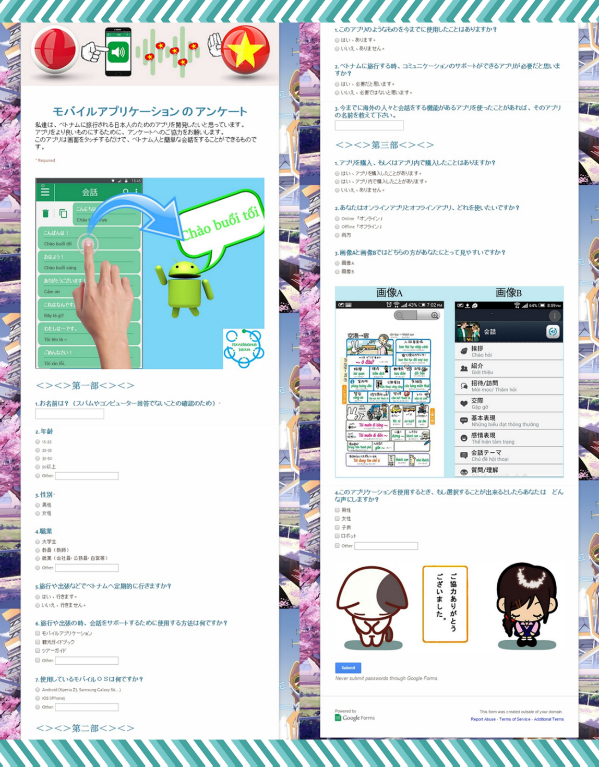

1. Survey (Japanese version)

Its audience is all Japanese people. Within two weeks, there are 66 responses. The respondent come from many different age and job.

1. Audience statistical

We analyzed responses from that survey. Theses graph below is one part of result.

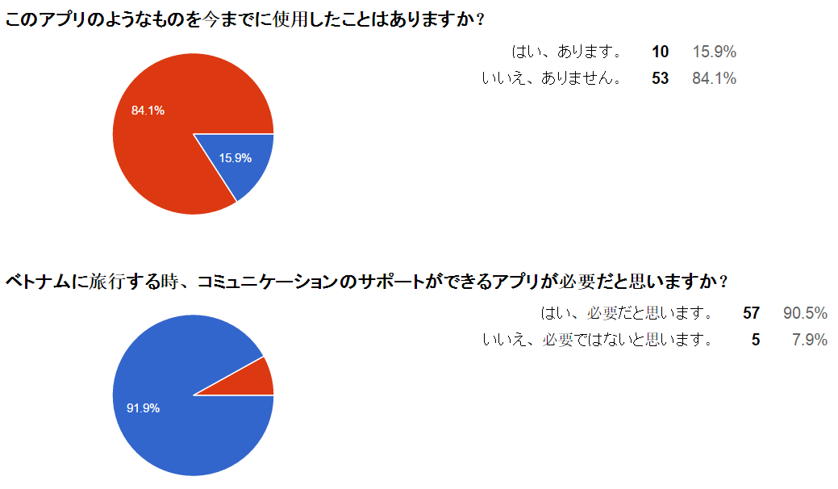

1. Summary of responses

The first question we asked: “Have you ever used something like our app?” According to the graph, 4/5 respondents have never used a CST before. However, there are about 90% agree that CST is necessary (with the second question: “When you travel to Vietnam, do you think we need an app that can support communication?”) We can see that the demand for this product is high, but not many developer build it. So we have plenty of chance join in this sector.

## Competitor analysis

After each member in group has a research action about competitor app, and a Competitor Analysis Meeting had been performed, this section will summary the competitive description, strength and weakness.

### RightNow Conversation

|  |  |
| --- | --- |
|  | * Full name: RightNow Vietnamese Conversation. * Owner: TIME SPACE SYSTEM Co., Ltd. * Term: Education. * Self-Description: All the essential sentences for conversations in a foreign language have been collected and stored in one app. * Features:   + Interactive translation for conversations in a foreign language, including a native speaker's pronunciation reference.   + Word conversion.   + Interpretation function.   + Today’s expression widget.   + Notifications of today’s expression.   + Recent sentences & Favorite sentences.   + Question and answer list.   + Voice playback sensor.   + Sending an e-mail or text message.   + Voice search. |

### Yubisashi

|  |  |
| --- | --- |
|  | * Full name: YUBISASHI Viet Nam touch & talk. * Owner: Joho Center Publishing Co., Ltd. * Term: Travel and Local. * Self-Description: App of The Original “Point-and-Speak Phrasebook” that has sold more than 5.1 million copies. * Features:   + Audio: You can listen to the pronunciation of the words you tap.   + Versatile vocabulary: The pages are full of essential words for everyday life.   + Resize function: Adjust the size of the screen for easy reading. |

### Product comparison

1. Product characteristics

|  |  |  |
| --- | --- | --- |
| **Characteristics** | **RightNow** | **Yubisashi** |
| Separate sentences into different category and subcategory | Yes | Yes |
| Search by text function | Has | N/A |
| Category appear at home screen | Yes | No |
| Can save history and favorite | Yes | Yes |
| Offline version | Yes | Yes |
| Interpreter function | Has | N/A |
| Friendly or funny interface | No | Yes |
| Short sentence, easy to understand. | No | Yes |
| Min value of manipulations to find out a sentence | 5 | 1 |
| Text size | 20sp | 10sp |
| Zoom text | N/A | Has |
| Vietnamese meaning | Poor | Good |
| Sound quality | Normal | Good |
| Good for traveler | No | Yes |
| Maintainable (easy to update data) | Easy (soft code) | Hard (hard code) |
| Performance (loading screen time) | Less than 3s | Less than 2s |

## Our proposal

Having learned from the drawbacks of the competitor apps, our project aims to develop a new app to provide best user experience.

This app will totally focus on support user in normal communication.

## Product

After review those characteristics of other applications, they have their own strength and weakness, so we came to an agreement about which functions our app should support to inherit or combine their strong points and reduce their limitations.

### Main objective

Base on Product Comparison table, we defined some main characteristics below:

* Separate sentences into different category and subcategory.
* Should have search function, history function, favorite function.
* Min value of manipulations to find out a need sentence should stay between 1 and 5 inclusive.
* Care more about Vietnamese meaning when build data.
* All of the sentences in this app will be sort sentence (less than 13 words) so the sender and receiver can easily and quickly understand.
* If the sentence is a question, it have to be Yes/No question or question that can archive by non-verbal language.
* Limit hard code as possible for maintainability.
* Loading time for a screen is less than 3 seconds.

### Main function

Our app will have 6 main feature below:

* Touch to talk
* Tagging
* Search tag and sentence
* Suggestion base on location
* Favorite
* History
* Create new sentence

### Out of scope function

This app doesn’t provide any function or gadget for education purpose.

This app only support for communication between Japanese and Vietnamese.

# Software project management

## Project Organization

### Organizational Structure

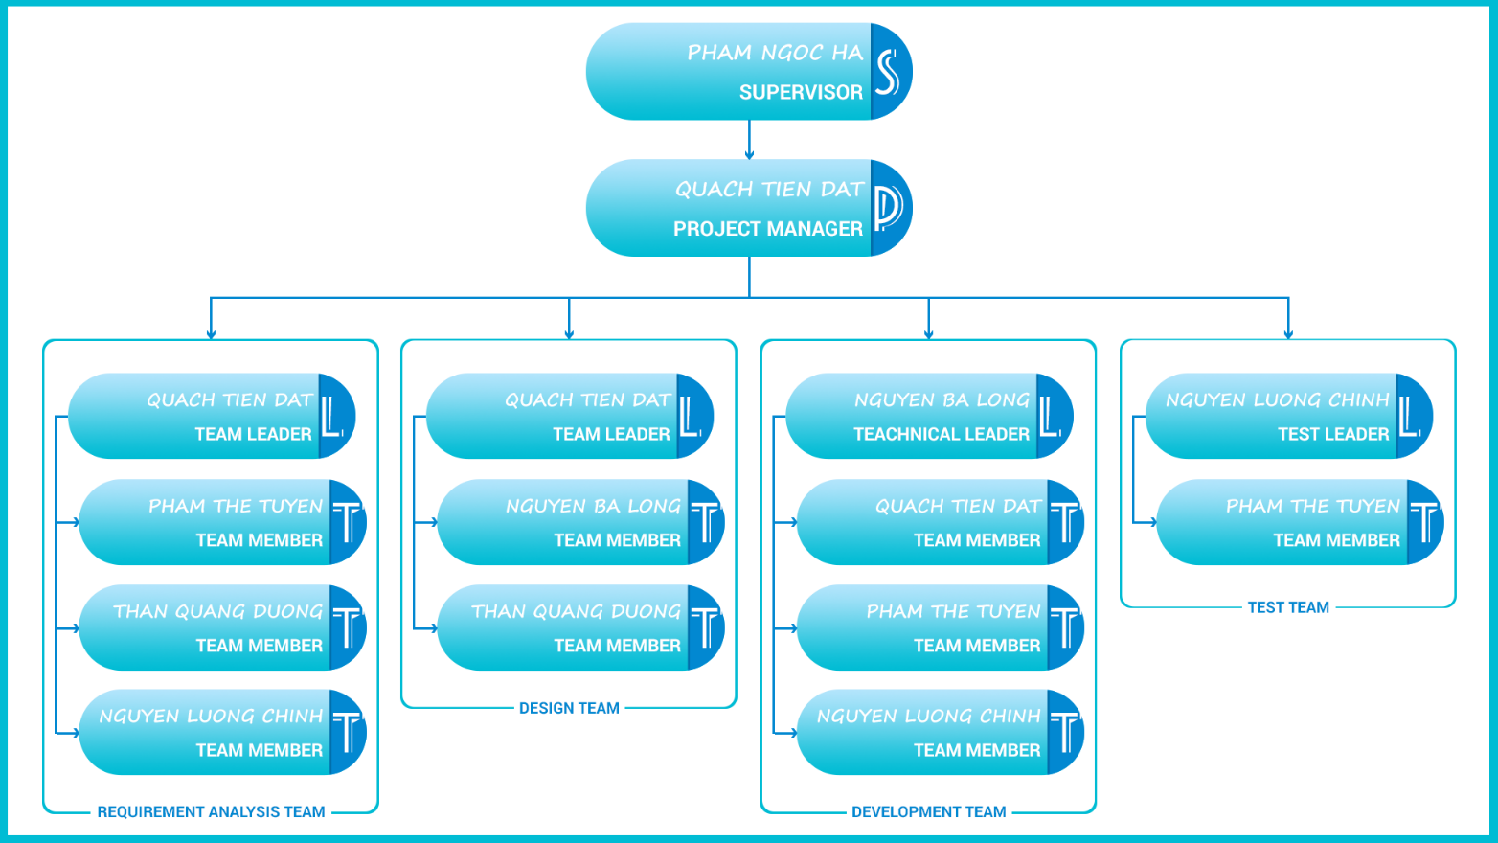

1. Organizational Structure

### Project team

1. Project team description

|  |  |  |
| --- | --- | --- |
| **Role** | **Responsibility** | **Full name** |
| **Supervisor** | * Provide document template. * Review deliverables. * Review project status. * Resole escalated issues. | Pham Ngoc Ha |
| **Project manager** | * Develop project plan. * Manage project stakeholders, project team and resolve conflicts. * Manage project schedule, project risk. * Communication with members and supervisor, include weekly plan, weekly status report, hold meetings and assure to submit reports to supervisor on schedule. * Manage document synchronization in project. * Task assignment and tracking. * Translate document to Japanese. | Quach Tien Dat |
| Requirement analysis team | | |
| **Team leader** | * Review and tracking SRD. * Create SRD format standard. | Quach Tien Dat |
| **Team member** | * Define use-case description. * Define screen flow description. | Pham The Tuyen |
| **Team member** | * Create screen flow and use-case diagram. * Create ER diagram. | Than Quang Duong |
| **Team member** | * Define use-case description. | Nguyen Luong Chinh |
| Design team | | |
| **Team leader** | * Design demo GUI. * Review and tracking SDD document. * Create SDD format standard. * Design software overall. | Quach Tien Dat |
| **Team member** | * Design demo GUI. * Create SDD document. | Nguyen Ba Long |
| **Team member** | * Draw all diagram base on software overall. | Than Quang Duong |
| Development team | | |
| **Team leader** | * Provide suitable technology solutions * Co-operate with members to coding and fix bug (core member). | Nguyen Ba Long |
| **Team member** | * Manage source code. * Review code. * Create coding conventions. | Quach Tien Dat |
| **Team member** | * Co-operate with members to coding and fix bug. * Review code. | Pham The Tuyen |
| **Team member** | * Co-operate with members to coding and fix bug. * Create database base on Design document. | Than Quang Duong |
| Test team | | |
| **Test leader** | * Develop the test plan based on project plan, SRS and Design documents * Delegate testing tasks to testers and manage the rate of progress * Create test data for all functions * Write test report | Nguyen Luong Chinh |
| **Team member** | * Create unit test case document. * Implement unit test case. | Pham The Tuyen |

## Software development process

### Iterative and Incremental development (I&I)

#### Definition

“**Iterative and Incremental development** is any combination of both iterative design or iterative method and incremental build model for software development. The combination is of long standing and has been widely suggested for large development efforts.”

Source: <https://en.wikipedia.org/wiki/Iterative_and_incremental_development>

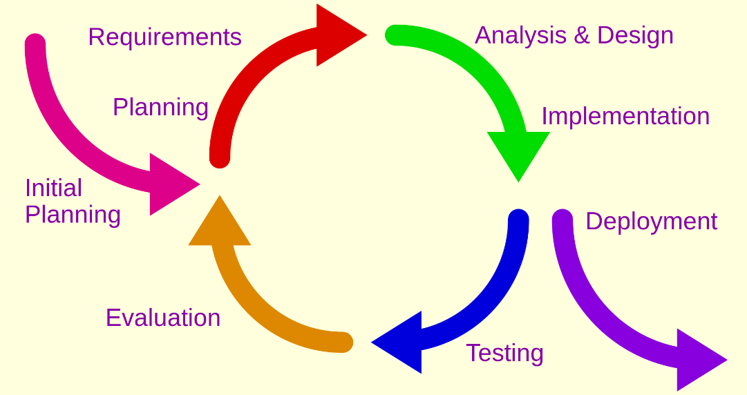

1. Iterative and Incremental model

This definition tell us that this development process combine from 2 model. They are iterative model which based on a cyclic process, and incremental model where the product will be added a little more each time until it is finished. Any combination of two model can be called as **Iterative and Incremental development.**

#### Advantages of I&I

* Generates working software quickly and early during the software life cycle.
* This model is more flexible – less costly to change scope and requirements.
* It is easier to test and debug during a smaller iteration.
* In this model customer can respond to each built.
* Lowers initial delivery cost.
* Easier to manage risk because risky pieces are identified and handled during it’d iteration.

### Project development model

Based on what we understood in the previous sector, we created a combination model that look like the diagram below.

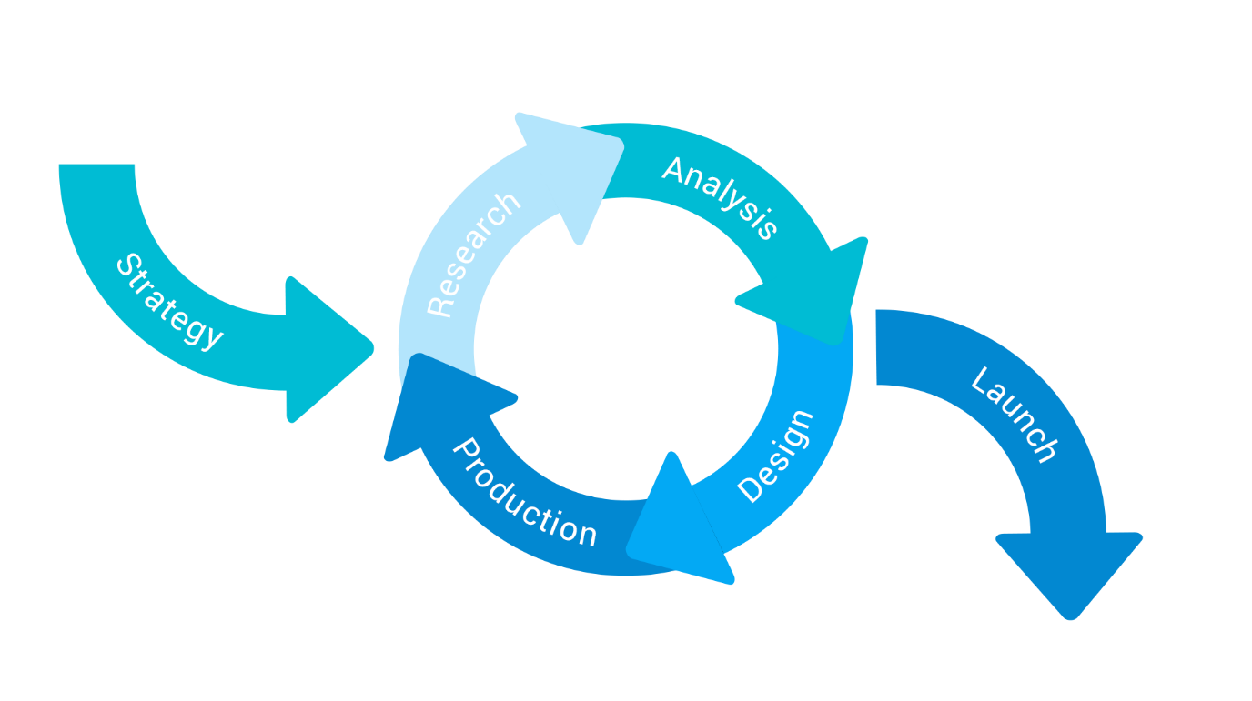

1. Project development model

#### Software life cycle

1. **Strategy** — in this phase, we need to define the vision and shape the goal of project. Get to know what the organization is hoping to achieve with this project and how its success should be measured.
2. **Research** — in this phase, we learn a about user, market, and also technic that require to complete the project.
3. **Analysis** — the aim of this phase is to draw insights from data collected during the Research phase.
4. **Design** — Base on what we get after researching and analyzing, in this phase, we create UI design, SRD and SDD.
5. **Production** — this phase contain all the process that require to build a product. In this project, we have 3 process run in parallel: Build data, Coding, Testing. The end of this phase is “Evaluation and continuous plan meeting” before we start a new cycle.
6. **Launch** — after all iterative cycle have been closed. We make a meeting for project overall review purpose, and release the product.

#### Idea for the software development model

Base on advantage of I&I model, our model should inherit I&I model, VTT is a project that the idea for product cannot come up at the first time, that why the model need to be flexible. So we kept the cycle but changed the phase.

We changed model phase to focus more on research, analysis and design. Because we don’t know anything about the user habit, user experience, market and also the available technic for this project. So now we have time to research about project related sector (or how to achieve the plan), analysis to filter information and design base on what we learn on the previous phases.

Other change is combine 3 separated process (Build data, Coding, Testing) in Production phase and run in parallel. The reason for this change is our project time is very short (only 4 months), and we need to spend a lots of time on research, analysis or design. So we decided to combine them and run in parallel to fit the time left behind.

One last change is the combination of evaluation phase and planning phase into one small step in Production phase. It’s “Evaluation and continuous plan meeting”. In this step, we summary what have done and plan what need to do on the next cycle.

With this model, we believe that this project will be on time and the product will match target market and sector.

## Project schedule

It is expected to have following effort distribution along phases:

1. Project effort

|  |  |  |  |  |  |  |
| --- | --- | --- | --- | --- | --- | --- |
|  | **Strategy** | **Research** | **Analysis** | **Design** | **Production** | **Launch** |
| **Effort (%)** | 4 | 15 | 10 | 30 | 40 | 1 |
| **Elapsed time (%)** | 4 | 15 | 8 | 35 | 47 | 1 |

### Project Milestones and Deliverables

1. Milestones and Deliverables

|  |  |  |  |  |
| --- | --- | --- | --- | --- |
| **No.** | **Deliverable/Milestone** | **Delivery Date** | **Delivery Location** | **Delivery type** |
|  | Capstone Project Register | 2015/03/06 | University | Hard and soft copy |
|  | Report 1 | 2015/05/22 | Supervisor | Soft copy |
|  | Report 2 | 2015/06/01 | Supervisor | Soft copy |
|  | Report 3 | 2015/06/15 | Supervisor | Soft copy |
|  | Report 4 | 2015/06/27 | Supervisor | Soft copy |
|  | Report 5 | 2015/07/20 | Supervisor | Soft copy |
|  | Report 6 | 2015/08/06 | Supervisor | Soft copy |
|  | Final report | 2015/08/15 | Supervisor | Soft copy |
|  | All project resource | 2015/08/26 | University | Hard and soft copy |

### Task Sheet

**Gantt chart**: Refer to the VTT_Project_Plan.mpp

Below are the image of task list used to assign and tracking tasks.

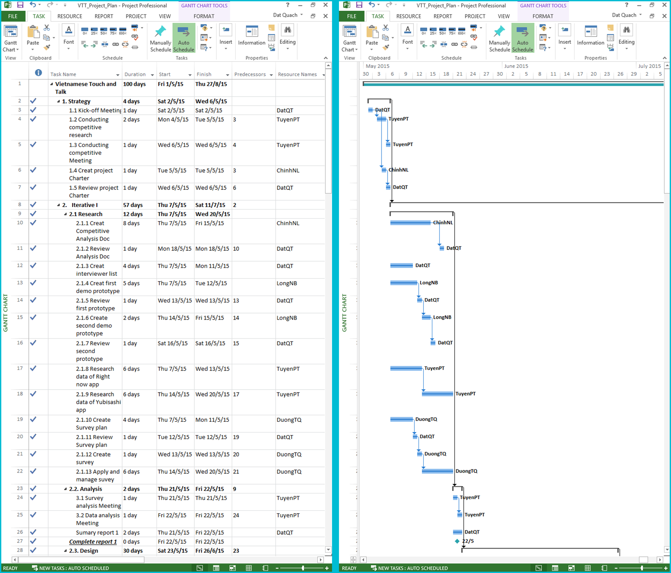

1. Work breakdown(left) and Gantt Chart

## Risk Management

### Schedule Categories

1. Risk Categories

|  |  |  |
| --- | --- | --- |
| **Category** | **Sub-category** | **Acronym & Abbreviation** |
| **Technical** | Requirement Definition | T-RD |
| Technology | T-T |
| Complexity and Interfaces | T-CI |
| Performance and Reliability | T-PR |
| Design | T-D |
| Quality | T-Q |
| **Management** | Estimating | M-E |
| Human Resources | M-HR |
| Communication | M-Cm |
| Source | M-S |
| Controlling | M-Cn |
| **External** | Market | E-M |
| Weather | E-W |
| User | E-U |

### Risk register

1. Risk register

|  |  |  |  |  |  |  |  |
| --- | --- | --- | --- | --- | --- | --- | --- |
| **ID** | **Description of risk** | **Cat** | **Impact** | **Root Cause** | **Avoidance Plan** | **Contingency Plan** | **Fallback Plan** |
| **1** | The processes does not meet their deadline | M-Cn | Affect the team members’ attitude and delay task | Poor control | Research carefully about how to control team | Increase work performance | Operate a lot of work at the same time |
| M-E | Poor estimate | Ask who will work to estimate |
| **2** | A team member’s absence | M-HR | Have influence on the project schedule and quality | Personal reason | Motivate  members | Other members replace that member’s work |  |
| **3** | Low team member’s motivation | M-Cm | Affect the team members’ attitude and delay task |  | Organize team building so that team member can get well to each other | Conduct a meeting so that the team members can express their opinions and find out solutions | Take responsibility in front of the team/ apply team punishment rules |
| **4** | Training process is not effective | M-HR | Have influence on the project schedule and quality |  | - Each member needs to do research by themselves and writes report  - Each member must be active to learn | Attend more training meeting. | Hire someone to help with technical training |
| **5** | Quality of user research and analysis is low | M-C | Affect the Project quality |  | Make a detail communication plan for user | Conduct a meeting to seek for root cause then modify the communication plan. | Renew communication plan on this part |
| **6** | Low data quality | T-Q | Have influence on the schedule and project quality |  | - Build data in a logical way  - Ask teacher for help to check the quality | Fix data immediately | Decrease unnecessary data |
| **7** | Poor unit test and test case | T-Q | Affect the Project quality |  | Each member needs to do research and work carefully. | Increase work performance | Ask for other people’s help to test |

### Resource Risk

The probability and impact of occurrence for each identified risk will be assessed by the project manager, with input from the project team using the following approach:

* **Probability**
  + High – Greater than <70%> probability of occurrence
  + Medium – Between <30%> and <70%> probability of occurrence
  + Low – Below <30%> probability of occurrence
* **Impact**
  + High – Risk that has the potential to greatly impact project cost, project schedule or performance
  + Medium – Risk that has the potential to slightly impact project cost, project schedule or performance
  + Low – Risk that has relatively little impact on cost, schedule or performance

1. Probability/Impact matrix

|  |  |  |  |  |
| --- | --- | --- | --- | --- |
| **Probability** | **High** |  | Risk 6 | Risk 1 |
| **Medium** |  | Risk 7, Risk 4 | Risk 5 |
| **Low** | Risk 2 | Risk 3 |  |
|  | **Low** | **Medium** | **High** |
|  | **Impact** | | | |

### Risk Tracking

A “Top 10 Risk List” will be maintained by the PM and will be reported as a component of the project status reporting process for this project. The list will follow the format below:

1. Risk Tracking

|  |  |  |  |  |
| --- | --- | --- | --- | --- |
| **Risk Event** | **MONTHLY RANKING** | | | |
| **Rank This Month** | **Rank Last Month** | **Number of Months in Top Ten** | **Risk Resolution Progress** |
| The processes does not meet their deadline | 3 | 1 | 1 |  |
| **A team member’s absence** | 7 | 7 | 1 |  |
| **Low team member’s motivation** | 4 | 6 | 1 |  |
| **Training process is not effective** | 5 | 4 | 1 |  |
| Quality of user research and analysis is low | 1 | 2 | 1 |  |
| Low data quality | 2 | 3 | 1 |  |
| Poor unit test and test case | 6 | 4 | 1 |  |

### Closing risk

A risk will be considered closed when it meets the following criteria:

* Risk is no longer valid.
* Risk Event has occurred.
* Risk is no longer considered a risk.
* Risk closure at the direction of the Project Manager.

## Communication Management

### Gathering and storing project information

For each milestone in this project, there is a report that stored project information of the previous process. Only PM can access theses file after storing it into Google Drive, other team member can view but cannot modify or copy.

After create a report, it will be reviewed by supervisor in Face-to-face meeting at the next Tuesday.

A final report that storing all previous reports will be created at the last project process. This report should summary in less than 200 page of paper.

### Technologies or access method use for communications

1. Communication tools

|  |  |  |
| --- | --- | --- |
| **Technologies or access method** | **Tool Name** | **Purpose** |
| Email and message | Gmail | Contact with supervisor |
| Facebook/ Skype | Keep track of team process |
| Video call | Skype | Online meeting |
| Mobile phone | Cellphone | Contact directly with other stakeholders in an emergency situation |
| Collaboration tool | Tortoise SVN | Managing source code |
| Google Drive | Managing document |

### Escalation procedures

1. Escalation procedures

|  |  |  |  |
| --- | --- | --- | --- |
| **Priority** | **Definition** | **Decision Authority** | **Timeframe for Resolution** |
| **Priority 1** | High impact which may stop all process of the project. | Supervisor | Within two business days. |
| **Priority 2** | Medium impact which may cause some scheduling difficulties with the project. | Project Manager | Within three business days. |
| **Priority 3** | Insignificant impact to project but there may be a better solution. | Project Manager | Work continues and any recommendations are submitted via the project change control process. |
| **Priority 4** | Technical impact which may cause stop a part of the project. | Technical Leader | Within three business days.  Work continues with another project part. |

## Configuration Management Process

### CI Identification & Naming convention

1. CI Identification & Naming convention

|  |  |  |
| --- | --- | --- |
| No | Configuration Items | Naming convention |
| Project Management | | |
| 1 | Project Plan | VTT_Project Plan_v.[version number]  For example: VTT_Project Plan_v1.0 |
| Requirement & Design | | |
| 2 | Software Requirements Specification | VTT_Software Requirements Specification_v.[version number]  For example: VTT_Software Requirements Specification_v1.0 |
| 3 | Software Design Description | VTT_Software Design Description_v.[version number]  For example: VTT_ Software Design Description_v1.0 |
| 4 | Screen Design | VTT_Screen Design_v.[version number]  For example: VTT_Screen Design_v1.0 |
| 5 | Data Design | VTT_ Data Design_v.[version number]  For example: VTT_ Data Design_v1.0 |
| Source Code | | |
| 6 | Source Code | VTT_Source Code_ v.[version number] [Tested/Untested] For example: VTT_Source Code_v1.0 Tested |
| Support Document | | |
| 7 | User Manual | VTT_User Manual_v.[version number]  For example: VTT_User Manual_v.[version number] |
| Test | | |
| 8 | Test Plan | VTT_Test Plan_v.[version number]  For example: VTT_Test Plan_v1.0 |
| 9 | Test Case | VTT_Test Case_v.[version number]  For example: VTT_Test Case_v1.0 |
| 10 | Test Result | VTT_Test Report_v.[version number]  For example: VTT_Test Report_v1.0 |
| Process | | |
| 11 | Guideline | VTT_ [Name Of Guideline] Guideline_v.[version number]  For example: VTT_Unit Test Guideline_v1.0 |
| 12 | Convention | VTT_[Name Of Convention] Conventions_v.[version number]  For example: VTT_Coding Conventions_v1.0 |
| 13 | Checklist | VTT_[Name Of Checklist] Checklist_v.[version number]  For example: VTT_Review Code Checklist_v1.0 |
| File Type | | |
| 14 | MS Word | *.doc, *.docx |
| 15 | MS Excel | *.xls, *.xlsx |
| 16 | MS PowerPoint | *.ppt, *.pptx |
| 17 | MS Project | *.mpp |
| 18 | Enterprise Architect | *.eap |
| 19 | Images | *.png or *.jpg or *.jpeg or *.bmp or *.gif |

### Project Infrastructure

#### Software

1. Software infrastructure

|  |  |  |
| --- | --- | --- |
| **Category** | **Software name** | **Version** |
| **Operating system** | Microsoft window 8.1 | Professional |
| Microsoft window 7 | Ultimate |
| **Office tools** | Microsoft Office | 2013 |
| **Task tracking** | Microsoft Project | 2013 |
| **Design tools** | Astah Community | 6.9.0 |
| Edraw Max | 7.9 |
| Enterprise Architect | 7.1.831 (build 831) |
| **Database tool** | SQLite browser | 3.7.0 |
| MySQL Workbench | 6.3.4 |
| **Development Framework** | Microsoft .NET | 4.0 |
| JDK | Java 8 update 31 |
| **Development tool** | Android studio | 1.3 |
| Genymotion | 2.5.2 |
| **Source version control** | Tortoise SVN | 1.8.10.26129 |
| Google drive | 1.23.9648.8824 |
| **UI design tool** | Adobe Photoshop CC | 14.0 |

#### Hardware

* Personal computer for developing and testing with the minimum configuration: 4GB RAM, 500GB of hard disk, Intel Core i3.
* Internet network connection with minimum speech 512kbit/s.
* Android smartphone running Gingerbread 4.0 or higher.

#### Other infrastructure

* A room for team’s meeting.
* Internet and mobile phone services are needed for communication.

### Coding convention

Coding convention for this project will follow the “Code Style Guidelines for Contributors” for Android developer.

For more details, visit the following link:

<https://source.android.com/source/code-style.html#java-language-rules>

### Directory structure

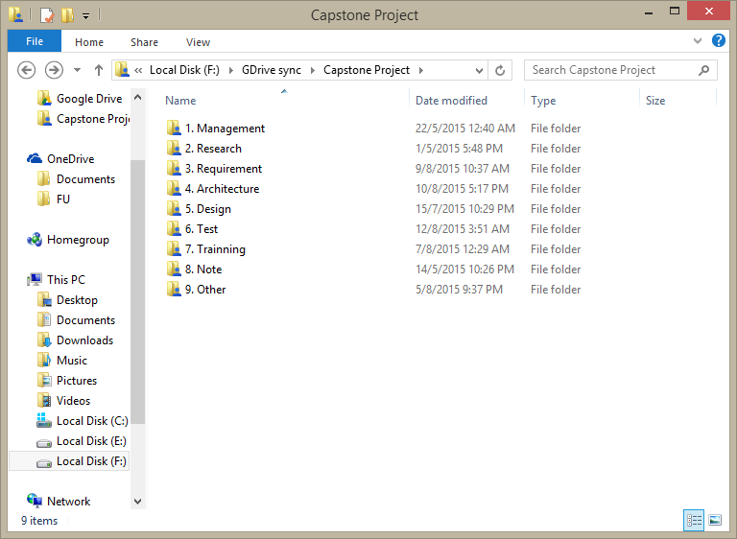

1. Folder structure on google drive
2. Folder structure

|  |  |  |
| --- | --- | --- |
| **Main folder** | **Sub folder** | **Purpose** |
| **Management** | Scope and Integration | Store project scope document |
| Time | Store project schedule document |
| Cost | Store project cost document |
| Human Resource | Store project human resource document |
| Quality | Store project quality management document |
| Communication | Store project communication document |
| Risk | Store project risk management document |
| Report | Store project report |
| **Research** | Conducting-competitive-research | Store all documents from conducting competitive research process |
| Data collection | Store all data document and resource |
| Survey | Store survey plan, result and template |
| **Requirement** | Use case | Store use-case diagram image and use-case description document |
|  | Store SRD document |
| **Architecture** | Class diagram | Store class diagram image |
| Sequence diagram | Store sequence diagram image |
|  | Store SDD document |
| **Design** | Font | Store alternative font for project |
| Other | Store other design for document |
| Demo UI | Store demo UI design |
| Final UI | Store final UI design |
| **Test** |  | Store testing document |
| **Training** |  | Store training document |
| **Note** |  | Store note document |
| **Other** |  | Store other document of project that not belong to other main sector. |

### Other CM Rules

* Email subject naming convention: Add prefix [HS-team] for all mail that related to this project.
* Document changing rule: Update newest version before modify any document.
* Submit code rule: Before submit new code, update all code resource to the newest version. If there are conflict file, resolve it immediately and resubmit.

# Software Requirement Specification

## Introduction

### Purpose

The main purpose of the requirement document is provides the information of the project from many perspectives. Readers can find out about the overview description or detail information in this document.

The information is the fully describing about the software system such as functional requirements, non-functional requirements, design constrains and any other necessary information.

This document is the software requirement specification of the project in order to develop the software, it includes two main parts: User Requirement Specification and System Requirements Specification:

* User Requirement Specification:
  + Provides the general information about the software system.
  + The project manager and supervisors should read this part because they can partly base on it to negotiate with each other about some particular problems.
* System Requirements Specification:
  + Provides the detail information about the software system. This part captures the complete software requirements for the system, and then it is important for software designer, software developer, machine maker and manufacturer, tester and maintainer.
  + This part is also for the project manager because it can help him to monitor all the activities of the project effectively.

### Scope

The document applies to many stages of developing the system:

* It is first used for project manager and supervisors to negotiate.
* It is also very important for designing, developing, manufacturing, testing and maintaining the system:
  + The designers must know what the system is and what function it needs to have.
  + The developing must know what the system does, how each function is implemented and the interface between components in system.
  + The tester must know that to check if the system meets the requirements or not.

## Overall description

### Product Function

VTT will be a native mobile application that look like a communication supporting tool. It will stand between a Japanese and Vietnamese and help them understand each other in a normal conversation.

The features of this product will aim to support the Japanese in a situation that he/she doesn’t know Vietnamese or hasn’t time to learn a new language (in this case is Vietnamese).

#### Touch to talk

This is a main function of this application. User touch on a Japanese sentence and a meaning in Vietnamese of that sentence will come out.

It will come out in two types, the sound from device’s speaker and the text on a popup.

The Japanese sentence should be short (smaller than 13 words) and could be impolite.

The Vietnamese sentence will be short but must be polite enough.

#### Tagging

Each sentence has its own default tag for sorting purpose. One sentence can have more than one tag or doesn’t have any tag.

An example of tag:

* Japanese: フォー お願いします。
* Vietnamese: Xin cho tôi một bát phở.
* Meaning: a pho, please!
* Tag: フォー (pho) ; 料理 (food)
* **Tag list**

There will be a list of tags that show all tags.

In this list, if user touch on a tag, app must list all the sentence which that tag belong to.

* **Create new tag**

User can create a new tag.

The name of new tag mustn’t match any other tag’s name.

* **Assign tag into sentence**

User can assign one or more than one tag into a sentence.

The tag could be in the tag list or user can create a new one.

* **Remove tag form sentence**

User can remove one or more than one tag from a sentence.

If user remove wrong tag, they can revert tag removed.

* **Delete tag**

In the tag list, user also can delete a tag permanently.

It also remove all of the relationship of that tag with other sentence.

#### Search

In this screen, user can use touch and talk function.

* **Search sentence**

Type a text on search box to search a sentence. User can enter both Hiragana and Kanji for what user want to say.

For every text enter, app should show suggestion base on what user is typing.

* **Search tag**

Type a text on search box to search a tag. User can enter both Hiragana and Kanji for what user want to find.

For every text enter, app should show suggestion base on what user is typing.

#### User’s sentences management

User cannot change the default sentence. However, he/she can create a new sentence and modify that sentence.

* **Add new user’s sentence**

User can add a new sentence. All the sentence will be place in a category, the name of category should be 私の文章 (My sentence).

New sentence’s detail require these information:

* Japanese part (kanji) - required
* Vietnamese meaning part – optional
* Image – optional
* Audio – optional
* **Modify user’s sentence**

User can change the information of a user’s sentence.

* **Remove user’s sentence**

User can delete a user’s sentence permanently.

#### History

A screen will list 50 recently sentences that had been used.

In this screen, user can use touch and talk function.

#### Favorite

User can add and remove a sentence to the favorite list.

In this screen, user can use touch and talk function.

#### Suggestion

Filter sentences which suitable to users basing on the current position and place nearby.

### User Characteristics

* People who come from Japan and use Japanese as mother tongue.
* Be able to use an android device.

## Specification Requirement

### Interface Requirements

#### User interface

* The text is Japanese only.
* The color use to design user interface is elegant, not flashy.

#### Hardware interface

* This app will be runnable Multiscreen, minimum support 720x1280 Density.
* Be tested on 720x1280, 768x1280, 1080x1920 screens.

#### Software interface

* This app will be developed on Android and support version 4.0 Gingerbread to 5.0.2 Lollipop.

### Functional Requirements

1. Use-case list

|  |  |  |  |
| --- | --- | --- | --- |
| **No.** | **Use-case name** | | **Use-case no.** |
| 1 | Touch to talk | View category list | UC-01-01 |
| 2 | View subcategory list | UC-01-02 |
| 3 | View sentence list | UC-01-03 |
| 4 | Touch to has voice | UC-01-04 |
| 5 | Search | Search | UC-02-01 |
| 6 | Search sentence | UC-02-02 |
| 7 | Search tag | UC-02-03 |
| 8 | User’s sentence management | View user’s sentence list | UC-03-01 |
| 9 | Modify user’s sentence | UC-03-02 |
| 10 | Remove user’s sentence | UC-03-03 |
| 11 | Add new user’s sentence | UC-03-04 |
| 12 | Take photo | UC-03-05 |
| 13 | Record audio | UC-03-06 |
| 14 | Tagging | View tag list | UC-04-01 |
| 15 | Modify sentence’s tag | UC-04-02 |
| 16 | Favorite | View favorite | UC-05-01 |
| 17 | History | View history | UC-06-01 |
| 18 | Suggestion | Suggestion | UC-07-01 |

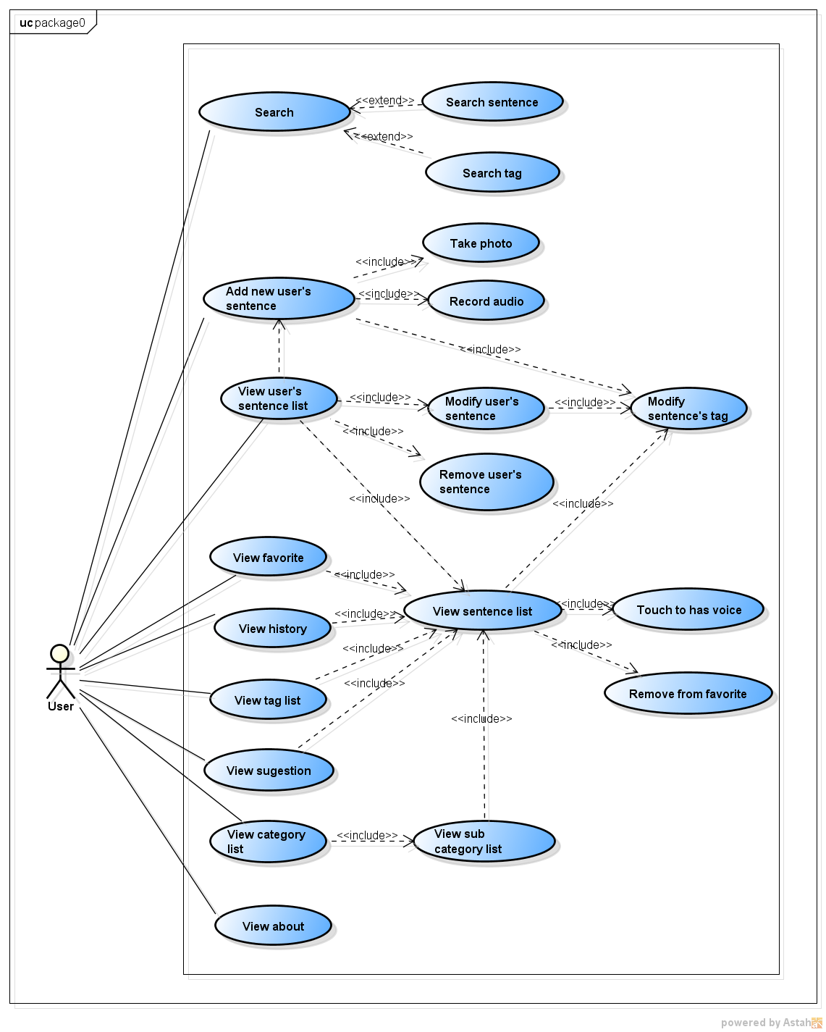

1. Use-case diagram

#### Business rule

1. Business rule

|  |  |
| --- | --- |
| **No** | **Description** |
| **B1** | 日本語 must not be blank |
| **B2** | 日本語 must less than 14 character |
| **B3** | ベトナム語 must less than 18 character |
| **B4** | タグ名 must not be duplicate |
| **B5** | タグ名 must not be blank |
| **B6** | タグ名 must less than 7 character |
| **B7** | Mobile phone must connect internet |

#### UC-01-01

|  |  |  |  |
| --- | --- | --- | --- |
| Use-case UC-01-01 specification | | | |
| **Use-case no.** | UC-01-01 | **Use-case version** | 2.0 |
| **Use-case name** | View category list | | |
| **Author** | LongNB | | |
| **Date** | 06/06/2015 | **Priority** | High |
| **Actor:**  User. | | | |
| **Summary:**  In this use-case, user can view category list. | | | |
| **Goal:**  User can view category list. | | | |
| **Triggers:**  N/A | | | |
| **Pre-conditions:**  N/A | | | |
| **Post-conditions:**  N/A | | | |
| **Main Scenario:**   |  |  |  | | --- | --- | --- | | Step | Action | Response | | 1 | User taps on navigation icon at the top left of main screen or swipes a finger from the left edge of the screen. | The app shows list items in Navigation drawer menu:  会話集  タグ  お気に入り  ヒストリー  通訳  私の文書 | | 2 | User taps on 会話集item in Navigation drawer menu. | The category list will be displayed on screen. It includes categories that are displayed by grid view. Each category includes image, title and description under title. | | | | |
| **Alternative Scenario:**  **1.1.1 View homepage**   |  |  |  | | --- | --- | --- | | Step | Action | Response | | 1 | User taps on VTT application icon on mobile screen. | Display loading screen with progress bar.  After the progress bar finished loading, display homepage screen (category list screen) | | | | |
| **Exceptions:**  N/A | | | |
| **Business Rules:** | | | |

#### UC-01-02

|  |  |  |  |
| --- | --- | --- | --- |
| Use-case UC-01-02 specification | | | |
| **Use-case no.** | UC-01-02 | **Use-case version** | 2.0 |
| **Use-case name** | View subcategory list | | |
| **Author** | TuyenPT | | |
| **Date** | 06/06/2015 | **Priority** | High |
| **Actor:**  Users | | | |
| **Summary:**  In this use-case, user can view subcategory list. | | | |
| **Goal:**  User can view category list. | | | |
| **Triggers:**  N/A | | | |
| **Pre-conditions:**  Passed use-case view category list. | | | |
| **Post-conditions:**  N/A | | | |
| **Main Scenario:**   |  |  |  | | --- | --- | --- | | Step | Action | Response | | 1 | On 会話集 screen user tap on one of eight categories icon or name under icon. | The list subcategory will be displayed on screen | | | | |
| **Alternative Scenario:**  N/A | | | |
| **Exceptions:**  N/A | | | |
| **Business Rules:** | | | |

#### UC-01-03

|  |  |  |  |
| --- | --- | --- | --- |
| Use-case UC-01-03 specification | | | |
| **Use-case no.** | UC-01-03 | **Use-case version** | 2.0 |
| **Use-case name** | View sentence list | | |
| **Author** | LongNB | | |
| **Date** | 06/06/2015 | **Priority** | High |
| **Actor:**  Users | | | |
| **Summary:**  In this use-case, user can view sentence list via category or tag | | | |
| **Goal:**  User can view sentence list. | | | |
| **Triggers:**  N/A | | | |
| **Pre-conditions:**  Passed use-case view subcategory list or view tag list. | | | |
| **Post-conditions:**  N/A | | | |
| **Main Scenario:**   |  |  |  | | --- | --- | --- | | Step | Action | Response | | 1 | User taps on one row subcategory | The sentence list of this subcategory will be displayed on screen | | User taps on a tag | The sentence list of this tag will be displayed on screen | | | | |
| **Alternative Scenario:**  **1.3.1 View images list**   |  |  |  | | --- | --- | --- | | Step | Action | Response | | 1 | On list sentence screen user tap on tab画像. | Display list image. This screen includes sentences which have illustrative image. It’s has the same layout with the category screen. |   **1.3.2 Add or remove sentence or image to favorite**   |  |  |  | | --- | --- | --- | | Step | Action | Response | | 1 | On list sentence or image screen user swipe on a sentence from left to right. | Display button favorite at the left of sentence or image. If list favorite has this sentence, this button will have pale color. If list favorite has not this sentence, this button will have bold color. | | 2 | Tap on button favorite. | If this button is pale color, changes it to bold color, remove this sentence from favorite and this sentence auto sliding original location. If this button is bold color, changes it to pale color, add this sentence on favorite and this sentence auto sliding original location. | | | | |
| **Exceptions:**  N/A | | | |
| **Business Rules:** | | | |

#### UC-01-04

|  |  |  |  |
| --- | --- | --- | --- |
| Use-case UC-01-04 specification | | | |
| **Use-case no.** | UC-01-04 | **Use-case version** | 2.0 |
| **Use-case name** | Touch to has voice | | |
| **Author** | TuyenPT | | |
| **Date** | 06/06/2015 | **Priority** | High |
| **Actor:**  Users | | | |
| **Summary:**  In this use-case, User touch to sentence on the screen and system generate voice. | | | |
| **Goal:**  User has needed voice to communicate. | | | |
| **Triggers:**  N/A | | | |
| **Pre-conditions:**  Passed use-case view sentence list. | | | |
| **Post-conditions:**  Display pop-up. | | | |
| **Main Scenario:**   |  |  |  | | --- | --- | --- | | Step | Action | Response | | 1 | On list sentence screen user tap on one sentence row. | Generate Vietnamese voice of sentence and display pop-up includes Japanese and Vietnamese of sentence and two buttons: “exit” and “replay”. | | 2 | On pop-up user tap on button exit (x) | Exit pop-up and return sentences screen. | | 3 | On pop-up user tap on button replay. | Keep pop-up and generate Vietnamese voice of sentence again. | | | | |
| **Alternative Scenario:**  **1.4.1 Replay sound**   |  |  |  | | --- | --- | --- | | Step | Action | Response | | 1 | On list sentence screen user tap on tab画像. | Display list image. This screen includes sentences which have illustrative image. It’s has the same layout with the catagory screen. | | 2 | On list image screen user tap on one image. | Generate Vietnamese voice of sentence and display pop-up includes image, Japanese and Vietnamese of sentence and two buttons: exit and replay. | | 3 | On pop-up user tap on button exit (x) | Exit pop-up and return list image screen. | | 4 | On pop-up user tap on button replay. | Keep pop-up and generate Vietnamese voice of sentence again. | | | | |
| **Exceptions:**  N/A | | | |
| **Business Rules:** | | | |

#### UC-02-01

|  |  |  |  |
| --- | --- | --- | --- |
| Use-case UC-02-01 specification | | | |
| **Use-case no.** |  | **Use-case version** | 2.0 |
| **Use-case name** | Search | | |
| **Author** | TuyenPT | | |
| **Date** | 06/06/2015 | **Priority** | Normal |
| **Actor:**  User | | | |
| **Summary:**  In the use-case, user can search needed sentences or tags. | | | |
| **Goal:**  Save time for user. | | | |
| **Triggers:**  N/A | | | |
| **Pre-conditions:**  N/A | | | |
| **Post-conditions:**  N/A | | | |
| **Main Scenario:**   |  |  |  | | --- | --- | --- | | Step | Action | Response | | 1 | User tap on button search at action bar. | Display search screen include edit text for user can type keyword and all of sentences or tag. | | 2 | Type keyword. | A smart function will display a list of suggested keywords based on what user is tapping. | | 3 | Choose a result or continue to type the keyword. | Display all results in the search result page. | | | | |
| **Alternative Scenario:**  N/A | | | |
| **Exceptions:**  N/A | | | |
| **Business Rules:** | | | |

#### UC-02-02

|  |  |  |  |
| --- | --- | --- | --- |
| Use-case UC-02-02 specification | | | |
| **Use-case no.** | UC-02-02 | **Use-case version** | 2.0 |
| **Use-case name** | Search sentence | | |
| **Author** | TuyenPT | | |
| **Date** | 06/06/2015 | **Priority** | Normal |
| **Actor:**  User | | | |
| **Summary:**  In the use-case, user can search needed sentence. | | | |
| **Goal:**  Save time for user. | | | |
| **Triggers:**  N/A | | | |
| **Pre-conditions:**  N/A | | | |
| **Post-conditions:**  N/A | | | |
| **Main Scenario:**   |  |  |  | | --- | --- | --- | | Step | Action | Response | | 1 | User tap on button search at action bar. | Display search screen include edit text for user can type keyword and all of sentences. | | 2 | User type keyword | A smart function will display a list of suggested keywords based on what user is tapping. | | 3 | Choose a sentence or continue to type the keyword. | Display all of results in the search result page. | | | | |
| **Alternative Scenario:**  N/A | | | |
| **Exceptions:**  N/A | | | |
| **Business Rules:** | | | |

#### UC-02-03

|  |  |  |  |
| --- | --- | --- | --- |
| Use-case UC-02-04 specification | | | |
| **Use-case no.** | UC-02-03 | **Use-case version** | 2.0 |
| **Use-case name** | Search tag | | |
| **Author** | TuyenPT | | |
| **Date** | 06/06/2015 | **Priority** | Normal |
| **Actor:**  User | | | |
| **Summary:**  In the use-case, user can search needed tag. | | | |
| **Goal:**  Save time for user. | | | |
| **Triggers:**  N/A | | | |
| **Pre-conditions:**  Pass use-case View tag list. | | | |
| **Post-conditions:**  N/A | | | |
| **Main Scenario:**   |  |  |  | | --- | --- | --- | | Step | Action | Response | | 1 | User tap on button search at action bar. | Display search screen include edit text for user can type keyword. | | 2 | User type keyword. | A smart function will display a list of suggested keywords based on what user is tapping. | | 3 | Choose a tag or continue to type the keyword. | Display all results in the search result page. | | | | |
| **Alternative Scenario:**  N/A | | | |
| **Exceptions:**  N/A | | | |
| **Business Rules:** | | | |

#### UC-03-01

|  |  |  |  |
| --- | --- | --- | --- |
| Use-case UC-03-01 specification | | | |
| **Use-case no.** | UC-03-01 | **Use-case version** | 1.0 |
| **Use-case name** | View user’s sentence list | | |
| **Author** | TuyenPT | | |
| **Date** | 06/06/2015 | **Priority** | High |
| **Actor:**  Users | | | |
| **Summary:**  In this use-case, user can view user’s sentence list. | | | |
| **Goal:**  User can view sentence list. | | | |
| **Triggers:**  N/A | | | |
| **Pre-conditions:**  N/A | | | |
| **Post-conditions:**  N/A | | | |
| **Main Scenario:**   |  |  |  | | --- | --- | --- | | Step | Action | Response | | 1 | User taps on navigation icon at the top left of main screen or swipes a finger from the left edge of the screen. | The app shows list items in Navigation drawer menu:  会話集  タグ  お気に入り  ヒストリー  通訳  私の文書 | | 2 | User taps on私の文書item in Navigation drawer menu. | The user’s sentence list will be displayed on screen. | | | | |
| **Alternative Scenario:**  **3.1.1 View user’s images list**   |  |  |  | | --- | --- | --- | | Step | Action | Response | | 1 | On list user’s sentence screen user tap on tab画像. | Display list image. This screen includes sentences which have illustrative image. It’s has the same layout with the category screen. |   **3.1.2 Add or remove user’s sentence or image to favorite**   |  |  |  | | --- | --- | --- | | Step | Action | Response | | 1 | On list user’s sentence or image screen user swipe on a sentence from left to right. | Display button favorite at the left of sentence or image. If list favorite has this sentence, this button will have pale color. If list favorite has not this sentence, this button will have bold color. | | 2 | Tap on button favorite. | If this button is pale color, changes it to bold color, remove this sentence from favorite and this sentence auto sliding original location. If this button is bold color, changes it to pale color, add this sentence on favorite and this sentence auto sliding original location. | | | | |
| **Exceptions:**  N/A | | | |
| **Business Rules:** | | | |

#### UC-03-02

|  |  |  |  |
| --- | --- | --- | --- |
| Use-case UC-03-02 specification | | | |
| **Use-case no.** | UC-03-02 | **Use-case version** | 2.0 |
| **Use-case name** | Modify user’s sentence | | |
| **Author** | DuongTQ | | |
| **Date** | 06/06/2015 | **Priority** | High |
| **Actor:**  User | | | |
| **Summary:**  In this use-case, Users can edit information of any sentences which was added by themselves. | | | |
| **Goal:**  The information of selected sentence is edited. | | | |
| **Triggers:**  N/A | | | |
| **Pre-conditions:**  Passed use-case view user’s sentence list. | | | |
| **Post-conditions:**  Back to list user’s sentence screen. | | | |
| **Main Scenario:**   |  |  |  | | --- | --- | --- | | Step | Action | Response | | 1 | On list sentence screen user swipe on a sentence from right to left. | Display button edit and delete at the right of sentence. | | 2 | Tap on button edit. | Display edit sentence screen include fields: 日本語, ベトナム語, タグ, 写真, レコーダー. | | 3 | User edit Japanese, Vietnamese, or add, remove tag, image, audio then tap OK button. | Back to user’s sentence list screen and update new information for sentence just edited. | | User edit Japanese, Vietnamese, or add, remove tag, image, audio then tap Cancel button. | Display confirm dialog. | | 4 | Tap on OK button. | Back to user’s sentence list screen with nothing changed. | | Tap on Cancel button. | Stay at modify user sentence screen. | | | | |
| **Alternative Scenario:**  **3.2.1 Modify tag**   |  |  |  | | --- | --- | --- | | Step | Action | Response | | 1 | Tap on button add at field tag on modify user’s sentence screen. | Display modify tag screen include text to fill tag’s name, row to show tag added, and suggestion tags. | | 2 | Reference step 3 to step 6 at main scenario of use-case modify sentence’s tag. | |   **3.2.2 Add audio**   |  |  |  | | --- | --- | --- | | Step | Action | Response | | 1 | Tap on add button at field audio on modify user’s sentence screen. | Display browse screen to user choose available audio in mobile. | | 2 | Tap to choose needed audio. | Back to modify user’s sentence screen with chose audio. | | 3 | Tap on OK button. | Back to user’s sentence list screen and update new information for sentence just edited. | | Tap on Cancel button. | Back to user’s sentence list screen with nothing changed. |   **3.2.3 Play audio**   |  |  |  | | --- | --- | --- | | Step | Action | Response | |  |  | If this sentence has file audio, enable play button.  If this sentence has not file audio, disable play button. | | 1 | Tap on play button at field audio on modify user’s sentence screen. | If this sentence had file audio, generate audio. | | If this sentence hadn’t file audio, do nothing. |   **3.2.4 Remove audio**   |  |  |  | | --- | --- | --- | | Step | Action | Response | |  |  | If this sentence has file audio, enable delete button.  If this sentence has not file audio, disable delete button. | | 1 | Tap on delete button at field audio on modify user’s sentence screen. | If this sentence had file audio, display confirm dialog and continue step 2. | | If this sentence hadn’t file audio, do nothing. | | 2 | Tap on OK button. | Back to modify user’s sentence screen and remove audio from field audio. | | Tap on Cancel button. | Back to modify user’s sentence screen and delete nothing. | | 3 | Tap on OK button. | Back to user’s sentence list screen and update new information for sentence just edited. | | Tap on Cancel button. | Back to user’s sentence list screen with nothing changed. |   **3.2.5 Add image**   |  |  |  | | --- | --- | --- | | Step | Action | Response | | 1 | Tap on add button at field image on modify user’s sentence screen. | Display browse screen to user choose available image in mobile. | | 2 | Tap to choose needed image. | Back to modify user’s sentence screen with chose image and display it on this screen. | | 3 | Tap on OK button. | Back to user’s sentence list screen and update new information for sentence just edited. | | Tap on Cancel button. | Back to user’s sentence list screen with nothing changed. |   **3.2.6 Remove image**   |  |  |  | | --- | --- | --- | | Step | Action | Response | |  |  | If this sentence has file image, enable delete button.  If this sentence has not file image, disable delete button. | | 1 | Tap on delete button at field image on modify user’s sentence screen. | If this sentence had file image, display confirm dialog and continue step 2. | | If this sentence hadn’t file image, do nothing. | | 2 | Tap on OK button. | Back to modify user’s sentence screen and remove image from field image. | | Tap on Cancel button. | Back to modify user’s sentence screen and remove nothing. | | 3 | Tap on OK button. | Back to user’s sentence list screen and update new information for sentence just edited. | | Tap on Cancel button. | Back to user’s sentence list screen with nothing changed. | | | | |
| **Exceptions:**  N/A | | | |
| **Business Rules:**  B1, B2, B3, B4, B5, B6 | | | |

#### UC-03-03

|  |  |  |  |
| --- | --- | --- | --- |
| Use-case UC-03-03 specification | | | |
| **Use-case no.** | UC-03-03 | **Use-case version** | 2.0 |
| **Use-case name** | Remove user’s sentence | | |
| **Author** | DuongTQ | | |
| **Date** | 06/06/2015 | **Priority** | High |
| **Actor:**  User | | | |
| **Summary:**  In this use-case, User can remove from this app any sentences which were created by themselves. | | | |
| **Goal:**  These removed sentence will be deleted from database and disappear from list sentences screen. | | | |
| **Triggers:**  N/A | | | |
| **Pre-conditions:**  Passed use-case view user’s sentence list. | | | |
| **Post-conditions:**  Reload user’s sentence list screen. | | | |
| **Main Scenario:**   |  |  |  | | --- | --- | --- | | Step | Action | Response | | 1 | On list sentence screen user swipe on a sentence from right to left. | Display button edit and delete at the right of sentence. | | 2 | Tap on button delete. | Display confirm dialog. | | 3 | Tab on button “OK” | Delete this sentence and reload user’s sentence list screen. | | Tab on button “Cancel” | Back to users sentence list screen. | | | | |
| **Alternative Scenario:**  N/A | | | |
| **Exceptions:**  N/A | | | |
| **Business Rules:**  N/A | | | |

#### UC-03-04

|  |  |  |  |
| --- | --- | --- | --- |
| Use-case UC-03-04 specification | | | |
| **Use-case no.** | UC-03-04 | **Use-case version** | 2.0 |
| **Use-case name** | Add new user’s sentence | | |
| **Author** | DuongTQ | | |
| **Date** | 06/06/2015 | **Priority** | High |
| **Actor:**  User | | | |
| **Summary:**  In this use-case, User can add new sentences to this app. | | | |
| **Goal:**  A new sentence is added. | | | |
| **Triggers:**  N/A | | | |
| **Pre-conditions:**  N/A | | | |
| **Post-conditions:**  Back to list my sentences screen and new sentence is added. | | | |
| **Main Scenario:**   |  |  |  | | --- | --- | --- | | Step | Action | Response | | 1 | Tap to “add” button at bottom right of home screen (category list screen) or at action bar of my sentences screen. | Open quick add button list include add new sentence, add quick sound and add quick image. | | 2 | Tap to “新しい文章” button | Display add new sentence screen include fields: 日本語, ベトナム語, タグ, 写真 レコーダー. | | 3 | User input Japanese, Vietnamese, or add, remove tag, image, audio just inputted then tap OK button. | Back to list my sentences screen and new sentence is added. | | | | |
| **Alternative Scenario:**  Same Alternative Scenario of use-case modify user’s sentence. | | | |
| **Exceptions:**  N/A | | | |
| **Business Rules:**  B1, B2, B3, B4, B5, B6 | | | |

#### UC-03-05

|  |  |  |  |
| --- | --- | --- | --- |
| Use-case UC-03-05 specification | | | |
| **Use-case no.** | UC-03-05 | **Use-case version** | 1.0 |
| **Use-case name** | Take photo | | |
| **Author** | TuyenPT | | |
| **Date** | 06/06/2015 | **Priority** | High |
| **Actor:**  User | | | |
| **Summary:**  In this use-case, User can take quickly a photo to add new sentence. | | | |
| **Goal:**  Take a photo to add new sentence. | | | |
| **Triggers:**  N/A | | | |
| **Pre-conditions:**  N/A | | | |
| **Post-conditions:**  Back to add new sentences screen with photo just taken. | | | |
| **Main Scenario:**   |  |  |  | | --- | --- | --- | | Step | Action | Response | | 1 | Tap to “add” button at bottom left of home screen (category list screen) or at action bar of my sentences screen. | Open quick add button list include add new sentence, add quick sound and add quick image. | | 2 | Tap to “撮影” button. | Access to camera of mobile to take a picture. | | 3 | Take a picture and save. | Back to add sentences screen with photo just taken. | | | | |
| **Alternative Scenario:**  N/A | | | |
| **Exceptions:**  N/A | | | |
| **Business Rules:**  N/A | | | |

#### UC-03-06

|  |  |  |  |
| --- | --- | --- | --- |
| Use-case UC-03-06 specification | | | |
| **Use-case no.** | UC-03-06 | **Use-case version** | 1.0 |
| **Use-case name** | Record audio | | |
| **Author** | TuyenPT | | |
| **Date** | 06/06/2015 | **Priority** | High |
| **Actor:**  User | | | |
| **Summary:**  In this use-case, User can record audio to add new sentence. | | | |
| **Goal:**  Record audio to add new sentence. | | | |
| **Triggers:**  N/A | | | |
| **Pre-conditions:**  N/A | | | |
| **Post-conditions:**  Back to add my sentences screen and with audio just recorded. | | | |
| **Main Scenario:**   |  |  |  | | --- | --- | --- | | Step | Action | Response | | 1 | Tap to “add” button at bottom left of home screen (category list screen) or at action bar of my sentences screen. | Open quick add button list include add new sentence, add quick sound and add quick image. | | 2 | Tap to “レコーダー” button. | Access to recorder of mobile to record audio. | | 3 | Record audio and save. | Back to add my sentences screen with audio just recorded. | | | | |
| **Alternative Scenario:**  N/A | | | |
| **Exceptions:**  N/A | | | |
| **Business Rules:**  N/A | | | |

#### UC-04-01

|  |  |  |  |
| --- | --- | --- | --- |
| Use-case UC-04-01 specification | | | |
| **Use-case no.** | UC-04-01 | **Use-case version** | 2.0 |
| **Use-case name** | View tag list | | |
| **Author** | LongNB | | |
| **Date** | 06/06/2015 | **Priority** | High |
| **Actor:**  User | | | |
| **Summary:**  In this use-case, user can view available tags or tags that user created before. | | | |
| **Goal:**  User can view tag list. | | | |
| **Triggers:**  N/A | | | |
| **Pre-conditions:**  N/A | | | |
| **Post-conditions:**  Tags list be displayed on screen. | | | |
| **Main Scenario:**   |  |  |  | | --- | --- | --- | | Step | Action | Response | | 1 | User taps on navigation icon menu icon at the top left of main screen | The app shows list items in Navigation drawer menu:  会話集  タグ  お気に入り  ヒストリー  通訳  私の文書 | | 2 | User taps on タグitem in Navigation drawer menu. | The tag list will be displayed on screen include: Number of available tags which have sentence and number of unused tags which have not sentence at header. List tags include tag’s name at the left and number of sentence of tag at the right. | | | | |
| **Alternative Scenario:**  **4.1.1 Delete tag**   |  |  |  | | --- | --- | --- | | Step | Action | Response | | 1 | Swipe on a tag from right to left. | Display edit and delete button at the right of tag. | | 2 | Tap on delete button. | Display confirm dialog. | | 3 | Tap on OK button. | Delete tag and reload tag list screen. | | Tap on Cancel button. | Back to tag list screen and delete nothing. |   **4.1.2 Modify tag name**   |  |  |  | | --- | --- | --- | | Step | Action | Response | | 1 | Swipe on a tag from right to left. | Display edit and delete button at the right of tag. | | 2 | Tap on button edit. | Display edit tag name popup. | | 3 | Edit name of tag then tap on OK button. | Back to tag list screen and display new name of edited tag. | | Edit name of tag then tap on Cancel button. | Back to tag list screen with edit nothing. |   **4.1.3 View sentence order by tag**   |  |  |  | | --- | --- | --- | | Step | Action | Response | | 1 | Tap on one row of tag | Display sentences list which have tag tapped. | | | | |
| **Exceptions:**  N/A | | | |
| **Business Rules:**  B5, B6 | | | |

#### UC-04-02

|  |  |  |  |
| --- | --- | --- | --- |
| Use-case UC-04-02 specification | | | |
| **Use-case no.** | UC-04-02 | **Use-case version** | 2.0 |
| **Use-case name** | Modify sentence’s tag | | |
| **Author** | LongNB | | |
| **Date** | 06/06/2015 | **Priority** | High |
| **Actor:**  User | | | |
| **Summary:**  In this use-case, user can add or delete sentence’s tag. | | | |
| **Goal:**  User can modify sentence’s tag. | | | |
| **Triggers:**  N/A | | | |
| **Pre-conditions:**  Passed use-case View sentence list. | | | |
| **Post-conditions:**  Back to sentence list screen. | | | |
| **Main Scenario:**   |  |  |  | | --- | --- | --- | | Step | Action | Response | | 1 | Swipe on a sentence from right to left. | Display tag button at the right of sentence. | | 2 | Tap on tag button. | Display modify tag screen include text to fill tag’s name, row to show tag added, suggestion tags, and button revert. | | 3 | Tap on an added tag to remove tag. | Hide tag tapped on screen. | | Type tag’s name on text to add tag. | A smart function will display a list of suggested tags based on what user is tapping. If tag does not exist allows users to add as a new tag. | | 4 | Tap on suggestion tag or new tag to add. | Display tapped tag on row which shows added tag. | | 5 | Tap on OK button. | Back to sentence list screen with sentence modified. | | Tap on Cancel button. | Display confirm dialog if user modified tag. Step 6 continues. | | 6 | Tap on OK button. | Back to sentence list screen with nothing removed or added. | | Tap on Cancel button. | Stay at modify tag screen. | | | | |
| **Alternative Scenario:**  **4.2.1 Revert tag**   |  |  |  | | --- | --- | --- | | Step | Action | Response | | 1 | User delete wrong tag of sentence and tap on revert button at action bar. | Revert one by one tag what user just deleted. | | 2 | Tap on revert button when nothing to revert. | Show toast message: “データはありません”. | | | | |
| **Exceptions:**  N/A | | | |
| **Business Rules:** | | | |

#### UC-05-01

|  |  |  |  |
| --- | --- | --- | --- |
| Use-case UC-05-01 specification | | | |
| UC-05-01 | UC-05-01 | **Use-case version** | 2.0 |
| **Use-case name** | View favorite | | |
| **Author** | ChinhNL | | |
| **Date** | 06/06/2015 | **Priority** | High |
| **Actor:**  User | | | |
| **Summary**  In this use-case, User views all favorite sentences. | | | |
| **Goal:**  User can view their favorite sentence. | | | |
| **Triggers:**  N/A | | | |
| **Pre-conditions:**  N/A | | | |
| **Post-conditions:**  N/A | | | |
| **Main Scenario:**   |  |  |  | | --- | --- | --- | | Step | Action | Response | | 1 | User taps on navigation icon at the top left of main screen or swipes a finger from the left edge of the screen. | Display list items in Navigation drawer menu:  会話集  タグ  お気に入り  ヒストリー  通訳  私の文書 | | 2 | Tap on お気に入り item in navigation drawer menu. | The favorite list will be displayed on screen include 2 tabs: 文章 which contain favorite sentences list and 画像 which contain favorite image list. | | 3 | Reference step 1 to step 3 at main scenario of use-case touch to has voice. | | | | | |
| **Alternative Scenario:**  **5.1.1 Delete user’s sentence**   |  |  |  | | --- | --- | --- | | Step | Action | Response | | 1 | Swipe on a sentence from right to left. | Display button delete at the right of sentence. | | 2 | Tap on delete button. | Display confirm dialog. | | 3 | Tap on OK button. | Remove sentence from favorite list and reload favorite screen. | | Tap on Cancel button. | Back to favorite screen and do nothing. | | | | |
| **Exceptions:**  N/A | | | |
| **Business Rules:** | | | |

#### UC-06-01

|  |  |  |  |
| --- | --- | --- | --- |
| Use-case UC-06-01 specification | | | |
| **Use-case no.** | UC-06-01 | **Use-case version** | 2.0 |
| **Use-case name** | View history | | |
| **Author** | ChinhNL | | |
| **Date** | 06/06/2015 | **Priority** | Normal |
| **Actor:**  User | | | |
| **Summary:**  In this use-case, User view 50 sentences used last. | | | |
| **Goal:**  User can view the sentence used last. | | | |
| **Triggers:**  N/A | | | |
| **Pre-conditions:**  N/A | | | |
| **Post-conditions:**  N/A | | | |
| **Main Scenario:**   |  |  |  | | --- | --- | --- | | Step | Action | Response | | 1 | User taps on navigation icon at the top left of main screen or swipes a finger from the left edge of the screen. | Display list items in Navigation drawer menu:  会話集  タグ  お気に入り  ヒストリー  通訳  私の文書 | | 2 | Touching on ヒストリー item in navigation drawer menu. | The history list will be displayed on screen include 2 tabs: 文章 which contain history sentences list and 画像 which contain history image list. | | 3 | Reference step 1 to step 3 at main scenario of use-case touch to has voice. | | | | | |
| **Alternative Scenario:**  N/A | | | |
| **Exceptions:**  N/A | | | |
| **Business Rules:** | | | |

#### UC-07-01

|  |  |  |  |
| --- | --- | --- | --- |
| Use-case UC-07-01 specification | | | |
| **Use-case no.** | UC-07-01 | **Use-case version** | 2.0 |
| **Use-case name** | Suggestion | | |
| **Author** | ChinhNL | | |
| **Date** | 06/06/2015 | **Priority** | Normal |
| **Actor:**  User | | | |
| **Summary:**  In this use-case, app will show suggestion sentences fit user’s current position. | | | |
| **Goal:**  Filter sentences which suitable to users basing on the current position. | | | |
| **Triggers:**  N/A | | | |
| **Pre-conditions:**  N/A | | | |
| **Post-conditions:**  N/A | | | |
| **Main Scenario:**   |  |  |  | | --- | --- | --- | | Step | Action | Response | | 1 | User taps on おすすめ on home page screen. | Load location of user and show suggestion sentences on screen. If this location have not data show an image with notice “ダタがありません。” | | 2 | Reference step 1 to step 3 at main scenario of use-case touch to has voice. | | | | | |
| **Alternative Scenario:**  **7.1.1 Set position**   |  |  |  | | --- | --- | --- | | Step | Action | Response | | 1 | Tap on location button at bottom-right of suggestion screen. | Display map at current position of user. | | 2 | Swipe location point to another location on map. | Display suggestion sentences of this location. | | If this location have not data show an image with notice “一致する結果がありません。” |   **7.1.2 Back to my location**   |  |  |  | | --- | --- | --- | | Step | Action | Response | | 1 | Tap on my location button on map screen | Back to current location of user at map. | | | | |
| **Exceptions:**   |  |  |  | | --- | --- | --- | | Step | Action | Response | | 1 | Tap on location button at bottom-right of suggestion screen. | If mobile has not connected Internet, display インターネット接続おねがいします！. | | | | |
| **Business Rules:**  B7 | | | |

### Screen Flow

1. Screen list

|  |  |  |  |
| --- | --- | --- | --- |
| No. | Screen name | Screen no. | Associate Use-cases |
|  | Home screen | SC_VTT_00_1 | UC-01-01, UC-01-02, UC-02-01, UC-02-02, UC-03-04 |
|  | Quick add screen | SC_VTT_00_2 | UC-01-01, UC-03-04, UC-03-05, UC-03-06 |
|  | Navigation screen | SC_VTT_00_3 | UC-01-01, UC-03-01, UC-04-01, UC-05-01, UC-06-01, |
|  | Suggestion screen | SC_VTT_00_4 | UC-01-01, UC-02-01, UC-02-02, UC-07-01 |
|  | Map screen | SC_VTT_00_4_1 | UC-07-01 |
|  | Sub-category list screen | SC_VTT_01 | UC-01-01, UC-01-02, UC-02-01, UC-02-02, UC-01-03 |
|  | Sentence list screen | SC_VTT_02_1 | UC-01-02, UC-01-03, UC-01-04, UC-02-01, UC-02-02, UC-04-02 |
|  | Image list screen | SC_VTT_02_2 | UC-01-02, UC-01-03, UC-01-04, UC-02-01, UC-02-02, UC-04-02 |
|  | Pop up sentence | SC_VTT_02_3 | UC-01-04 |
|  | Pop up image sentence | SC_VTT_02_4 | UC-01-04 |
|  | Favorite screen | SC_VTT_03 | UC-01-04, UC-02-01, UC-02-02, UC-05-01 |
|  | History screen | SC_VTT_04_1 | UC-01-04, UC-02-01, UC-02-02, UC-06-01 |
|  | Modify sentence’s tag screen | SC_VTT_05 | UC-01-03, UC-04-02 |
|  | My sentence list screen | SC_VTT_06 | UC-01-04, UC-02-01, UC-02-02, UC-03-01, UC-03-02, UC-03-03 |
|  | Add/Edit my sentence screen | SC_VTT_07 | UC-03-01, UC-03-02 |
|  | Tag list screen | SC_VTT_08 | UC-04-01, UC-02-03 |
|  | Pop up edit tag’s name | SC_VTT_08_1 | UC-04-01 |
|  | Sentence list order by tag screen | SC_VTT_09_1 | UC-01-04, UC-02-01, UC-02-02, UC-04-01 |
|  | Image list order by tag screen | SC_VTT_09_2 | UC-01-04, UC-02-01, UC-02-02, UC-04-01 |
|  | Record screen | SC_VTT_10_1 | UC-03-02, UC-03-06 |
|  | Take picture screen | SC_VTT_11 | UC-03-02, UC-03-05 |
|  | Search screen | SC_VTT_12 | UC-02-01, UC-02-02, UC-02-03, UC-01-01, UC-01-02, UC-01-03, UC-03-01, UC-04-01, UC-05-01, UC-06-01 |
|  | About screen | SC_VTT_13 | UC-02-01, UC-02-02 |

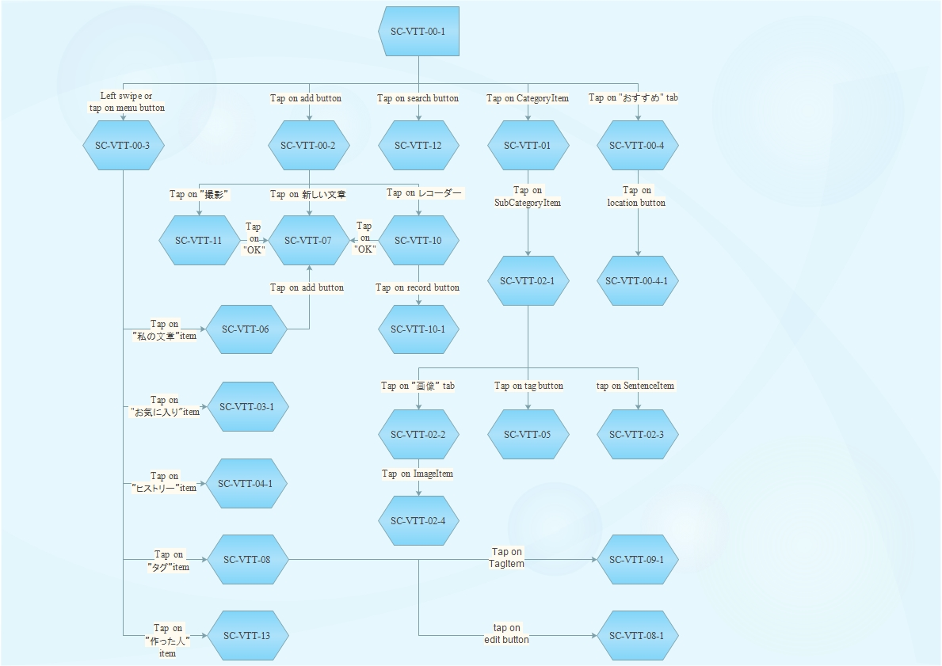

1. Main flow

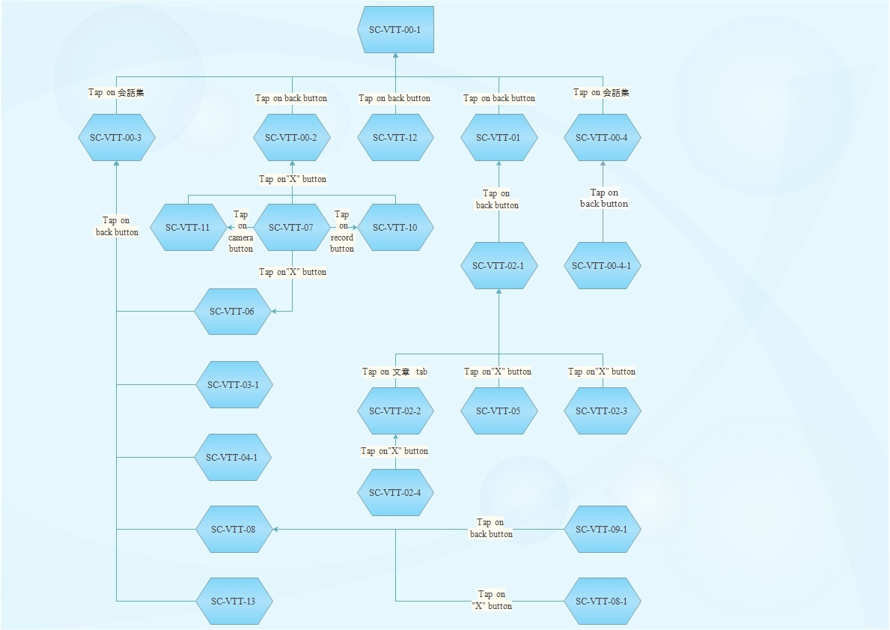

1. Back flow

### Non-functional Requirements

#### Usability

* Easy to understand and use app (range of age: 15 to 50).
* All of the sentences in this app will be sort sentence (less than 13 words).
* If the sentence is a question, it have to be Yes/No question or question that can archive by non-verbal language.
* Min value of manipulations to find out a need sentence should stay between 1 and 5 inclusive.

#### Reliability

* There aren’t any spelling errors in both Japanese and Vietnamese. (About 1% that a spelling error will happen).
* Data of this app need to base on “旅の指さし” (tabi no yubisashi) – a best seller conversation book for Japanese Traveler.
* A sound should always come out when user touch a sentence. (About 90% for every touch). If there are not any sound, app should have some kind of notification to user.
* App does not crash, force close, freeze, or otherwise function abnormally on any targeted device.

#### Performance

* App loads quickly or provides onscreen feedback to the user (a progress indicator or similar cue) if the app takes longer than two seconds to load.

#### Maintainability

* The data should be easily to maintain over time. When update data, the source code does not need to be changed.
* Limit hard code as possible.

#### Extendibility

* Because nowadays the quality of the sound that come out by Vietnamese text to speech method is poor. So this app will use record sound instead. However, in the future, when Vietnamese text to speech is improve the quality sound, this app have to easily change to new method.

# Software Design Specification

## Architecture Design

### Overall system architecture

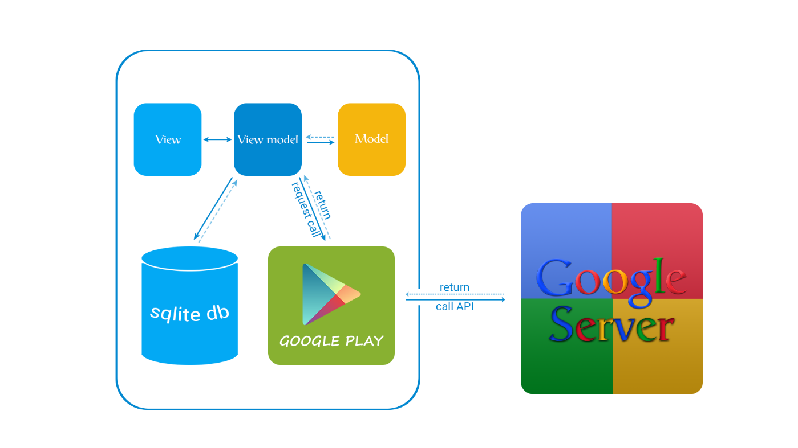

1. System architecture diagram

### Software architecture

#### Model – View – View model (MVVM)

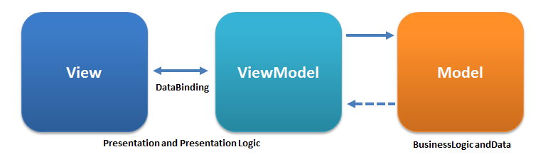

1. MVVM

MVVM is an architectural pattern for software development that extend from MVC pattern. This pattern attempts to gain both the advantages of separation of functional development provided by MVC, while leveraging the advantages of data bindings and the framework by binding data as close to the pure application model as possible.

Source: https://en.wikipedia.org/wiki/Model_View_ViewModel

* View
  + This is User Interface of the application
  + This displays data from the View-model.
  + This sends command to View-model
  + User interaction occurs here
  + This is XML
* View-model
  + It contains business logic
  + Temporary data to be displayed on the View
  + It handles all the user actions to send commands to View-model
  + This is java object
* Model
  + Contain domain model (object-oriented approach) – represents the real state content
  + Contain data access layers (data-centric approach) – represents content or access method to database
  + This is java object

#### Reason of choosing MVVM

* It fits the scope and pattern of VTT project: focus more on user experience needs rather than programming of business logic.
* Easily manage the complexity of application by dividing the application into three components: model, view, and view-model.

#### Complete architecture

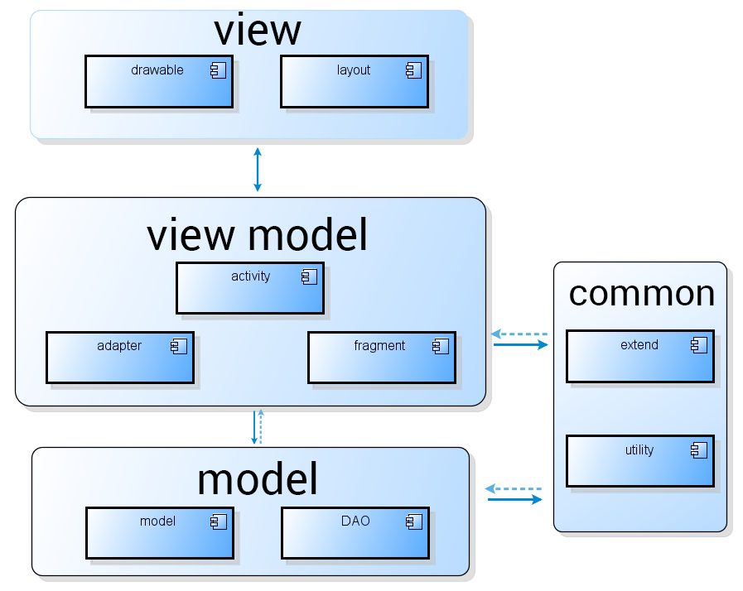

1. Component diagram

## Detail Design

### Common class

#### DAO

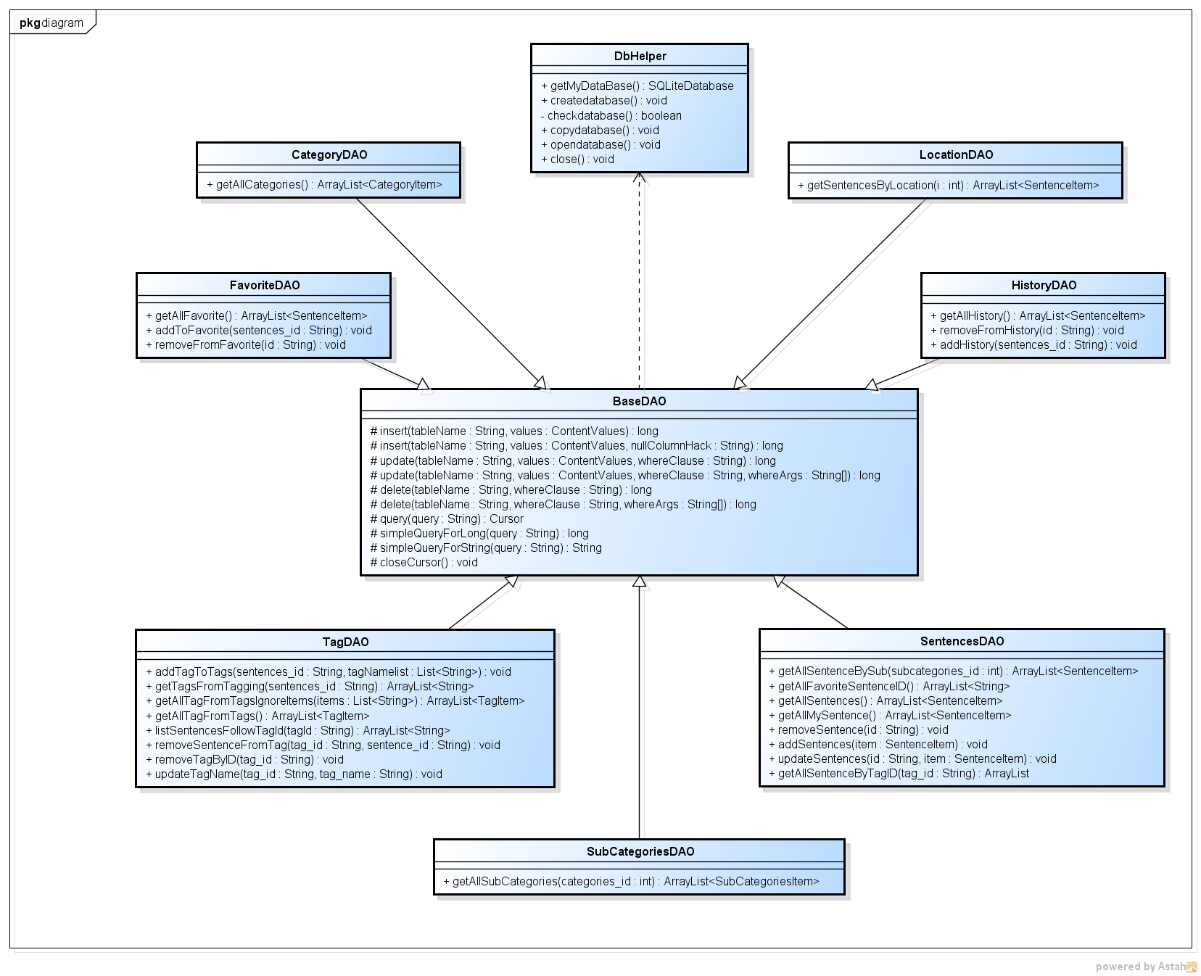

1. DAO class diagram
2. Specification of BaseDAO class

|  |  |
| --- | --- |
| **Class name** | **BaseDAO** |
| **Attribute** | N/A |
| **Method** | |  |  |  |  |  | | --- | --- | --- | --- | --- | | **insert()** | | | | | | **Purpose** | insert into database | | | | | **Return** | **Type** | | | **Description** | | long | | | return the row has been affected | | **Parameter** | **No** | **Name** | **Type** | **Description** | | 1 | tableName | String | name of table | | 2 | values | ContentValues | value list of table attribute | | 3 | whereClause | String | clause to apply where command | | 4 | whereArgs | String[] | apply multiple where command |  |  |  |  |  |  | | --- | --- | --- | --- | --- | | **update()** | | | | | | **Purpose** | update into database | | | | | **Return** | **Type** | | | **Description** | | long | | | return the row has been affected | | **Parameter** | **No** | **Name** | **Type** | **Description** | | 1 | tableName | String | name of table | | 2 | values | ContentValues | value list of table attribute | | 3 | whereClause | String | clause to apply where command | | 4 | whereArgs | String[] | apply multiple where command |  |  |  |  |  |  | | --- | --- | --- | --- | --- | | **delete()** | | | | | | **Purpose** | delete row in database | | | | | **Return** | **Type** | | | **Description** | | long | | | return the row has been affected | | **Parameter** | **No** | **Name** | **Type** | **Description** | | 1 | tableName | String | name of table | | 2 | whereClause | String | clause to apply where command | | 3 | whereArgs | String[] | apply multiple where command |  |  |  |  |  |  | | --- | --- | --- | --- | --- | | **query()** | | | | | | **Purpose** | run query in database | | | | | **Return** | **Type** | | | **Description** | | Cursor | | | a collection of data has been queried | | **Parameter** | **No** | **Name** | **Type** | **Description** | | 1 | query | String | query will be run |  |  |  |  |  |  | | --- | --- | --- | --- | --- | | **simpleQueryForLong()** | | | | | | **Purpose** | run query in database return get only one long variable | | | | | **Return** | **Type** | | | **Description** | | long | | | return value after run query in database | | **Parameter** | **No** | **Name** | **Type** | **Description** | | 1 | query | String | query will be run |  |  |  |  |  |  | | --- | --- | --- | --- | --- | | **simpleQueryForString()** | | | | | | **Purpose** | run query in database return get only one String variable | | | | | **Return** | **Type** | | | **Description** | | String | | | return value after run query in database | | **Parameter** | **No** | **Name** | **Type** | **Description** | | 1 | query | String | query will be run |  |  |  |  | | --- | --- | --- | | **closeCursor()** | | | | **Purpose** | close Cursor to improve performance | | | **Return** | **Type** | **Description** | | void |  | |

1. Specification of CategoryDAO class

|  |  |
| --- | --- |
| **Class name** | **CategoryDAO** |
| **Attribute** | N/A |
| **Method** | |  |  |  | | --- | --- | --- | | **getAllCategories()** | | | | **Purpose** | get all categories from database | | | **Return** | **Type** | **Description** | | ArrayList<CategoryItem> | category list | |

1. Specification of SubCategoriesDAO class

|  |  |
| --- | --- |
| **Class name** | **SubCategoriesDAO** |
| **Attribute** | N/A |
| **Method** | |  |  |  |  |  | | --- | --- | --- | --- | --- | | **getAllSubCategories ()** | | | | | | **Purpose** | get all sub_categories filter by category id from database | | | | | **Return** | **Type** | | | **Description** | | ArrayList<SubCategoriesItem> | | | sub category list | | **Parameter** | **No** | **Name** | **Type** | **Description** | | 1 | categories_id | int | id of category | |

1. Specification of LocationDAO class

|  |  |
| --- | --- |
| **Class name** | **LocationDAO** |
| **Attribute** | N/A |
| **Method** | |  |  |  |  |  | | --- | --- | --- | --- | --- | | **getSentenceByLocation()** | | | | | | **Purpose** | get all sentence filter by location | | | | | **Return** | **Type** | | | **Description** | | ArrayList<SentenceItem> | | | list of sentence | | **Parameter** | **No** | **Name** | **Type** | **Description** | | 1 | location_id | int | id of location | |

1. Specification of FavoriteDAO class

|  |  |
| --- | --- |
| **Class name** | **FavoriteDAO** |
| **Attribute** | N/A |
| **Method** | |  |  |  | | --- | --- | --- | | **getAllFavorite ()** | | | | **Purpose** | get all favorite sentence from database | | | **Return** | **Type** | **Description** | | ArrayList<SentenceItem> | list of sentence |  |  |  |  |  |  | | --- | --- | --- | --- | --- | | **addToFavorite()** | | | | | | **Purpose** | add new favorite sentence | | | | | **Return** | **Type** | | | **Description** | | void | | |  | | **Parameter** | **No** | **Name** | **Type** | **Description** | | 1 | sentence_id | String | id of sentence |  |  |  |  |  |  | | --- | --- | --- | --- | --- | | **removeFromFavorite()** | | | | | | **Purpose** | remove a favorite sentence | | | | | **Return** | **Type** | | | **Description** | | void | | |  | | **Parameter** | **No** | **Name** | **Type** | **Description** | | 1 | id | String | id of sentence | |

1. Specification of HistoryDAO class

|  |  |
| --- | --- |
| **Class name** | **HistoryDAO** |
| **Attribute** | N/A |
| **Method** | |  |  |  | | --- | --- | --- | | **getAllHistory ()** | | | | **Purpose** | get all history from database | | | **Return** | **Type** | **Description** | | ArrayList<SentenceItem> | list of sentence |  |  |  |  |  |  | | --- | --- | --- | --- | --- | | **addToHistory()** | | | | | | **Purpose** | add new history sentence | | | | | **Return** | **Type** | | | **Description** | | void | | |  | | **Parameter** | **No** | **Name** | **Type** | **Description** | | 1 | sentence_id | String | id of sentence |  |  |  |  |  |  | | --- | --- | --- | --- | --- | | **removeFromFavorite()** | | | | | | **Purpose** | remove a history | | | | | **Return** | **Type** | | | **Description** | | void | | |  | | **Parameter** | **No** | **Name** | **Type** | **Description** | | 1 | id | String | id of sentence | |

1. Specification of TagDAO class

|  |  |
| --- | --- |
| **Class name** | **TagDAO** |
| **Attribute** | N/A |
| **Method** | |  |  |  | | --- | --- | --- | | **getAllTagFromTags ()** | | | | **Purpose** | get all tag from tags table in database | | | **Return** | **Type** | **Description** | | ArrayList<TagItem> | tag list |  |  |  |  |  |  | | --- | --- | --- | --- | --- | | **getAllTagFromTagsIgnoreItems ()** | | | | | | **Purpose** | Get all tag from tags table in database and ignore some tag. | | | | | **Return** | **Type** | | | **Description** | | ArrayList<TagItem> | | | tag list | | **Parameter** | **No** | **Name** | **Type** | **Description** | | 1 | items | List<String> | list of tag id |      |  |  |  |  |  | | --- | --- | --- | --- | --- | | **addTagToTags()** | | | | | | **Purpose** | add new tag | | | | | **Return** | **Type** | | | **Description** | | void | | |  | | **Parameter** | **No** | **Name** | **Type** | **Description** | | 1 | sentence_id | String | id of sentence | | 2 | tagNamelist | List<String> | list of tag name |  |  |  |  |  |  | | --- | --- | --- | --- | --- | | **updateTagName()** | | | | | | **Purpose** | update name of tag | | | | | **Return** | **Type** | | | **Description** | | void | | |  | | **Parameter** | **No** | **Name** | **Type** | **Description** | | 1 | tag_id | String | id of tag | | 2 | tag_name | String | name of tag |  |  |  |  |  |  | | --- | --- | --- | --- | --- | | **removeSentenceFromTag()** | | | | | | **Purpose** | remove tag from tagging table | | | | | **Return** | **Type** | | | **Description** | | void | | |  | | **Parameter** | **No** | **Name** | **Type** | **Description** | | 1 | tag_id | String | id of tag | | 2 | sentence_id | String | id of sentence |  |  |  |  |  |  | | --- | --- | --- | --- | --- | | **removeTagByID()** | | | | | | **Purpose** | remove a tag from tags table by tag id | | | | | **Return** | **Type** | | | **Description** | | void | | |  | | **Parameter** | **No** | **Name** | **Type** | **Description** | | 1 | tag_id | String | id of tag | |

1. Specification of SentenceDAO class

|  |  |
| --- | --- |
| **Class name** | **SentenceDAO** |
| **Attribute** | N/A |
| **Method** | |  |  |  |  |  | | --- | --- | --- | --- | --- | | **getAllSentenceBySub ()** | | | | | | **Purpose** | Get all sentence filter by sub category from database | | | | | **Return** | **Type** | | | **Description** | | ArrayList<SentenceItem> | | | sentence list | | **Parameter** | **No** | **Name** | **Type** | **Description** | | 1 | subcategories_id | int | id of sub category |  |  |  |  | | --- | --- | --- | | **getAllSentence ()** | | | | **Purpose** | get all sentence in database | | | **Return** | **Type** | **Description** | | ArrayList<TagItem> | sentence list |  |  |  |  | | --- | --- | --- | | **getAllMySentence ()** | | | | **Purpose** | get all my sentence in database | | | **Return** | **Type** | **Description** | | ArrayList<TagItem> | sentence list |      |  |  |  |  |  | | --- | --- | --- | --- | --- | | **addSentence()** | | | | | | **Purpose** | add new new sentence | | | | | **Return** | **Type** | | | **Description** | | void | | |  | | **Parameter** | **No** | **Name** | **Type** | **Description** | | 1 | item | SentenceItem | An object represent a sentence |  |  |  |  |  |  | | --- | --- | --- | --- | --- | | **updateSentence()** | | | | | | **Purpose** | update sentence info | | | | | **Return** | **Type** | | | **Description** | | void | | |  | | **Parameter** | **No** | **Name** | **Type** | **Description** | | 1 | sentence_id | String | id of sentence | | 2 | item | SentenceItem | An object represent a sentence |  |  |  |  |  |  | | --- | --- | --- | --- | --- | | **removeSentence ()** | | | | | | **Purpose** | remove a sentence | | | | | **Return** | **Type** | | | **Description** | | void | | |  | | **Parameter** | **No** | **Name** | **Type** | **Description** | | 1 | id | String | id of sentence | |

#### Sentence list

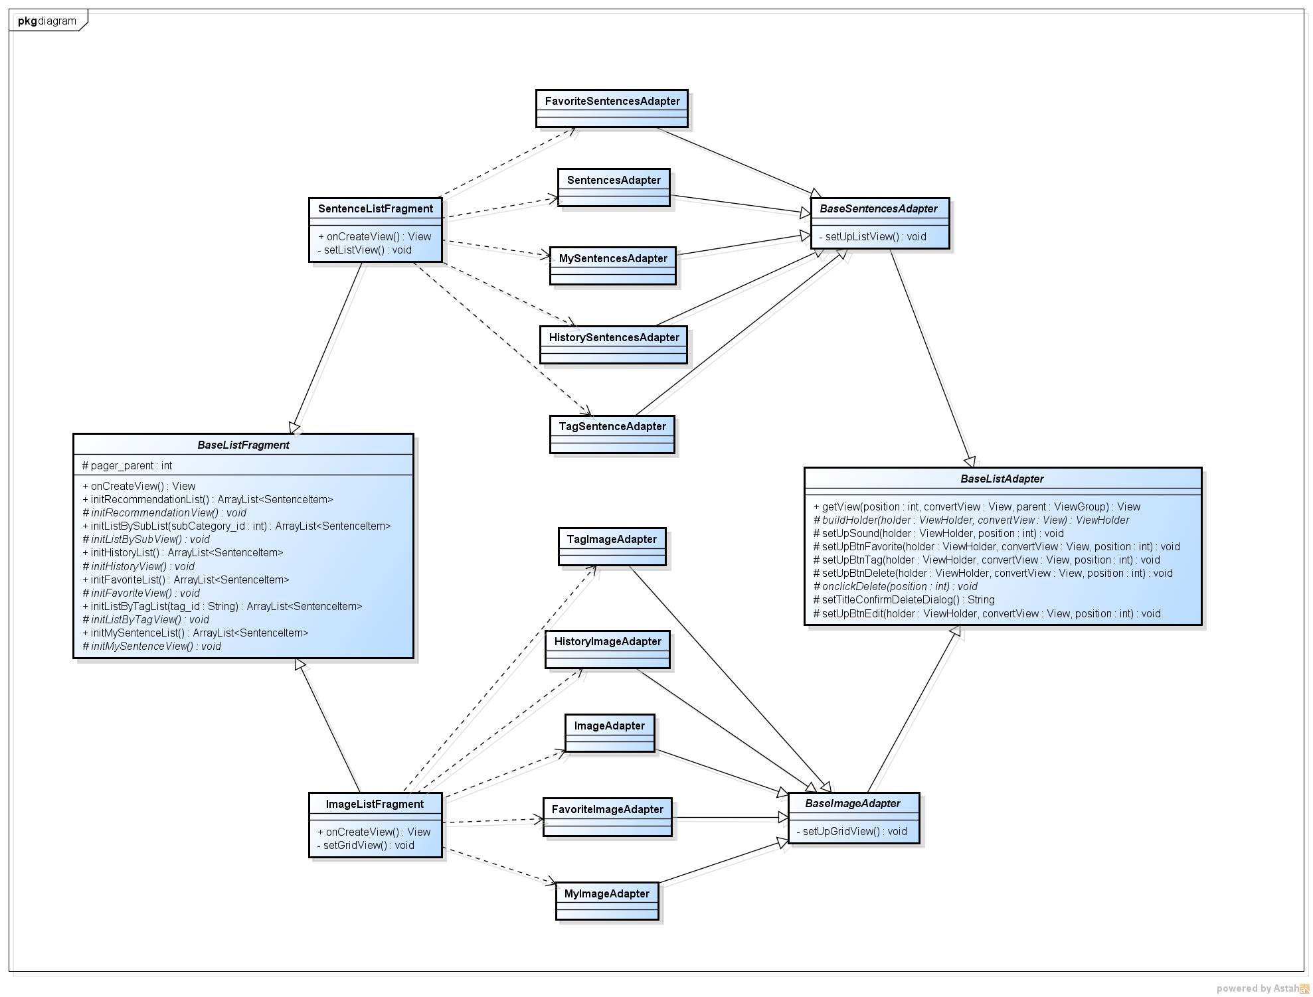

1. Sentence list class diagram
2. Specification of BaseListFragment class

|  |  |
| --- | --- |
| **Class name** | **BaseListFragment** |
| **Attribute** | |  |  |  |  | | --- | --- | --- | --- | | **No** | **Name** | **Type** | **Description** | | 1 | pager_parent | int | Specify the parent contain list fragment | |
| **Method** | |  |  |  | | --- | --- | --- | | **initRecommendationList()** | | | | **Purpose** | initialize data for recommendation list view | | | **Return** | **Type** | **Description** | | ArrayList<SentenceItem> | list of sentence |  |  |  |  | | --- | --- | --- | | **initRecommendationView()** | | | | **Purpose** | initialize view for recommendation list view | | | **Return** | **Type** | **Description** | | void |  |  |  |  |  |  |  | | --- | --- | --- | --- | --- | | **initListBySubList()** | | | | | | **Purpose** | initialize data for sentence filter by sub list view | | | | | **Return** | **Type** | | | **Description** | | ArrayList<SentenceItem> | | | list of sentence | | **Parameter** | **No** | **Name** | **Type** | **Description** | | 1 | subcategory_id | int | id of sub category |  |  |  |  | | --- | --- | --- | | **initListBySubView()** | | | | **Purpose** | initialize view for sentence filter by sub list view | | | **Return** | **Type** | **Description** | | void |  |  |  |  |  | | --- | --- | --- | | **initHistoryList()** | | | | **Purpose** | initialize data for history list view | | | **Return** | **Type** | **Description** | | ArrayList<SentenceItem> | list of sentence |  |  |  |  | | --- | --- | --- | | **initHistoryView()** | | | | **Purpose** | initialize view for history list view | | | **Return** | **Type** | **Description** | | void |  |  |  |  |  | | --- | --- | --- | | **initFavoriteList()** | | | | **Purpose** | initialize data for favorite list view | | | **Return** | **Type** | **Description** | | ArrayList<SentenceItem> | list of sentence |  |  |  |  | | --- | --- | --- | | **initFavoriteView()** | | | | **Purpose** | initialize view for favorite list view | | | **Return** | **Type** | **Description** | | void |  |  |  |  |  |  |  | | --- | --- | --- | --- | --- | | **initListByTagList()** | | | | | | **Purpose** | initialize data for sentence filter by tag list view | | | | | **Return** | **Type** | | | **Description** | | ArrayList<SentenceItem> | | | list of sentence | | **Parameter** | **No** | **Name** | **Type** | **Description** | | 1 | tag_id | int | id of tag |  |  |  |  | | --- | --- | --- | | **initListByTagView()** | | | | **Purpose** | initialize view for sentence filter by tag list view | | | **Return** | **Type** | **Description** | | void |  |  |  |  |  | | --- | --- | --- | | **initMySentenceList()** | | | | **Purpose** | initialize data for my sentence list view | | | **Return** | **Type** | **Description** | | ArrayList<SentenceItem> | list of sentence |  |  |  |  | | --- | --- | --- | | **initMySentenceView()** | | | | **Purpose** | initialize view for my sentence list view | | | **Return** | **Type** | **Description** | | void |  | |

1. Specification for SentenceListFragment class

|  |  |
| --- | --- |
| **Class name** | **SentenceListFragment** |
| **Attribute** | N/A |
| **Method** | |  |  |  | | --- | --- | --- | | **setListView ()** | | | | **Purpose** | set up list view | | | **Return** | **Type** | **Description** | | void |  | |

1. Specification for ImageListFragment class

|  |  |
| --- | --- |
| **Class name** | **ImageListFragment** |
| **Attribute** | N/A |
| **Method** | |  |  |  | | --- | --- | --- | | **setGridView ()** | | | | **Purpose** | set up grid view | | | **Return** | **Type** | **Description** | | void |  | |

1. Specification for BaseListAdapter class

|  |  |
| --- | --- |
| **Class name** | **BaseSentenceAdapter** |
| **Attribute** | N/A |
| **Method** | |  |  |  |  |  | | --- | --- | --- | --- | --- | | **buildHolder ()** | | | | | | **Purpose** | build a row view in table list adapter | | | | | **Return** | **Type** | | | **Description** | | ViewHolder | | | Content view | | **Parameter** | **No** | **Name** | **Type** | **Description** | | 1 | holder | ViewHolder | Content view | | 2 | convertView | View | Total view |  |  |  |  |  |  | | --- | --- | --- | --- | --- | | **setSound ()** | | | | | | **Purpose** | set sound for row | | | | | **Return** | **Type** | | | **Description** | | void | | |  | | **Parameter** | **No** | **Name** | **Type** | **Description** | | 1 | holder | ViewHolder | Content view | | 2 | position | int | position of row in list |  |  |  |  |  |  | | --- | --- | --- | --- | --- | | **setUpBtnFavorite ()** | | | | | | **Purpose** | set view for favorite button | | | | | **Return** | **Type** | | | **Description** | | void | | |  | | **Parameter** | **No** | **Name** | **Type** | **Description** | | 1 | holder | ViewHolder | Content view | | 2 | convertView | View | Total view | | 3 | position | int | position of row in list |  |  |  |  |  |  | | --- | --- | --- | --- | --- | | **setUpBtnTag ()** | | | | | | **Purpose** | set view for tag button | | | | | **Return** | **Type** | | | **Description** | | void | | |  | | **Parameter** | **No** | **Name** | **Type** | **Description** | | 1 | holder | ViewHolder | Content view | | 2 | convertView | View | Total view | | 3 | position | int | position of row in list |  |  |  |  |  |  | | --- | --- | --- | --- | --- | | **setUpBtnDelete ()** | | | | | | **Purpose** | set view for delete button | | | | | **Return** | **Type** | | | **Description** | | void | | |  | | **Parameter** | **No** | **Name** | **Type** | **Description** | | 1 | holder | ViewHolder | Content view | | 2 | convertView | View | Total view | | 3 | position | int | position of row in list |  |  |  |  |  |  | | --- | --- | --- | --- | --- | | **setUpBtnEdit ()** | | | | | | **Purpose** | set view for edit button | | | | | **Return** | **Type** | | | **Description** | | void | | |  | | **Parameter** | **No** | **Name** | **Type** | **Description** | | 1 | holder | ViewHolder | Content view | | 2 | convertView | View | Total view | | 3 | position | int | position of row in list | |

1. Specification for BaseSentenceAdapter class

|  |  |
| --- | --- |
| **Class name** | **BaseSentenceAdapter** |
| **Attribute** | N/A |
| **Method** | |  |  |  | | --- | --- | --- | | **setUpListView ()** | | | | **Purpose** | set up list view for adapter | | | **Return** | **Type** | **Description** | | void |  | |

1. Specification for BaseImageAdapter class

|  |  |
| --- | --- |
| **Class name** | **BaseImageAdapter** |
| **Attribute** | N/A |
| **Method** | |  |  |  | | --- | --- | --- | | **setUpGridView ()** | | | | **Purpose** | set up grid view for adapter | | | **Return** | **Type** | **Description** | | void |  | |

1. Other sentence list adapter

|  |  |
| --- | --- |
| **Class name** | **Description** |
| SentencesAdapter | Common adapter for list view |
| FavoriteSentenceAdapter | Adapter list view for Favorite screen |
| MySentencesAdapter | Adapter list view for My Sentence screen |
| HistorySentencesAdpater | Adapter list view for History screen |
| TagSentenceAdapter | Adapter list view for Sentence list by Tag screen |
| ImageAdapter | Common adapter for grid view |
| HistoryImageAdapter | Adapter grid view for History screen |
| TagImageAdpater | Adapter grid view for Sentence list by Tag screen |
| FavoriteImageAdpater | Adapter grid view for Favorite screen |
| MyImageAdapter | Adapter grid view for My Sentence screen |

#### Touch to talk

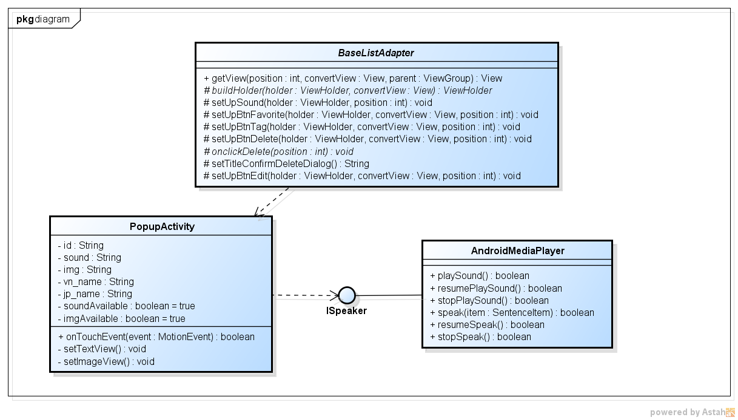

1. Touch to talk class diagram
2. Specification for AndroidMediaPlayer class

|  |  |
| --- | --- |
| **Class name** | **AndroidMediaPlayer** |
| **Attribute** | N/A |
| **Method** | |  |  |  | | --- | --- | --- | | **playSound ()** | | | | **Purpose** | play a normal sound | | | **Return** | **Type** | **Description** | | boolean | false if cannot execute task |  |  |  |  | | --- | --- | --- | | **resumePlaySound ()** | | | | **Purpose** | resume a sound | | | **Return** | **Type** | **Description** | | boolean | false if cannot execute task |  |  |  |  | | --- | --- | --- | | **stopPlaySound ()** | | | | **Purpose** | stop a sound | | | **Return** | **Type** | **Description** | | boolean | false if cannot execute task |  |  |  |  | | --- | --- | --- | | **speak ()** | | | | **Purpose** | speak a sentence | | | **Return** | **Type** | **Description** | | boolean | false if cannot execute task |  |  |  |  | | --- | --- | --- | | **resumeSpeak ()** | | | | **Purpose** | resume a speak | | | **Return** | **Type** | **Description** | | boolean | false if cannot execute task |  |  |  |  | | --- | --- | --- | | **stopSpeak ()** | | | | **Purpose** | stop speak sentence | | | **Return** | **Type** | **Description** | | boolean | false if cannot execute task | |

#### Model

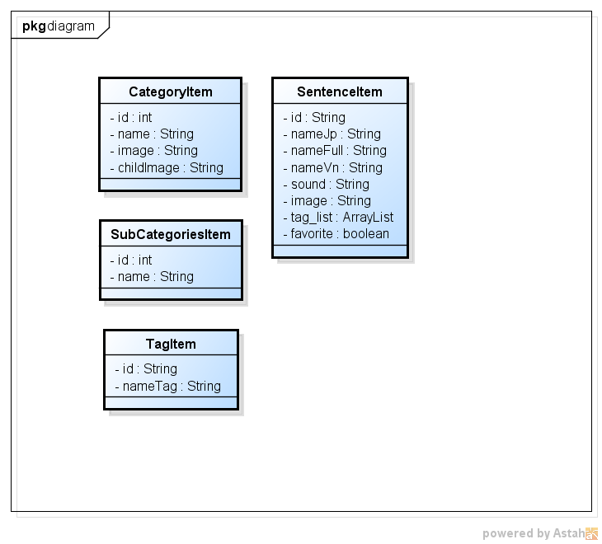

1. Model class diagram
2. Specification for CategoryItem class

|  |  |
| --- | --- |
| **Class name** | **CategoryItem** |
| **Attribute** | |  |  |  |  | | --- | --- | --- | --- | | **No** | **Name** | **Type** | **Description** | | 1 | id | int | code of sub category | | 2 | name | String | name of sub category | | 3 | image | String | image path or name of category | | 4 | childImage | String | image path or name of sub category | |
| **Method** | N/A |

1. Specification for SubCategoriesItem class

|  |  |
| --- | --- |
| **Class name** | **SubCategoriesItem** |
| **Attribute** | |  |  |  |  | | --- | --- | --- | --- | | **No** | **Name** | **Type** | **Description** | | 1 | id | int | code of sub category | | 2 | name | String | name of sub category | |
| **Method** | N/A |

1. Specification for SentenceItem class

| **Class name** | **SentenceItem** |
| --- | --- |
| **Attribute** | |  |  |  |  | | --- | --- | --- | --- | | **No** | **Name** | **Type** | **Description** | | 1 | id | String | code of sentence | | 2 | nameJp | String | normal Japanese sentence | | 3 | nameFull | String | sentence with full of hiragana | | 4 | nameVn | String | Vietnamese meaning of sentence | | 5 | sound | String | audio path or name | | 6 | image | String | image path or name | | 7 | tag_list | ArrayList | list of tag has been tagged to this sentence | | 8 | favorite | boolean | true if this is a favorite sentence | |
| **Method** | N/A |

1. Specification for TagItem class

|  |  |
| --- | --- |
| **Class name** | **TagItem** |
| **Attribute** | |  |  |  |  | | --- | --- | --- | --- | | **No** | **Name** | **Type** | **Description** | | 1 | id | String | code of tag | | 2 | nameTag | String | name of tag | |
| **Method** | N/A |

#### Utility

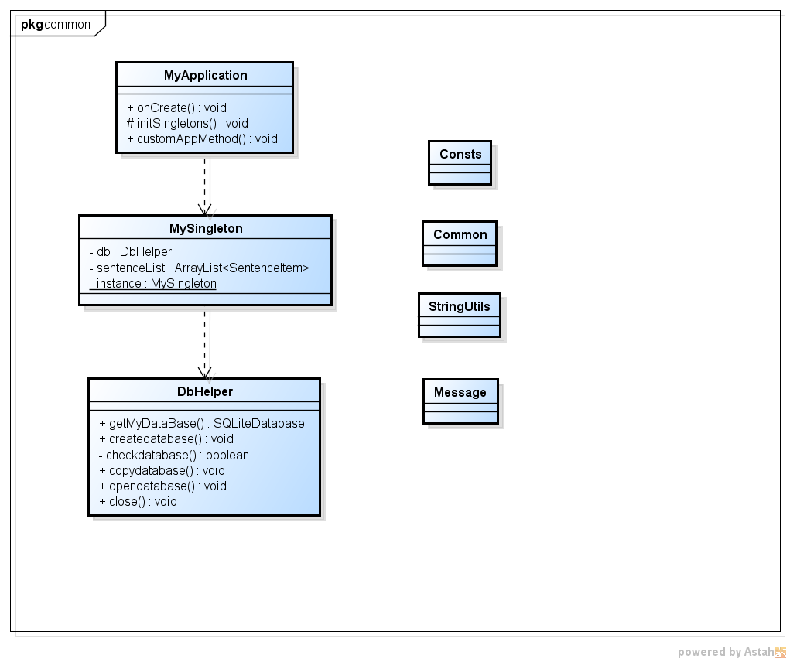

1. Class diagram for utility component
2. Class list for utility component

|  |  |
| --- | --- |
| **Class name** | **Description** |
| MyApplication | Create application space in android core |
| MySingleton | Create a data space in android core |
| DbHelper | Support SQLite database command |
| Consts | Contains all constant value |
| Common | Contains all common function |
| StringUtils | Contains all build String common function |
| Message | Contains all message |

#### Extend

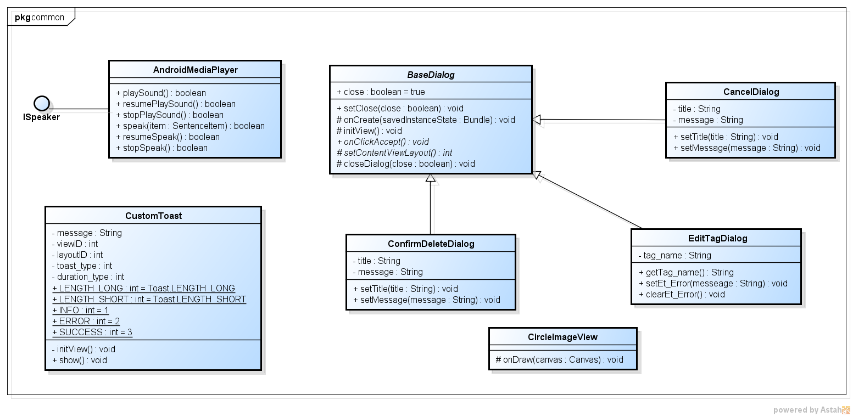

1. Class diagram for extend component
2. Class list for extend component

|  |  |
| --- | --- |
| **Class name** | **Description** |
| Speaker | Interface for play sound and speak |
| AndroidMediaPlayer | Object for android media player |
| CustomToast | Android Toast has been customized |
| BaseDialog | Android Dialog has been customized |
| Confirm dialog | Object for confirm dialog |
| Cancel dialog | Object for cancel dialog |
| Edit tag dialog | Object for Edit tag dialog |
| CircleImageView | Create circle view |

### Home

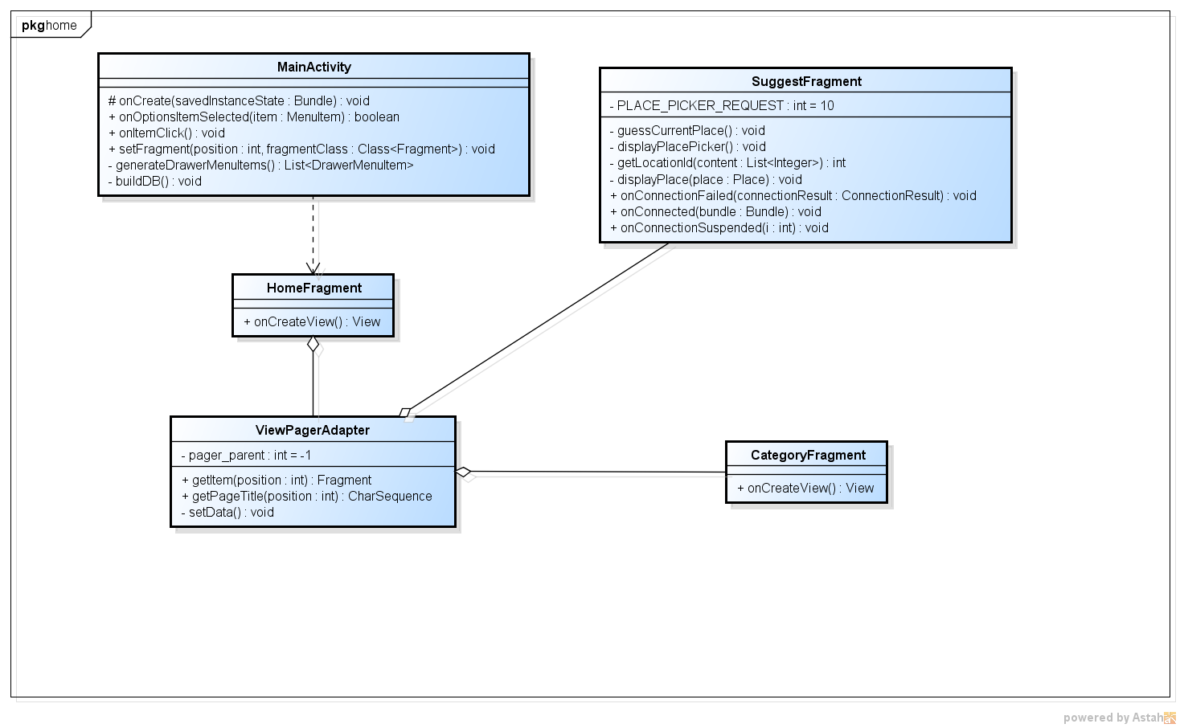

1. Home class diagram
2. Specification for MainActivity class

|  |  |
| --- | --- |
| **Class name** | **MainActivity** |
| **Attribute** | N/A |
| **Method** | |  |  |  |  |  | | --- | --- | --- | --- | --- | | **onOptionItemSelected ()** | | | | | | **Purpose** | initialize selected event for Action bar | | | | | **Return** | **Type** | | | **Description** | | boolean | | | return true if event trigger | | **Parameter** | **No** | **Name** | **Type** | **Description** | | 1 | item | MenuItem | An object represent item on action bar |  |  |  |  | | --- | --- | --- | | **onItemClick ()** | | | | **Purpose** | initialize click event for navigation drawer | | | **Return** | **Type** | **Description** | | void |  |  |  |  |  | | --- | --- | --- | | **generateDrawerMenuItems ()** | | | | **Purpose** | generate navigation drawer | | | **Return** | **Type** | **Description** | | List<DrawerMenuItem> | list of item in navigation drawer |  |  |  |  | | --- | --- | --- | | **buildDB ()** | | | | **Purpose** | create DB and set DBhelper common value to MySingleton | | | **Return** | **Type** | **Description** | | void |  | |

1. Specification of ViewPagerAdapter class

|  |  |
| --- | --- |
| **Class name** | **ViewPagerAdapter** |
| **Attribute** | |  |  |  |  | | --- | --- | --- | --- | | **No** | **Name** | **Type** | **Description** | | 1 | pager_parent | int | Specify the parent contain list fragment | |
| **Method** | |  |  |  | | --- | --- | --- | | **setData()** | | | | **Purpose** | set up data for child fragment | | | **Return** | **Type** | **Description** | | void |  |  |  |  |  |  |  | | --- | --- | --- | --- | --- | | **getItem()** | | | | | | **Purpose** | get the child fragment to set to pager | | | | | **Return** | **Type** | | | **Description** | | Fragment | | | child fragment | | **Parameter** | **No** | **Name** | **Type** | **Description** | | 1 | position | int | position of child fragment in pager |  |  |  |  |  |  | | --- | --- | --- | --- | --- | | **getPageTitle()** | | | | | | **Purpose** | get page title | | | | | **Return** | **Type** | | | **Description** | | ChareSequence | | | title of page | | **Parameter** | **No** | **Name** | **Type** | **Description** | | 1 | position | int | position of child fragment in pager | |

#### View category list

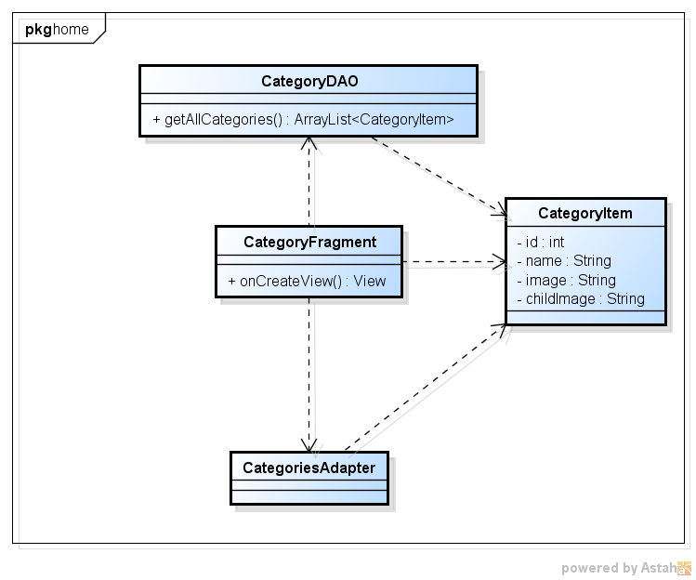

1. Category list class diagram
2. Specification of CategoryFragment class

|  |  |
| --- | --- |
| **Class name** | **CategoryFragment** |
| **Attribute** | N/A |
| **Method** | |  |  |  | | --- | --- | --- | | **onCreatView ()** | | | | **Purpose** | initialize view for this fragment | | | **Return** | **Type** | **Description** | | View | view value of this fragment | |

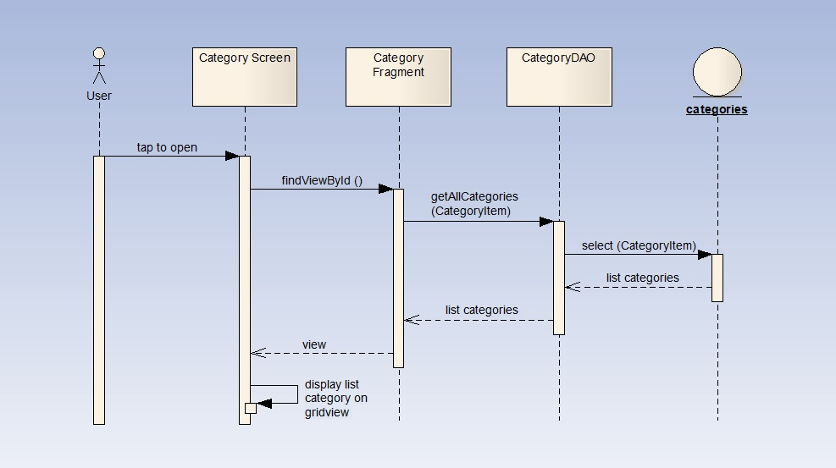

1. View category sequence diagram

#### View suggestion list

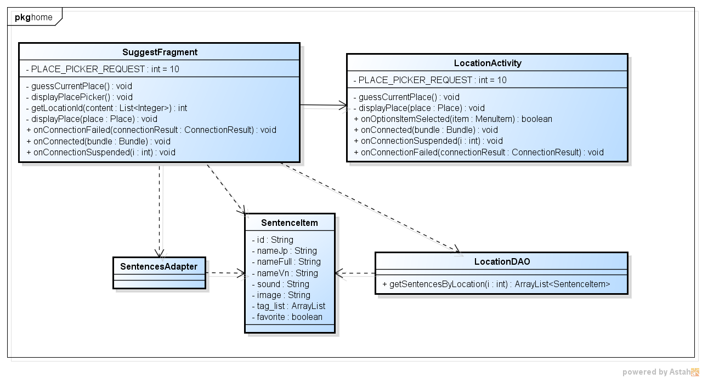

1. Suggestion list class diagram
2. Specification of SuggestFragment class

|  |  |
| --- | --- |
| **Class name** | **SuggestFragment** |
| **Attribute** | |  |  |  |  | | --- | --- | --- | --- | | **No** | **Name** | **Type** | **Description** | | 1 | PLACE_PICKER_REQUEST | int | request id for place picker | |
| **Method** | |  |  |  | | --- | --- | --- | | **guessCurrentPlace()** | | | | **Purpose** | get the current place of user | | | **Return** | **Type** | **Description** | | void |  |  |  |  |  | | --- | --- | --- | | **displayPlacePicker()** | | | | **Purpose** | display place picker screen | | | **Return** | **Type** | **Description** | | void |  |  |  |  |  |  |  | | --- | --- | --- | --- | --- | | **getLocationId()** | | | | | | **Purpose** | get the location type id of a location | | | | | **Return** | **Type** | | | **Description** | | int | | | type id | | **Parameter** | **No** | **Name** | **Type** | **Description** | | 1 | content | List<Interger> | list of place type |  |  |  |  |  |  | | --- | --- | --- | --- | --- | | **displayPlace()** | | | | | | **Purpose** | show the sentence list view that match the place type | | | | | **Return** | **Type** | | | **Description** | | void | | |  | | **Parameter** | **No** | **Name** | **Type** | **Description** | | 1 | place | Place | selected place | |

1. Specification of LocationAtivity class

|  |  |
| --- | --- |
| **Class name** | **LocationAtivity** |
| **Attribute** | |  |  |  |  | | --- | --- | --- | --- | | **No** | **Name** | **Type** | **Description** | | 1 | PLACE_PICKER_REQUEST | int | request id for place picker | |
| **Method** | |  |  |  | | --- | --- | --- | | **guessCurrentPlace()** | | | | **Purpose** | get the current place of user | | | **Return** | **Type** | **Description** | | void |  |  |  |  |  |  |  | | --- | --- | --- | --- | --- | | **displayPlace()** | | | | | | **Purpose** | show the sentence list view that match the place type | | | | | **Return** | **Type** | | | **Description** | | void | | |  | | **Parameter** | **No** | **Name** | **Type** | **Description** | | 1 | place | Place | selected place | |

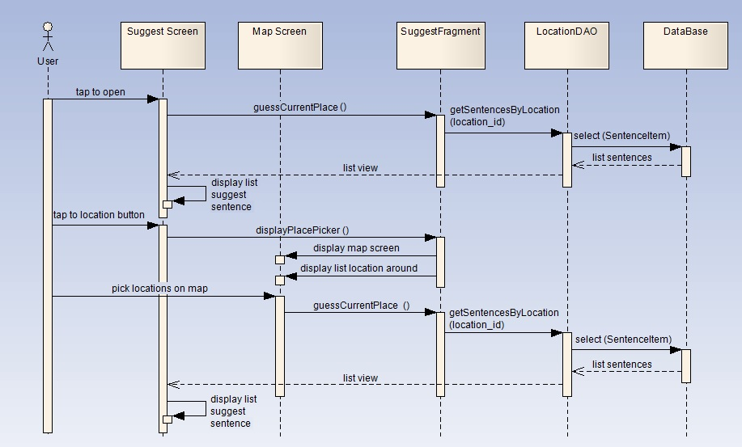

1. View suggestion sequence diagram

### Sub categories list

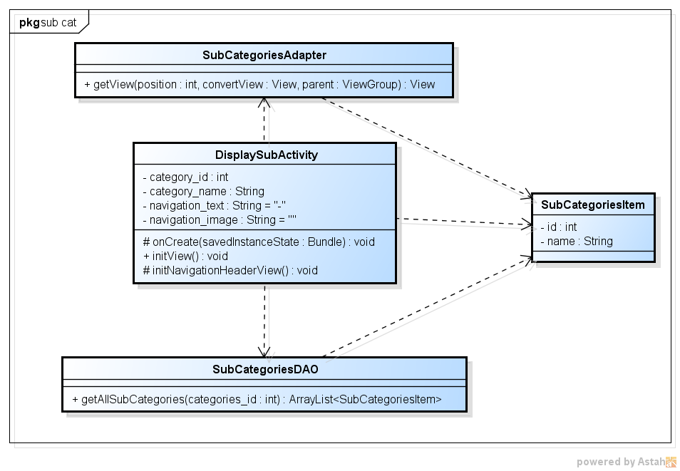

1. Sub categories list class diagram
2. Specification of DisplaySubAcitvity class

|  |  |
| --- | --- |
| **Class name** | **DisplaySubAcitvity** |
| **Attribute** | |  |  |  |  | | --- | --- | --- | --- | | **No** | **Name** | **Type** | **Description** | | 1 | category_id | int | code of category that contain sub category | | 2 | category_name | String | name of category that contain sub category | | 3 | navigation_text | String | text of navigation | | 4 | navigation_image | String | image for navigation | |
| **Method** | |  |  |  | | --- | --- | --- | | **initView()** | | | | **Purpose** | initialize view for this activity | | | **Return** | **Type** | **Description** | | void |  |  |  |  |  | | --- | --- | --- | | **initNavigationHeader()** | | | | **Purpose** | initialize view for navigation header | | | **Return** | **Type** | **Description** | | void |  | |

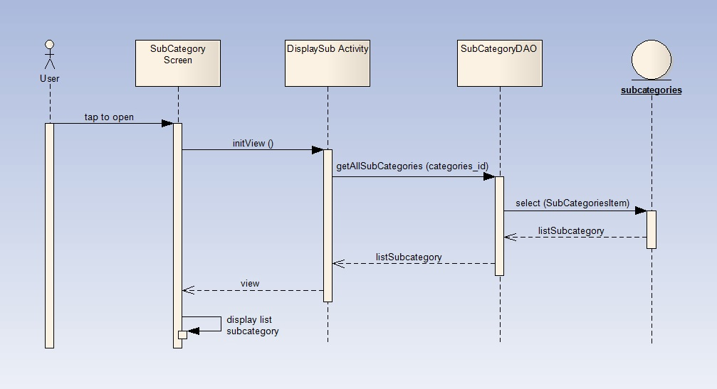

1. Sub categories list sequence diagram

### Sentence list by sub

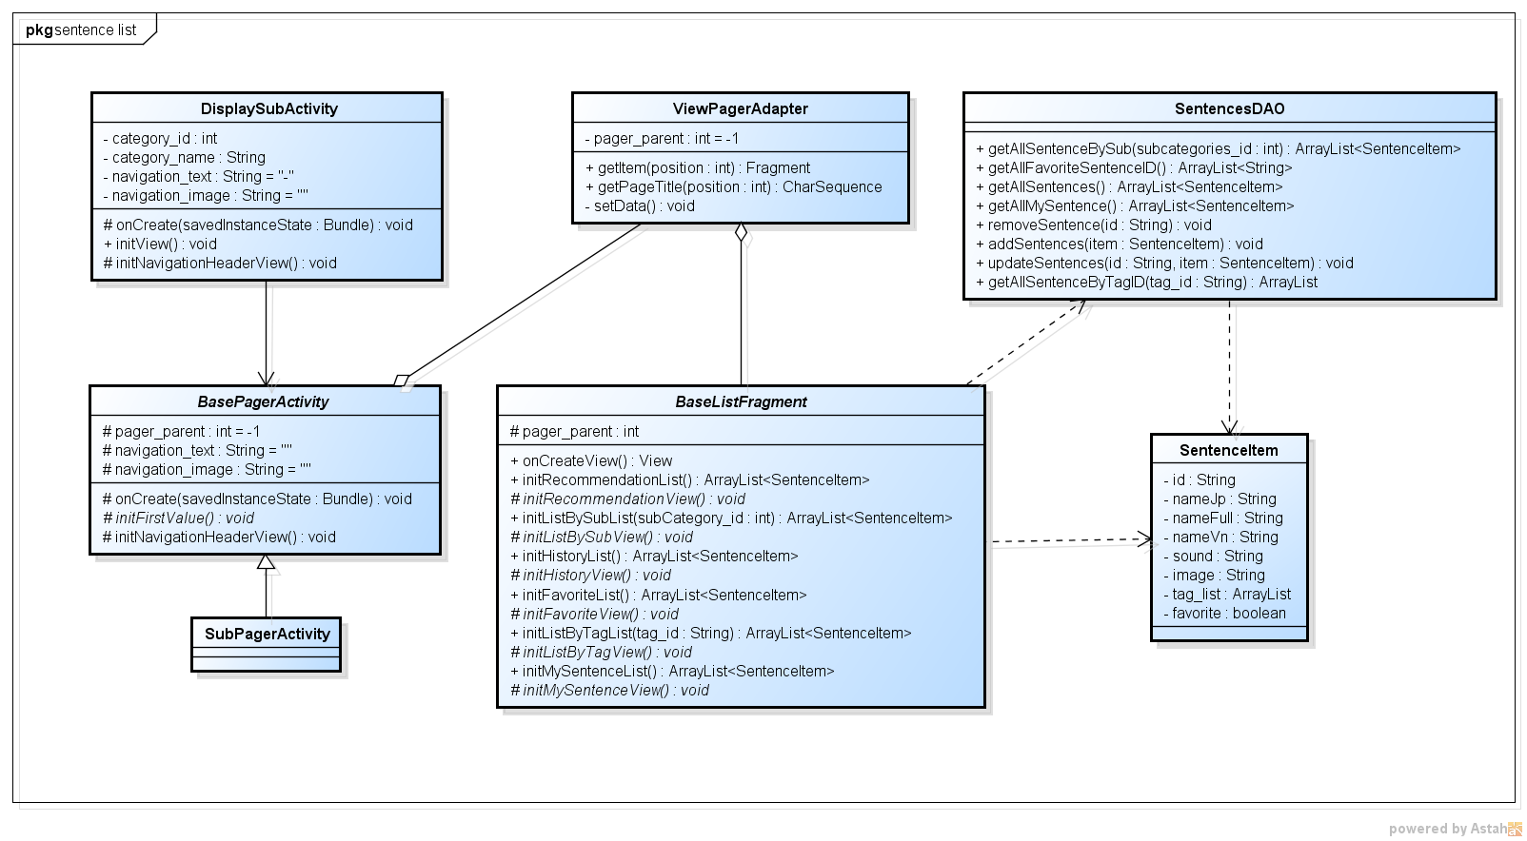

1. Sentence list by sub class diagram
2. Specification for BasePagerActivity class

|  |  |
| --- | --- |
| **Class name** | **BasePagerActivity** |
| **Attribute** | |  |  |  |  | | --- | --- | --- | --- | | **No** | **Name** | **Type** | **Description** | | 1 | pager_parent | int | Specify the parent contain list fragment | | 2 | navigation_text | String | text of navigation | | 3 | navigation_image | String | image for navigation | |
| **Method** | |  |  |  | | --- | --- | --- | | **initFirstValue()** | | | | **Purpose** | initialize value for pager_parent, navigation_text, navigation_image | | | **Return** | **Type** | **Description** | | void |  |  |  |  |  | | --- | --- | --- | | **initNavigationHeader()** | | | | **Purpose** | initialize view for navigation header | | | **Return** | **Type** | **Description** | | void |  | |

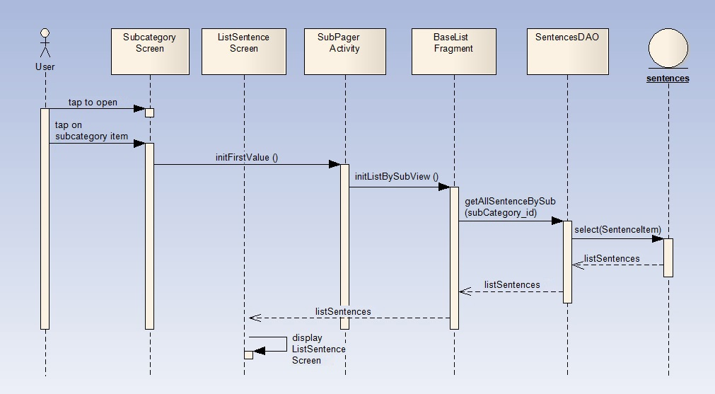

1. Sentence list by sub sequence diagram

### Modify sentence’s tag

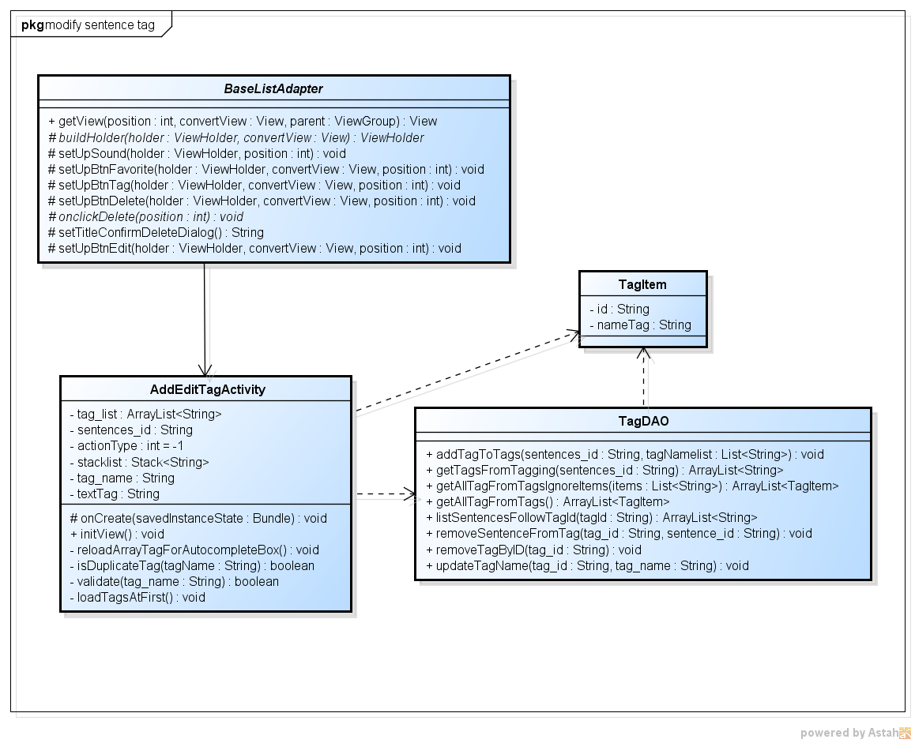

1. Modify sentence’s tag class diagram
2. Specification for AddEditTagActivity class

|  |  |
| --- | --- |
| **Class name** | **AddEditTagActivity** |
| **Attribute** | |  |  |  |  | | --- | --- | --- | --- | | **No** | **Name** | **Type** | **Description** | | 1 | tag_list | ArrayList<String> | list of all tag belong to selected sentence | | 2 | sentence_id | String | code of selected sentence | | 3 | actionType | int | specify what kind of user action | | 4 | stacklist | Stack<String> | save user edit action step by step | | 5 | tag_name | String | name of tag | | 6 | textTag | String | text to display in screen | |
| **Method** | |  |  |  | | --- | --- | --- | | **reloadArrayTagForAutocompletBox()** | | | | **Purpose** | reload list tag to display in autocomplete box | | | **Return** | **Type** | **Description** | | void |  |  |  |  |  |  |  | | --- | --- | --- | --- | --- | | **isDuplicateTag()** | | | | | | **Purpose** | check if tag has already exist in tag list | | | | | **Return** | **Type** | | | **Description** | | boolean | | | return true if tag is duplicated | | **Parameter** | **No** | **Name** | **Type** | **Description** | | 1 | tagName | String | name of tag |  |  |  |  | | --- | --- | --- | | **loadTagsAtFirst()** | | | | **Purpose** | reload list tag to display in autocomplete box | | | **Return** | **Type** | **Description** | | void |  |  |  |  |  |  |  | | --- | --- | --- | --- | --- | | **validate()** | | | | | | **Purpose** | validate tag information | | | | | **Return** | **Type** | | | **Description** | | boolean | | | return false if information is invalid | | **Parameter** | **No** | **Name** | **Type** | **Description** | | 1 | tag_name | String | name of tag | |

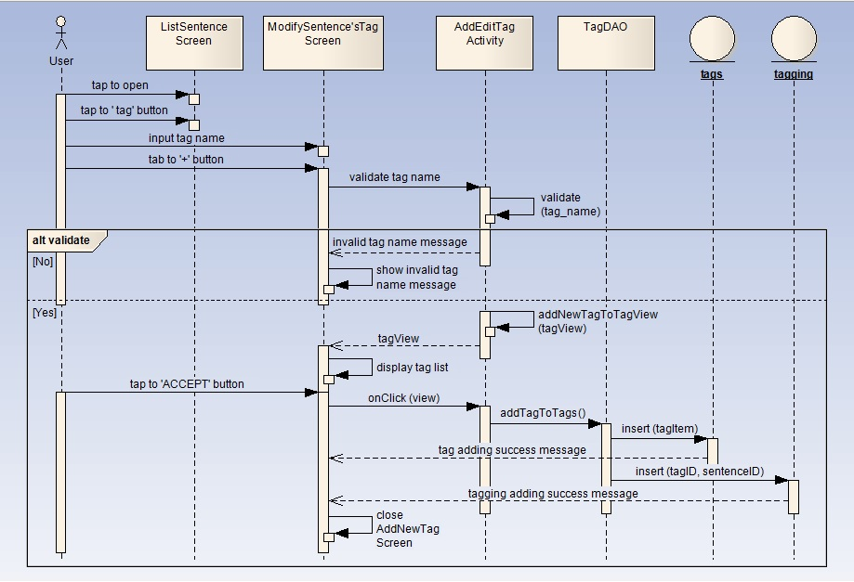

1. Add tag to sentence sequence diagram

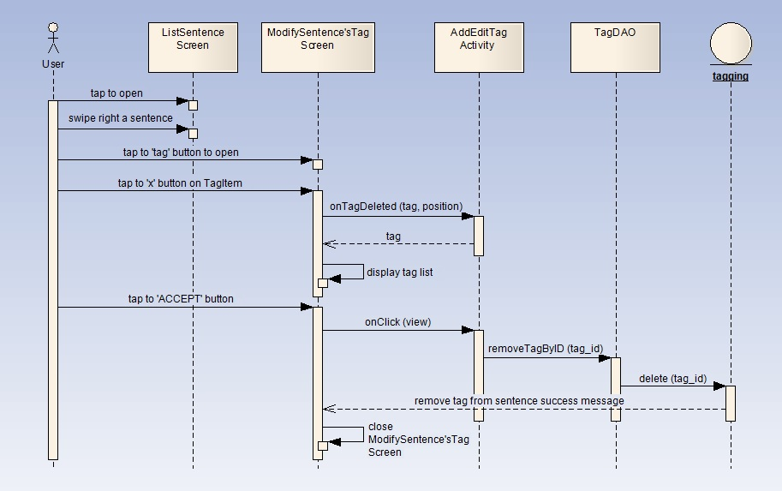

1. Remove tag from sentence

### Favorite & History

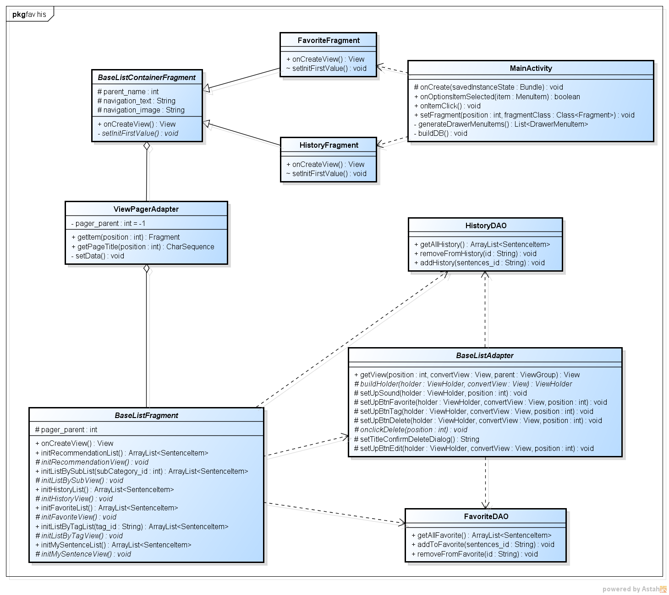

1. Favorite and history class diagram
2. Specification for BaseListContainerFragment class

|  |  |
| --- | --- |
| **Class name** | **BaseListContainerFragment** |
| **Attribute** | |  |  |  |  | | --- | --- | --- | --- | | **No** | **Name** | **Type** | **Description** | | 1 | pager_parent | int | Specify the parent contain list fragment | | 2 | navigation_text | String | text of navigation | | 3 | navigation_image | String | image for navigation | |
| **Method** | |  |  |  | | --- | --- | --- | | **initFirstValue()** | | | | **Purpose** | initialize value for pager_parent, navigation_text, navigation_image | | | **Return** | **Type** | **Description** | | void |  | |

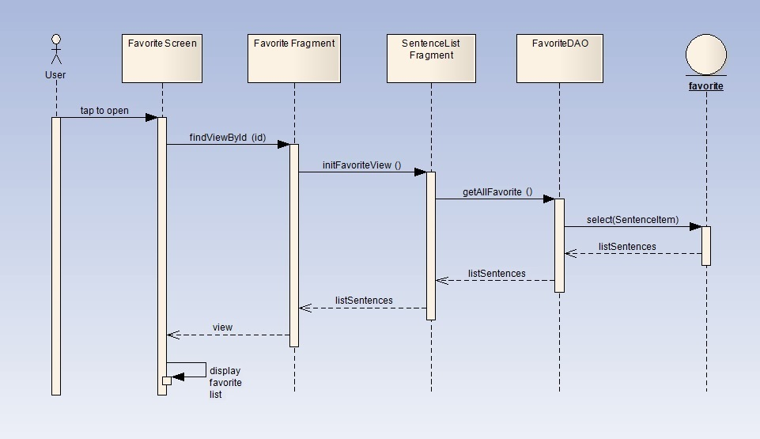

1. Favorite sequence diagram

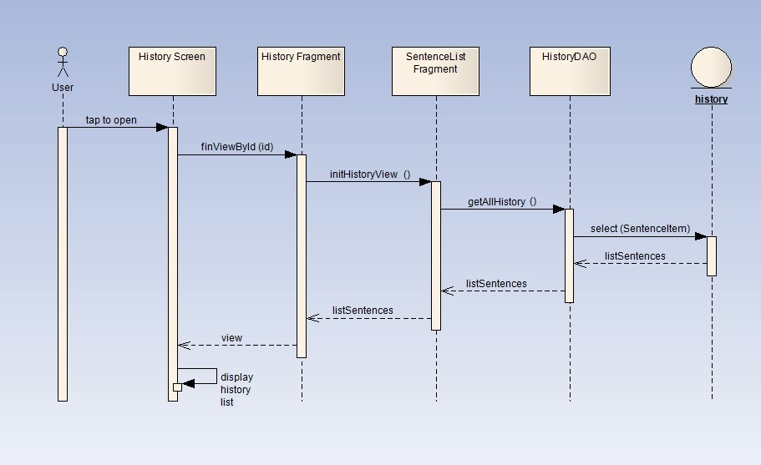

1. History sequence diagram

### My sentence

#### View my sentence

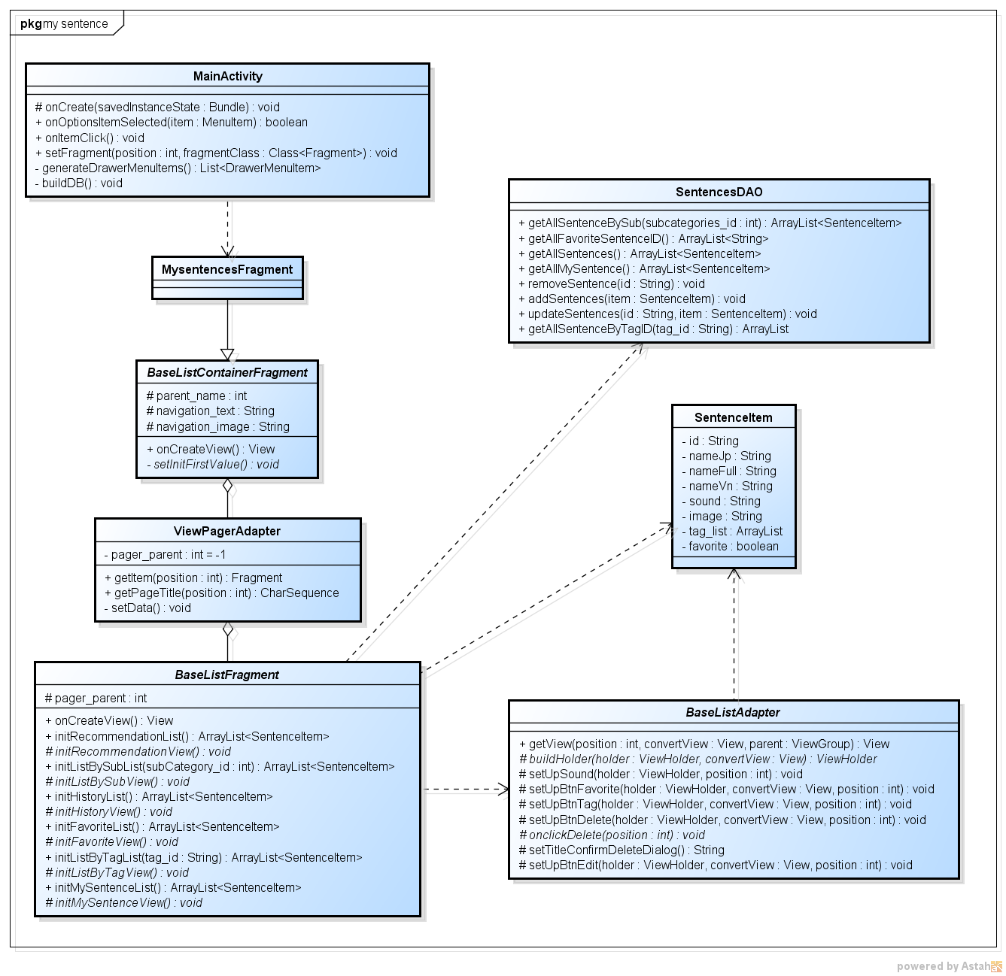

1. View my sentence class diagram

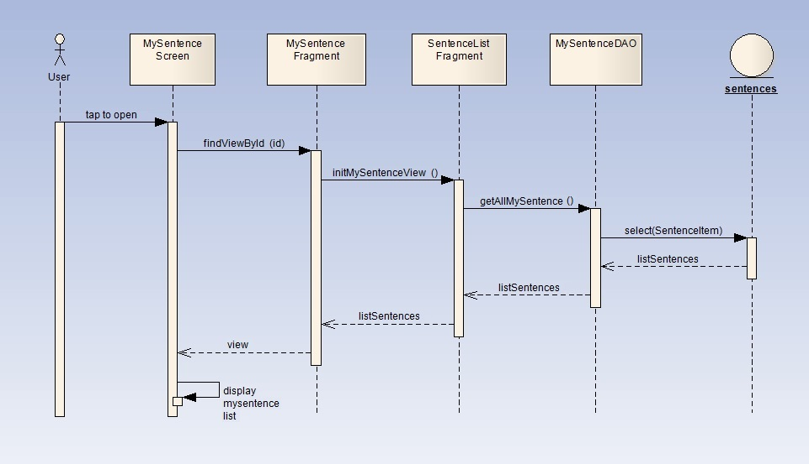

1. View my sentence sequence diagram

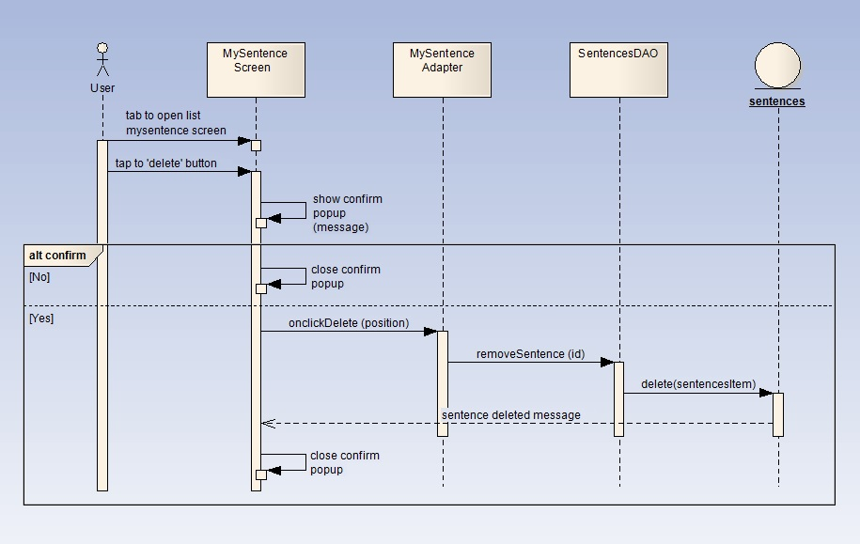

1. Delete my sentence sequence diagram

#### Modify my sentence

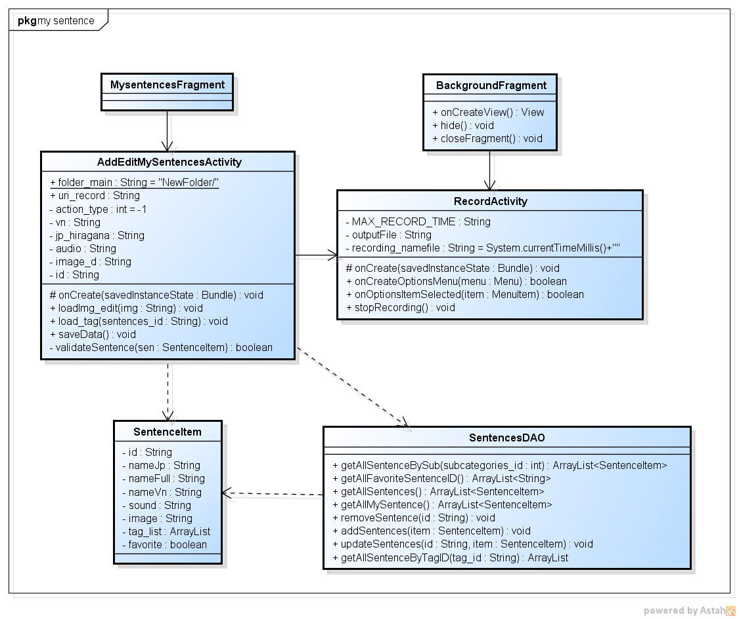

1. Modify my sentence class diagram
2. Specification for AddEditMySentencesActivity class

|  |  |
| --- | --- |
| **Class name** | **AddEditMySentencesActivity** |
| **Attribute** | |  |  |  |  | | --- | --- | --- | --- | | **No** | **Name** | **Type** | **Description** | | 1 | folder_main | String | folder to save image data and audio data | | 2 | uri_record | String | uri of audio file | | 3 | actionType | int | specify what kind of user action | | 4 | vn | String | Vietnamese meaning | | 5 | jp_hiragana | String | Japanese sentence | | 6 | audio | String | audio name or path | | 7 | image_d | String | image name of path | | 8 | id | String | code of sentence | |
| **Method** | |  |  |  |  |  | | --- | --- | --- | --- | --- | | **load_tag()** | | | | | | **Purpose** | load sentence’s tag to display on screen | | | | | **Return** | **Type** | | | **Description** | | void | | |  | | **Parameter** | **No** | **Name** | **Type** | **Description** | | 1 | sentences_id | String | code of sentence |  |  |  |  | | --- | --- | --- | | **loadTagsAtFirst()** | | | | **Purpose** | reload list tag to display in autocomplete box | | | **Return** | **Type** | **Description** | | void |  |  |  |  |  |  |  | | --- | --- | --- | --- | --- | | **validateSentence()** | | | | | | **Purpose** | validate sentence information | | | | | **Return** | **Type** | | | **Description** | | boolean | | | return false if information is invalid | | **Parameter** | **No** | **Name** | **Type** | **Description** | | 1 | sen | SentenceItem | an object represent a sentence | |

1. Specification for RecordActivity class

|  |  |
| --- | --- |
| **Class name** | **RecordActivity** |
| **Attribute** | |  |  |  |  | | --- | --- | --- | --- | | **No** | **Name** | **Type** | **Description** | | 1 | MAX_RECORD_TIME | String | Max record time for sentence | | 2 | outputFile | String | output file path | | 3 | recording_namefile | String | recording file name | | 4 | stacklist | Stack<String> | save user edit action step by step | | 5 | tag_name | String | name of tag | | 6 | textTag | String | text to display in screen | |
| **Method** | |  |  |  | | --- | --- | --- | | **stopRecording()** | | | | **Purpose** | stop recording audio | | | **Return** | **Type** | **Description** | | void |  | |

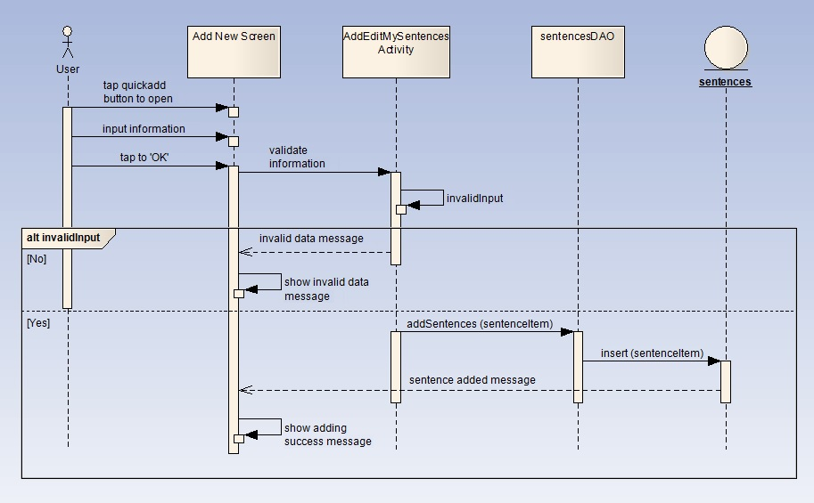

1. Add new sentence sequence diagram

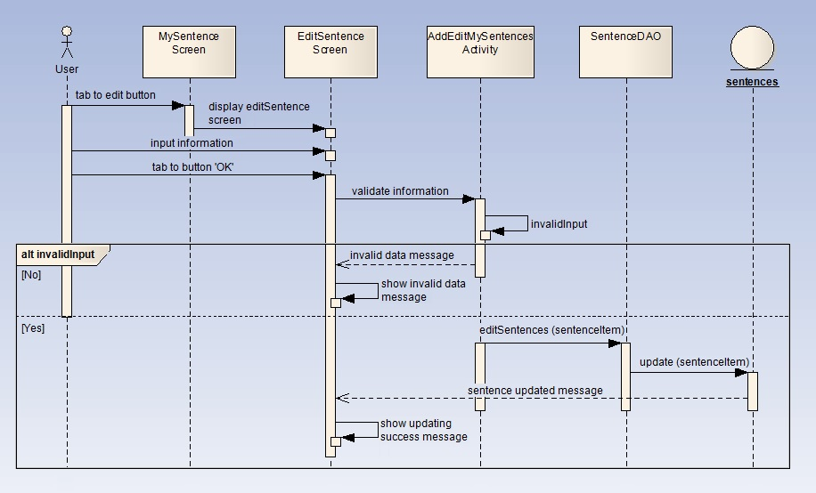

1. Edit sentence sequence diagram

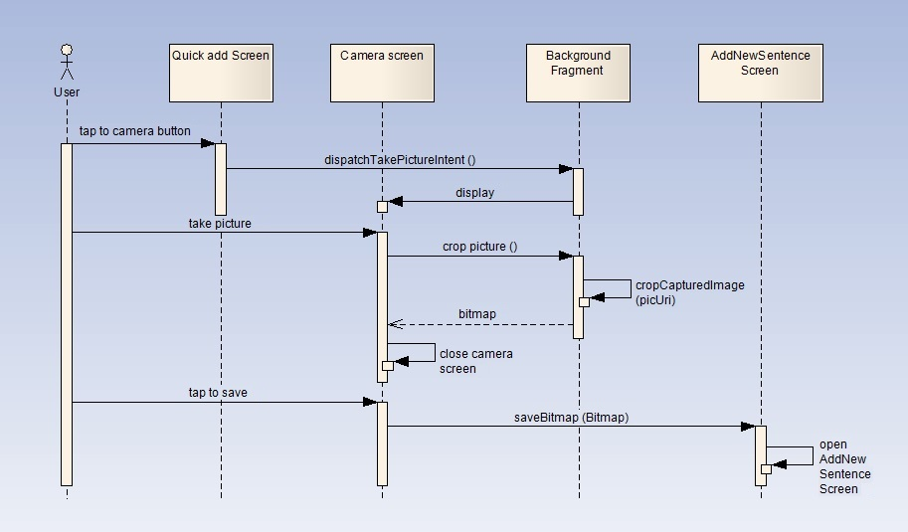

1. Capture sequence diagram

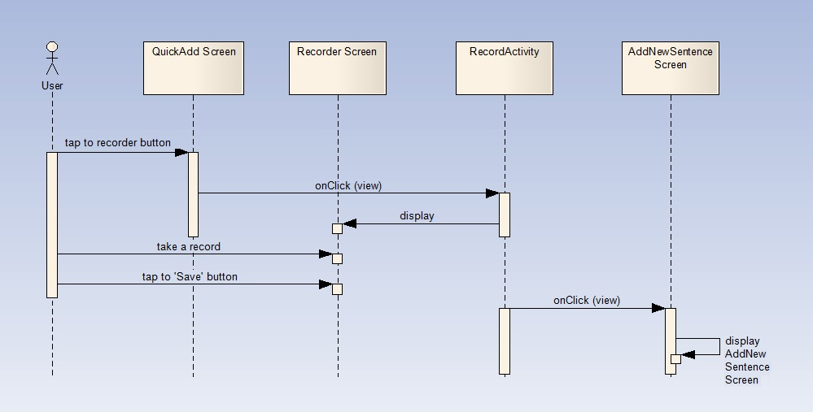

1. Record sequence diagram

### Tag list

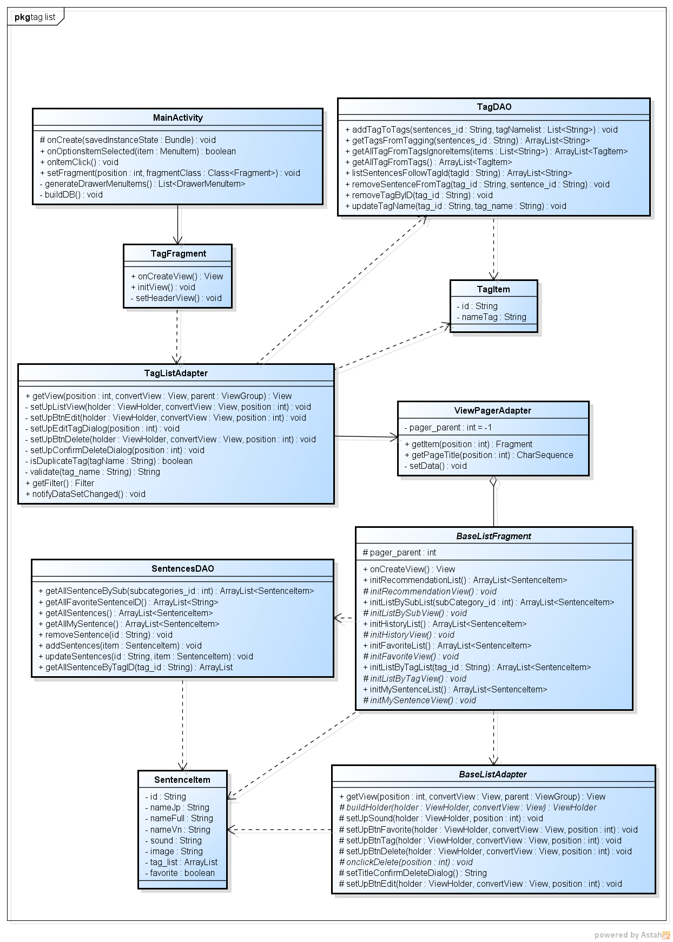

1. Tag list class diagram
2. Specification for TagListAdapter class

|  |  |
| --- | --- |
| **Class name** | **AddEditTagActivity** |
| **Attribute** | N/A |
| **Method** | |  |  |  |  |  | | --- | --- | --- | --- | --- | | **setUpListView ()** | | | | | | **Purpose** | set list view to display tag list | | | | | **Return** | **Type** | | | **Description** | | void | | |  | | **Parameter** | **No** | **Name** | **Type** | **Description** | | 1 | holder | ViewHolder | Content view | | 2 | convertView | View | Total view | | 3 | position | int | position of row in list |  |  |  |  |  |  | | --- | --- | --- | --- | --- | | **setUpBtnEdit ()** | | | | | | **Purpose** | set view for edit button | | | | | **Return** | **Type** | | | **Description** | | void | | |  | | **Parameter** | **No** | **Name** | **Type** | **Description** | | 1 | holder | ViewHolder | Content view | | 2 | convertView | View | Total view | | 3 | position | int | position of row in list |  |  |  |  |  |  | | --- | --- | --- | --- | --- | | **setUpBtnDelete ()** | | | | | | **Purpose** | set view for delete button | | | | | **Return** | **Type** | | | **Description** | | void | | |  | | **Parameter** | **No** | **Name** | **Type** | **Description** | | 1 | holder | ViewHolder | Content view | | 2 | convertView | View | Total view | | 3 | position | int | position of row in list |  |  |  |  |  |  | | --- | --- | --- | --- | --- | | **isDuplicateTag()** | | | | | | **Purpose** | check if tag has already exist in tag list | | | | | **Return** | **Type** | | | **Description** | | boolean | | | return true if tag is duplicated | | **Parameter** | **No** | **Name** | **Type** | **Description** | | 1 | tagName | String | name of tag |  |  |  |  |  |  | | --- | --- | --- | --- | --- | | **setUpEditTagDialog ()** | | | | | | **Purpose** | initialize Edit tag dialog | | | | | **Return** | **Type** | | | **Description** | | void | | |  | | **Parameter** | **No** | **Name** | **Type** | **Description** | | 1 | position | int | tag position in tag list |  |  |  |  |  |  | | --- | --- | --- | --- | --- | | **setConfirmDeleteDialog ()** | | | | | | **Purpose** | initialize Confirm delete dialog | | | | | **Return** | **Type** | | | **Description** | | void | | |  | | **Parameter** | **No** | **Name** | **Type** | **Description** | | 1 | position | int | tag position in tag list |  |  |  |  |  |  | | --- | --- | --- | --- | --- | | **validate()** | | | | | | **Purpose** | validate tag information | | | | | **Return** | **Type** | | | **Description** | | boolean | | | return false if information is invalid | | **Parameter** | **No** | **Name** | **Type** | **Description** | | 1 | tag_name | String | name of tag | |

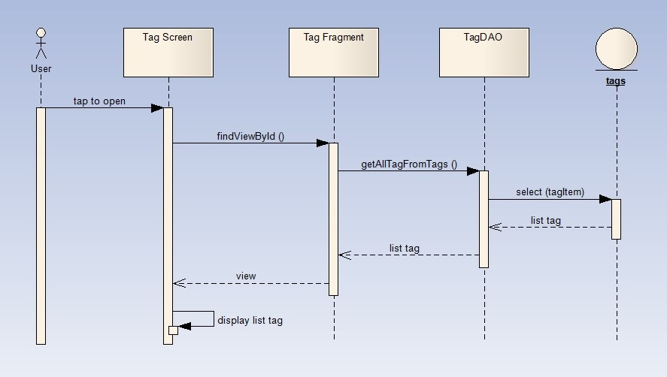

1. View tag list sequence diagram

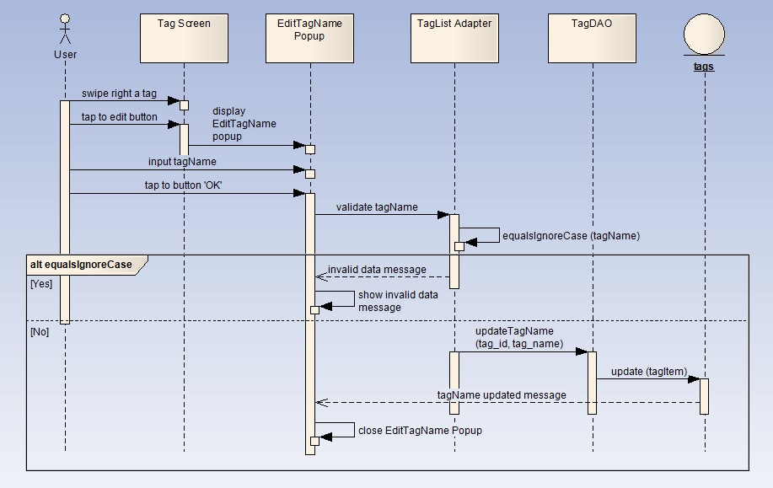

1. Edit tag name sequence diagram

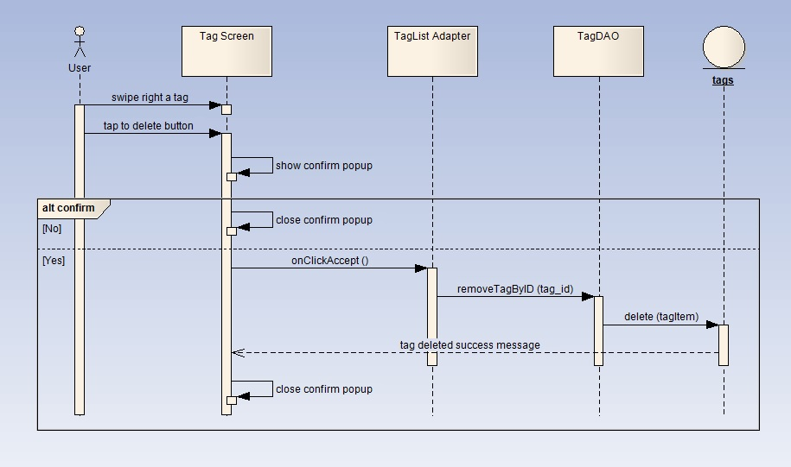

1. Delete tag sequence diagram

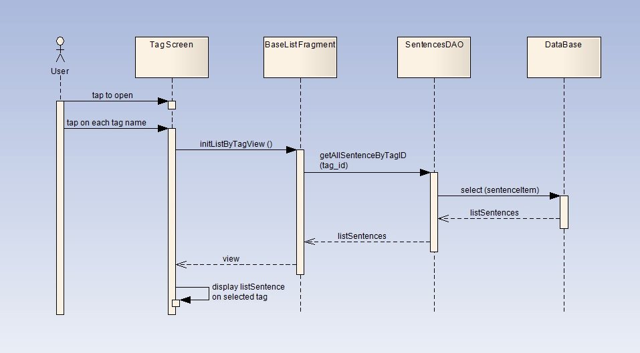

1. View sentence list by tag sequence diagram

## Data Design

### ERD

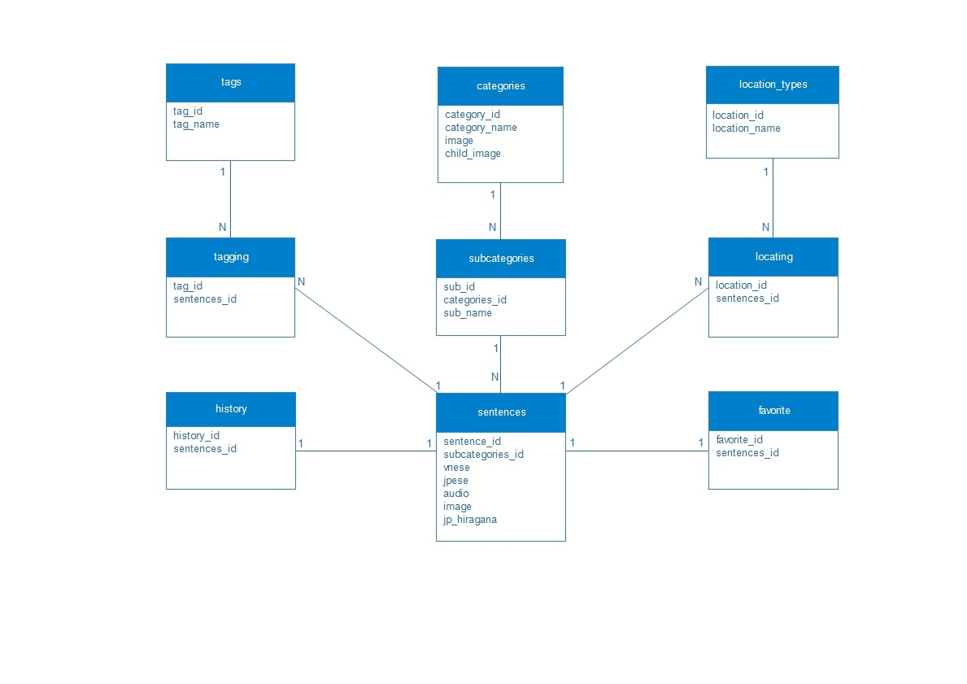

1. Entity relationship diagram (ERD)

### Table Diagram

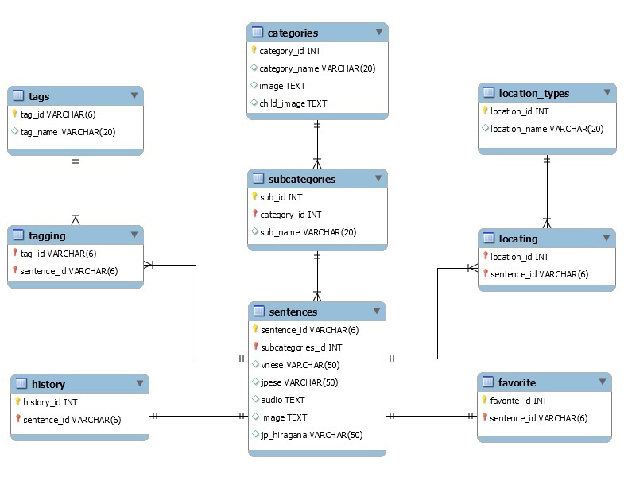

1. Table diagram

### Attribute description

#### “Categories” table

Contains all sentence category.

1. Categories table attribute

|  |  |  |  |  |  |  |  |
| --- | --- | --- | --- | --- | --- | --- | --- |
| **No** | **Field Name** | **Type** | **Null** | **Unique** | **P/F key** | **Default** | **Description** |
|  | category_id | INT |  | x | P |  | Code of category |
|  | category_name | Varchar(20) | x |  |  |  | Name of category |
|  | image | TEXT | x |  |  |  | Category image path |
|  | child_image | TEXT | x |  |  |  | Sub category image path |

#### “Subcategories” table

Contains all sentence sub-category.

1. Sub-categories table attribute

|  |  |  |  |  |  |  |  |
| --- | --- | --- | --- | --- | --- | --- | --- |
| **No** | **Field Name** | **Type** | **Null** | **Unique** | **P/F key** | **Default** | **Description** |
|  | sub_id | INT |  | x | P |  | Code of sub-category |
|  | category_id | INT |  |  | F |  | Code of category |
|  | sub_name | Varchar(20) | x |  |  |  | Sub-category name |

#### “Sentences” table

Contains all sentences.

1. Sentences table attribute

|  |  |  |  |  |  |  |  |
| --- | --- | --- | --- | --- | --- | --- | --- |
| **No** | **Field Name** | **Type** | **Null** | **Unique** | **P/F key** | **Default** | **Description** |
|  | sentence_id | Varchar(6) |  | x | P |  | Code of sentence |
|  | subcategory_name | Varchar(20) |  |  | F |  | Code of sub-category |
|  | vnese | Varchar(50) | x |  |  |  | Vietnamese meaning |
|  | jpese | Varchar(50) |  |  |  |  | Japanese meaning |
|  | audio | TEXT | x |  |  |  | Audio path |
|  | image | TEXT | x |  |  |  | Image path |
|  | jp_hiragana | Varchar(50) | x |  |  |  | Japanese meaning in Hiragana |

#### “Tags” table

Contains all tags.

1. Tags table attribute

|  |  |  |  |  |  |  |  |
| --- | --- | --- | --- | --- | --- | --- | --- |
| **No** | **Field Name** | **Type** | **Null** | **Unique** | **P/F key** | **Default** | **Description** |
|  | tag_id | Varchar(6) |  | x | P |  | Code of tag |
|  | tag_name | Varchar(20) | x |  |  |  | Name of tag |

#### “Tagging” table

Matching tag and sentence.

1. Tagging table attribute

|  |  |  |  |  |  |  |  |
| --- | --- | --- | --- | --- | --- | --- | --- |
| **No** | **Field Name** | **Type** | **Null** | **Unique** | **P/F key** | **Default** | **Description** |
|  | tag_id | Varchar(6) |  |  | F |  | Code of tag |
|  | sentence_id | Varchar(6) |  |  | F |  | Code of sentence |

#### “Location types” table

Contains all google location types.

1. Location types table attribute

|  |  |  |  |  |  |  |  |
| --- | --- | --- | --- | --- | --- | --- | --- |
| **No** | **Field Name** | **Type** | **Null** | **Unique** | **P/F key** | **Default** | **Description** |
|  | location_id | INT |  | x | P |  | Code of location type |
|  | location_name | Varchar(20) | x |  |  |  | Name of location |

#### “Locating” table

Matching location type and sentence.

1. Locating table attribute

|  |  |  |  |  |  |  |  |
| --- | --- | --- | --- | --- | --- | --- | --- |
| **No** | **Field Name** | **Type** | **Null** | **Unique** | **P/F key** | **Default** | **Description** |
|  | location_id | INT |  |  | F |  | Code of location |
|  | sentence_id | Varchar(6) |  |  | F |  | Code of sentence |

#### “Favorite” table

Contains all favorite sentence.

1. Favorite table attribute

|  |  |  |  |  |  |  |  |
| --- | --- | --- | --- | --- | --- | --- | --- |
| **No** | **Field Name** | **Type** | **Null** | **Unique** | **P/F key** | **Default** | **Description** |
|  | favorite_id | INT |  | x | P |  | Code of favorite |
|  | sentence_id | Varchar(6) |  |  | F |  | Code of sentence |

#### “History” table

Contains all sentence has been used.

1. History table attribute

|  |  |  |  |  |  |  |  |
| --- | --- | --- | --- | --- | --- | --- | --- |
| **No** | **Field Name** | **Type** | **Null** | **Unique** | **P/F key** | **Default** | **Description** |
|  | history_id | INT |  | x | P |  | Code of history |
|  | sentence_id | Varchar(6) |  |  | F |  | Code of sentence |

#### ID rules

* Sentence id:
  + If id for a default sentence, it will be a number. Ex: 1, 2, 10, 27…
  + If id for a user’s sentence, add “s” before id number. Ex: s1, s2, s10, s27…
* Tag id:
  + If id for a default tag, it will be a number. Ex: 1, 2, 10, 27…
  + If id for a user’s tag, add “t” before id number. Ex: t1, t2, t10, t27…

## Screen Design

### Home

#### Main

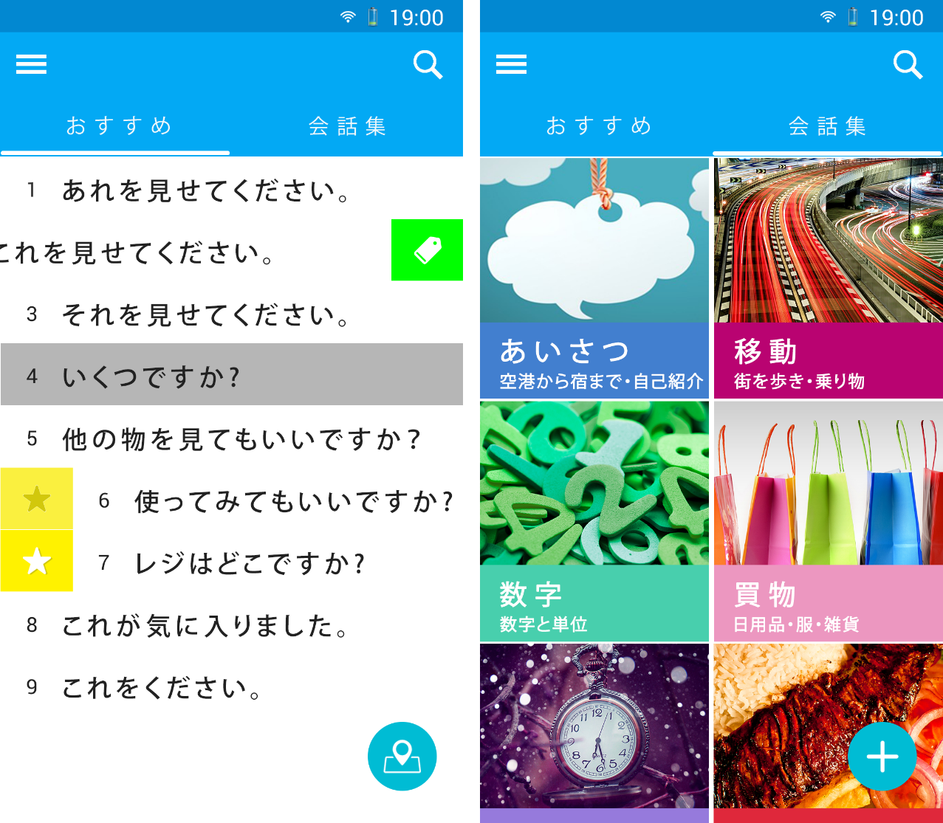

1. SC-VTT-00-4(left) and SC-VTT-00-1
2. Home screen description

|  |  |  |  |  |  |
| --- | --- | --- | --- | --- | --- |
| **No.** | **Element** | **Type** | **I/O** | **Description** | **Parent** |
| 1 | Action bar | Layout | I/O |  |  |
| 2 | Sliding tab bar | Layout | I/O |  |  |
| 3 | Navigation drawer | Button | I | Button for displaying Navigation drawer menu | 1 |
| 4 | Search | Button | I | Button for searching sentence | 1 |
| 5 | おすすめ | Listview | I | List view for displaying sentence suggestion list | 2 |
| 6 | 会話集 | Listview | I | List view for displaying category list | 2 |
| 7 | おすすめ list | Listview | O |  | 6 |
| 8 | 会話集list | Girdview | O |  | 6 |
| 9 | Add sentence | Button | I | Button for adding new sentence |  |

#### Other

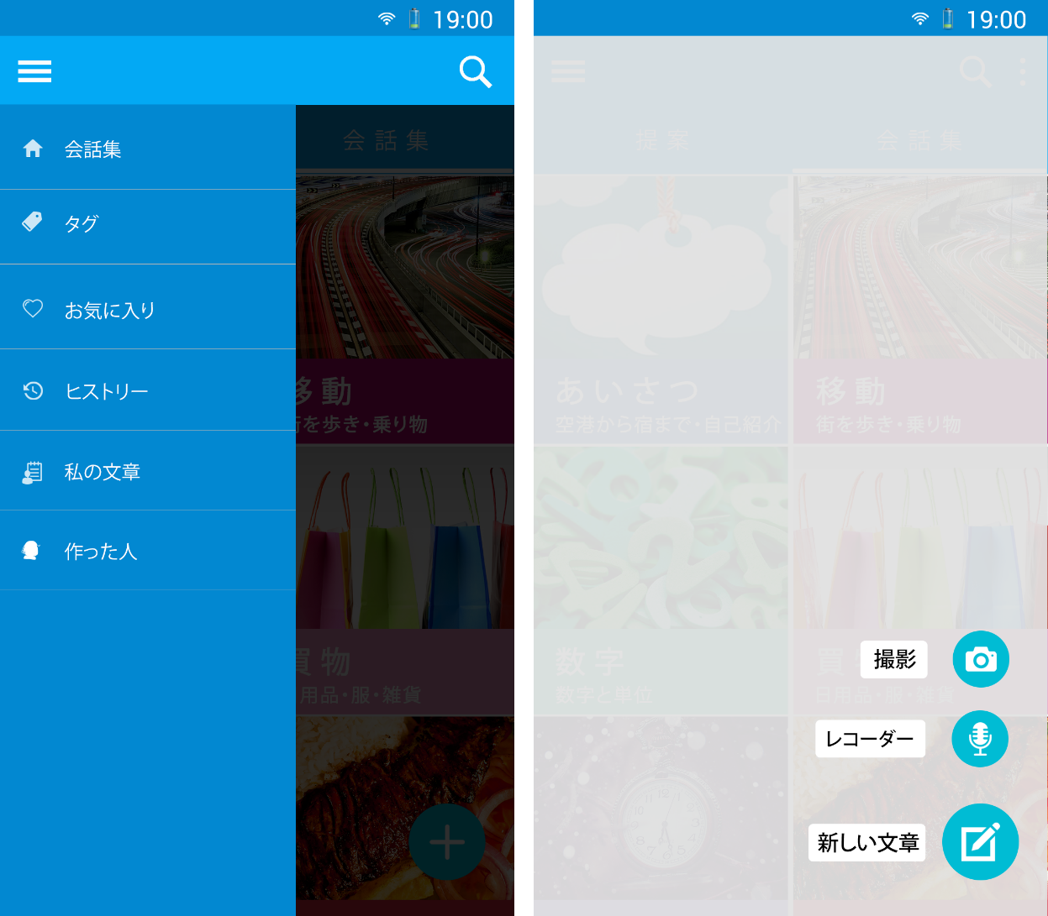

1. SC-VTT-00-3(left) and SC-VTT-00-2
2. Navigation and Add screen description

|  |  |  |  |  |  |
| --- | --- | --- | --- | --- | --- |
| **No.** | **Element** | **Type** | **I/O** | **Description** | **Parent** |
| 1 | Action bar | Layout | I/O |  |  |
| 2 | Sliding tab bar | Layout | I/O |  |  |
| 3 | Navigation drawer | Button | I | Button for displaying Navigation drawer menu | 1 |
| 4 | Search | Button | I | Button for searching sentence | 1 |
| 5 | 会話集 | Button | I | Button for displaying category list | 3 |
| 6 | タグ | Button | I | Button for displaying tag list | 3 |
| 7 | お気に入り | Button | I | Button for displaying favorite list | 3 |
| 8 | ヒストリー | Button | I | Button for displaying history list | 3 |
| 9 | 通訳 | Button | I | Button for displaying translation screen | 3 |
| 10 | 私の文書 | Button | I | Button for displaying User’s sentence list | 3 |
| 11 | 新しい文章 | Button | I | Button for displaying add new sentence screen |  |
| 12 | レコーダー | Button | I | Button for accessing to recorder of mobile |  |
| 13 | 撮影 | Button | I | Button for accessing to camera of mobile |  |

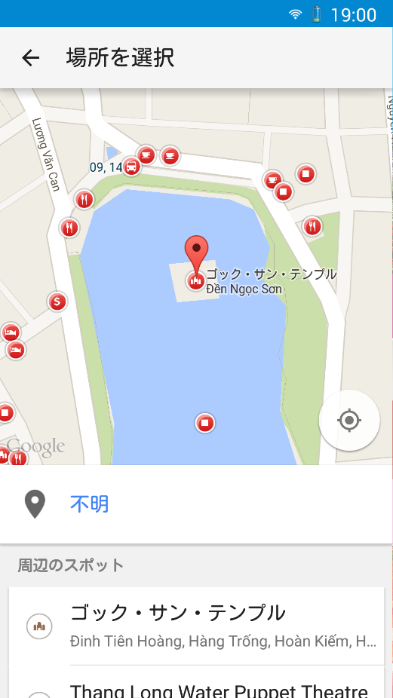

1. SC-VTT-00-4-1

SC-VTT-00-4-1 is default screen provide by “Google Places API for Android”. Refer this link for more details: https://developers.google.com/places/android/placepicker

### Sub-categories list

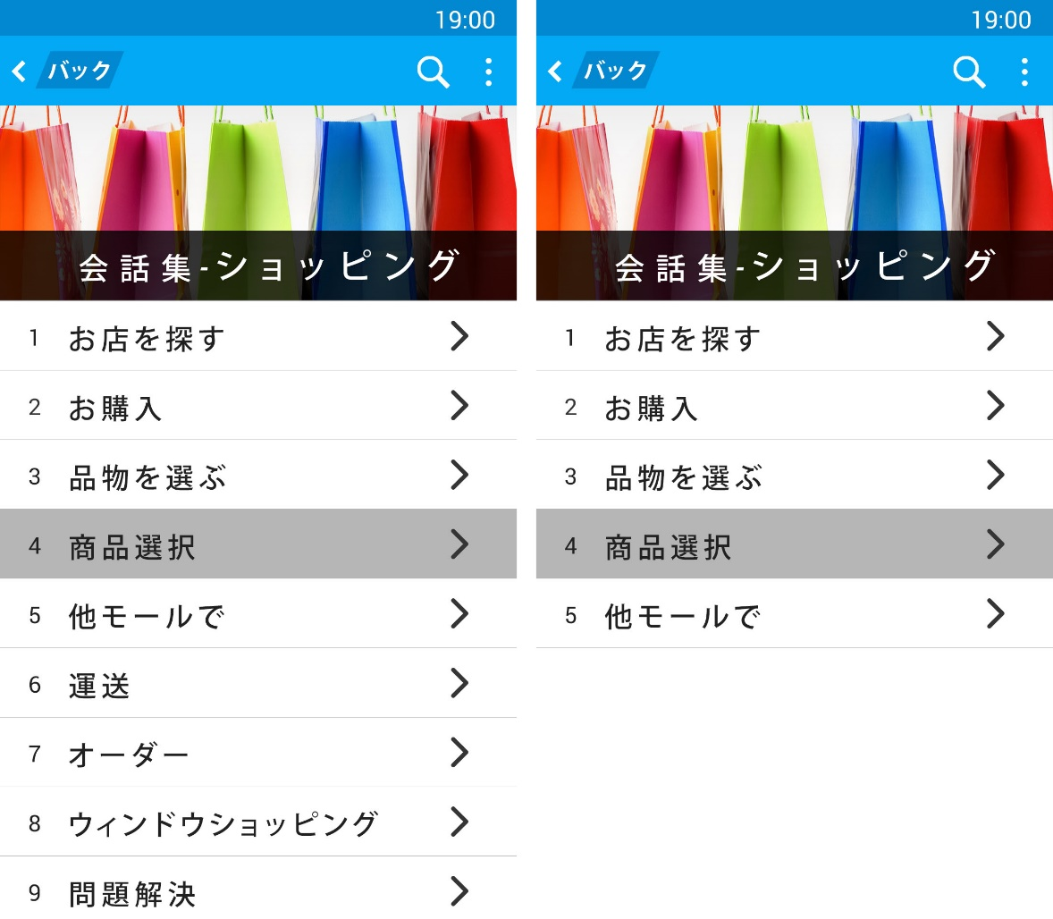

1. SC-VTT-01 (full and half)
2. Sub-categories list screen description

|  |  |  |  |  |  |
| --- | --- | --- | --- | --- | --- |
| **No.** | **Element** | **Type** | **I/O** | **Description** | **Parent** |
| 1 | Action bar | Layout | I/O |  |  |
| 2 | Sliding tab bar | Layout | I/O |  |  |
| 3 | Navigation drawer | Button | I | Button for displaying Navigation drawer menu | 1 |
| 4 | Option | Button | I | Button for displaying extend option | 1 |
| 5 | Search | Button | I | Button for searching sentence | 1 |
| 6 | バック | Button | I | Button for going back | 1 |
| 7 | Category title | Textview | O |  |  |
| 8 | Category Photo | Image | O |  |  |
| 9 | Subcategory list | Listview | O |  |  |

### Sentences list

#### Text list view

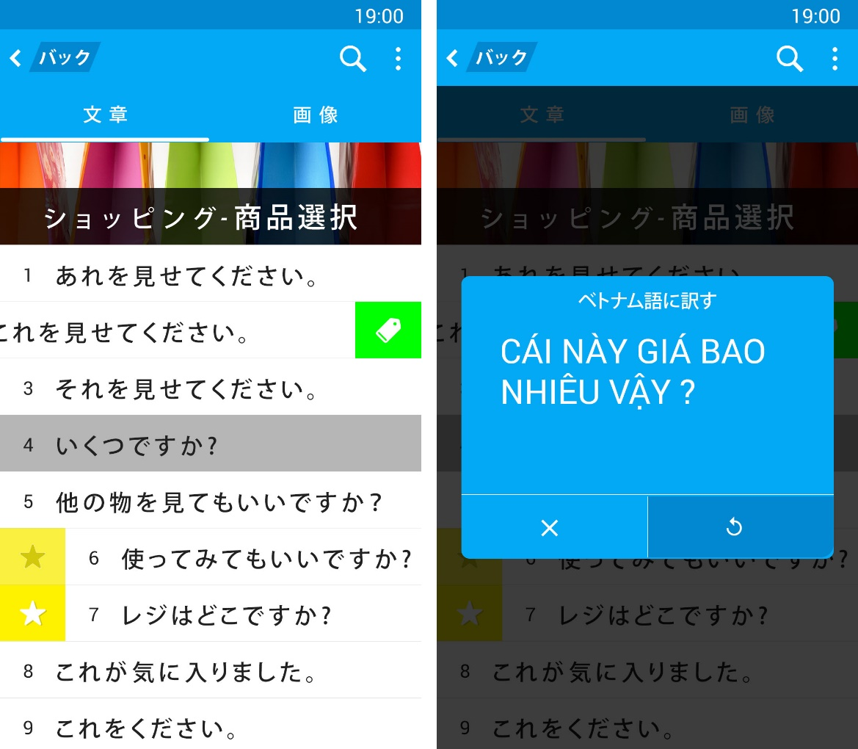

1. SC-VTT-02-1(left) and SC-VTT-02-3
2. Sentence list screen description

|  |  |  |  |  |  |
| --- | --- | --- | --- | --- | --- |
| **No.** | **Element** | **Type** | **I/O** | **Description** | **Parent** |
| 1 | Action bar | Layout | I/O |  |  |
| 2 | Sliding tab bar | Layout | I/O |  |  |
| 3 | Navigation drawer | Button | I | Button for displaying Navigation drawer menu | 1 |
| 4 | Option | Button | I | Button for displaying extend option | 1 |
| 5 | Search | Button | I | Button for searching sentence | 1 |
| 6 | バック | Button | I | Button for going back | 1 |
| 7 | 文章 | Listview | I | List view for displaying list sentence | 2 |
| 8 | 画像 | Listview | I | List view for displaying list image | 2 |
| 9 | Subcategory title | Textview | O |  |  |
| 10 | Sentence list | Listview | O |  |  |
| 11 | Subcategory photo | Image | O |  |  |
| 12 | Tag | Button | I | Button for tagging a sentence to tag list | 10 |
| 13 | Favorite-added | Button | I/O | Button for showing a sentence added to favorite list | 10 |
| 14 | Favorite-none | Button | I/O | Button for showing a sentence not add to favorite list | 10 |
| 15 | Talk screen(Pop-up) | Pop-up | O |  |  |
| 16 | Exit | Button | I | Button for exiting pop-up | 15 |
| 17 | Replay | Button | I | Button for generating voice of sentence again | 15 |
| 18 | Vietnamese Mean | Textview | I/O |  | 15 |
| 19 | Japanese Mean | Textview | I/O |  | 15 |

#### Image list view

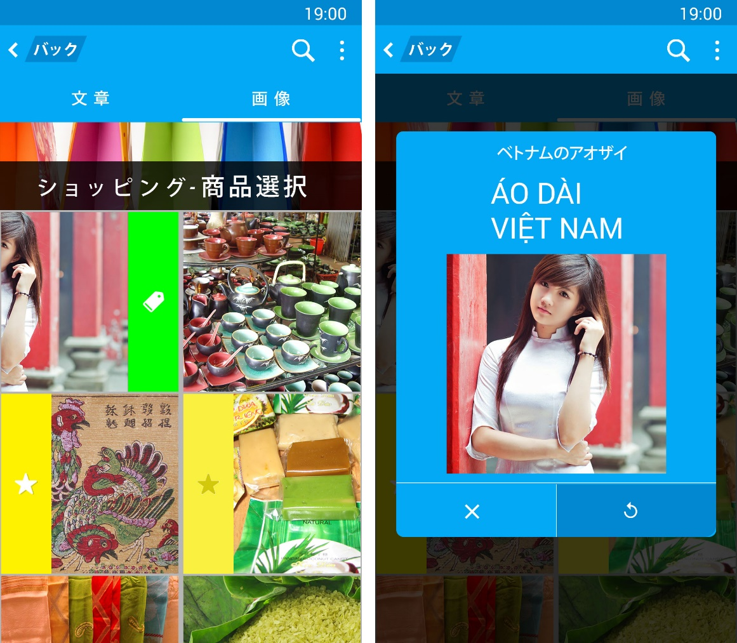

1. SC-VTT-02-2(left) and SC-VTT-02-4
2. Image list screen description

|  |  |  |  |  |  |
| --- | --- | --- | --- | --- | --- |
| **No.** | **Element** | **Type** | **I/O** | **Description** | **Parent** |
| 1 | Action bar | Layout | I/O |  |  |
| 2 | Sliding tab bar | Layout | I/O |  |  |
| 3 | Navigation drawer | Button | I | Button for displaying Navigation drawer menu | 1 |
| 4 | Option | Button | I | Button for displaying extend option | 1 |
| 5 | Search | Button | I | Button for searching sentence | 1 |
| 6 | バック | Button | I | Button for going back | 1 |
| 7 | 文章 | Listview | I | List view for displaying list sentence | 2 |
| 8 | 画像 | Listview | I | List view for displaying list image | 2 |
| 9 | Subcategory title | Textview | O |  |  |
| 10 | Subcategory photo | Image | O |  |  |
| 11 | Image list | Girdview | O |  |  |
| 12 | Tag | Button | I | Button for tagging a sentence to tag list | 11 |
| 13 | Favorite-added | Button | I/O | Button for showing a sentence added to favorite list | 11 |
| 14 | Favorite-none | Button | I/O | Button for showing a sentence not add to favorite list | 11 |
| 15 | Talk screen(Pop-up) | Pop-up | O |  |  |
| 16 | Picture of sentence | Imageview | O |  | 15 |
| 17 | Exit | Button | I | Button for exiting pop-up | 15 |
| 18 | Replay | Button | I | Button for generating voice of sentence again | 15 |
| 19 | Vietnamese Mean | Textview | I/O |  | 15 |
| 20 | Japanese Mean | Textview | I/O |  | 15 |

### Modify sentence’s tag

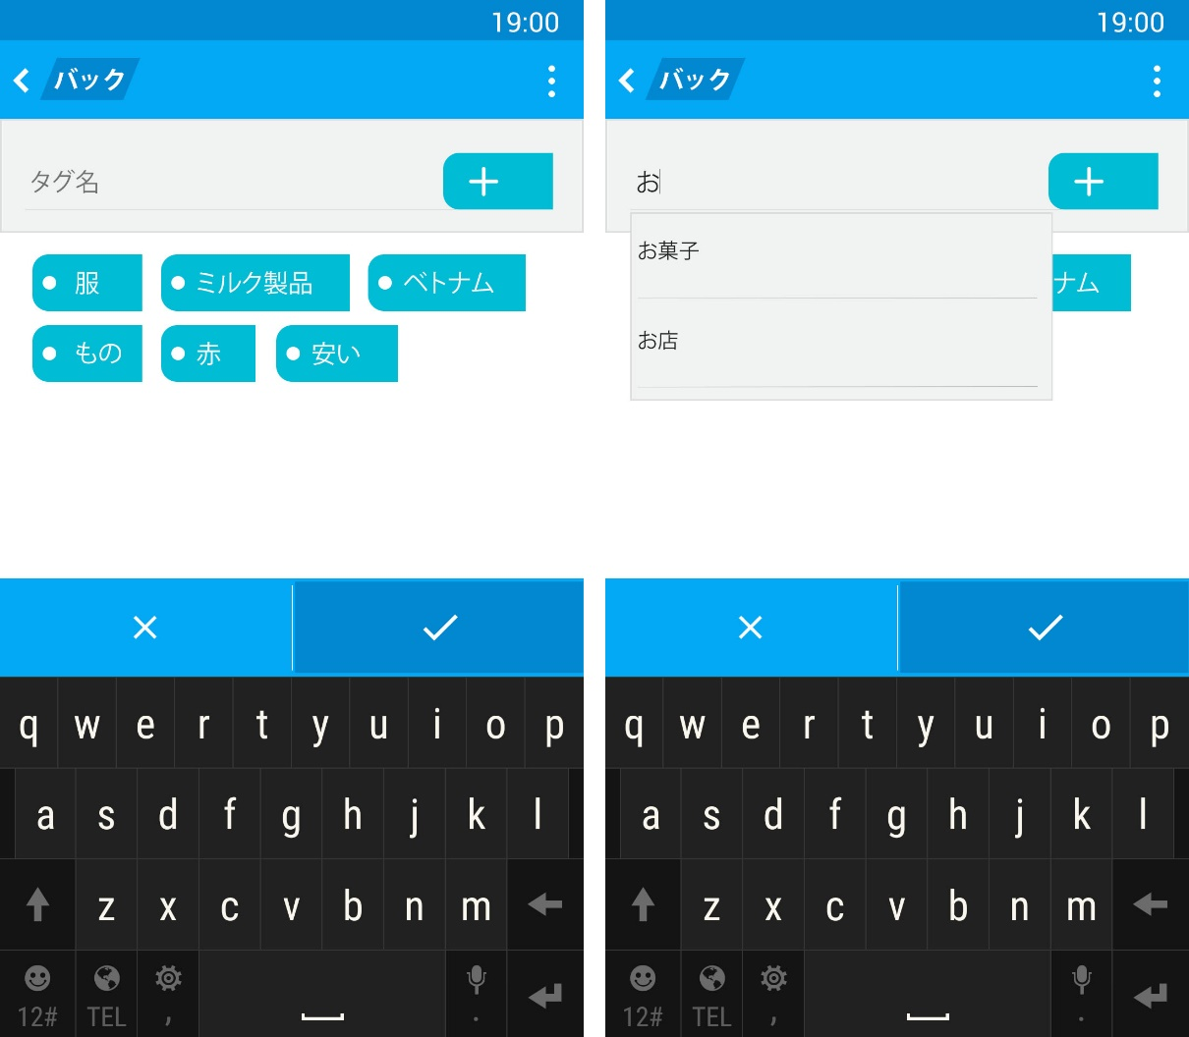

1. SC-VTT-05 (Normal state and autocomplete box state)
2. Modify sentence’s tag screen description

|  |  |  |  |  |  |
| --- | --- | --- | --- | --- | --- |
| **No.** | **Element** | **Type** | **I/O** | **Description** | **Parent** |
| 1 | Action bar | Layout | I/O |  |  |
| 2 | Option | Button | I | Button for displaying extend option | 1 |
| 3 | Search | Button | I | Button for searching sentence | 1 |
| 4 | バック | Button | I | Button for going back | 1 |
| 5 | Input tag field | Layout | I/O |  |  |
| 6 | Display tag field | Layout | I/O |  |  |
| 7 | Footer | Layout | I/O |  |  |
| 8 | Tag name | Textbox | I | Text box for entering tag name | 5 |
| 9 | Add tag | Button | I | Button for adding tag name | 5 |
| 10 | Suggestion tag | Spinner | I/O | Spinner for displaying tag suggestion | 5 |
| 11 | List tag | Layout | I/O | Layout for displaying list tag exited | 6 |
| 12 | OK | Button | I | Button for saving actions | 7 |
| 13 | Cancel | Button | I | Button for canceling actions | 7 |

### Favorite & History

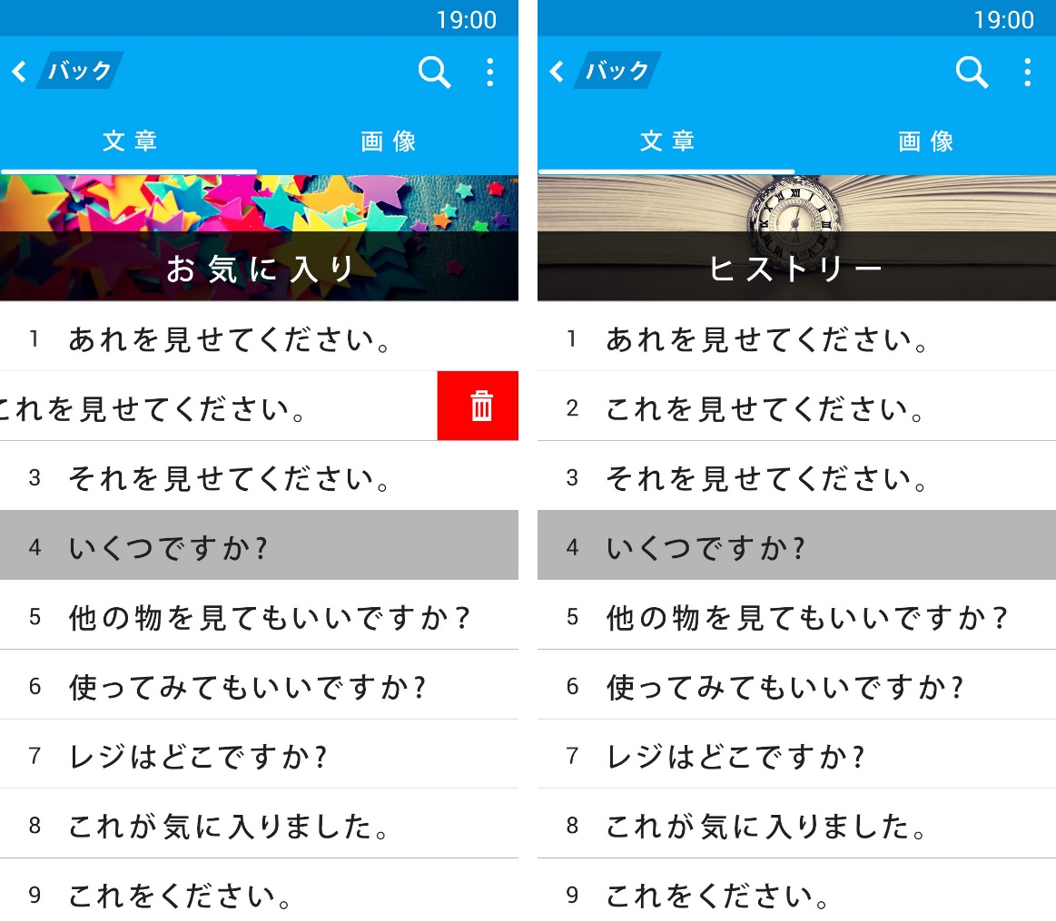

1. SC-VTT-03-01(left) and SC-VTT-04-1
2. Favorite screen description

|  |  |  |  |  |  |
| --- | --- | --- | --- | --- | --- |
| **No.** | **Element** | **Type** | **I/O** | **Description** | **Parent** |
| 1 | Action bar | Layout | I/O |  |  |
| 2 | Sliding tab bar | Layout | I/O |  |  |
| 3 | Navigation drawer | Button | I | Button for displaying Navigation drawer menu | 1 |
| 4 | Option | Button | I | Button for displaying extend option | 1 |
| 5 | Search | Button | I | Button for searching sentence | 1 |
| 6 | バック | Button | I | Button for going back | 1 |
| 7 | 文章 | Listview | I | List view for displaying list sentence | 2 |
| 8 | 画像 | Listview | I | List view for displaying list image | 2 |
| 9 | Favorite title | Textview | O |  |  |
| 10 | Favorite photo | Image | O |  |  |
| 11 | Favorite list | Listview | O |  |  |
| 12 | Remove | Button | I | Button for removing this sentence on favorite list | 11 |

1. History screen description

|  |  |  |  |  |  |
| --- | --- | --- | --- | --- | --- |
| **No.** | **Element** | **Type** | **I/O** | **Description** | **Parent** |
| 1 | Action bar | Layout | I/O |  |  |
| 2 | Sliding tab bar | Layout | I/O |  |  |
| 3 | Navigation drawer | Button | I | Button for displaying Navigation drawer menu | 1 |
| 4 | Option | Button | I | Button for displaying extend option | 1 |
| 5 | Search | Button | I | Button for searching sentence | 1 |
| 6 | バック | Button | I | Button for going back | 1 |
| 7 | 文章 | Listview | I | List view for displaying list sentence | 2 |
| 8 | 画像 | Listview | I | List view for displaying list image | 2 |
| 9 | History title | Textview | O |  |  |
| 10 | History photo | Image | O |  |  |
| 11 | History list | Listview | O |  |  |

### My sentence

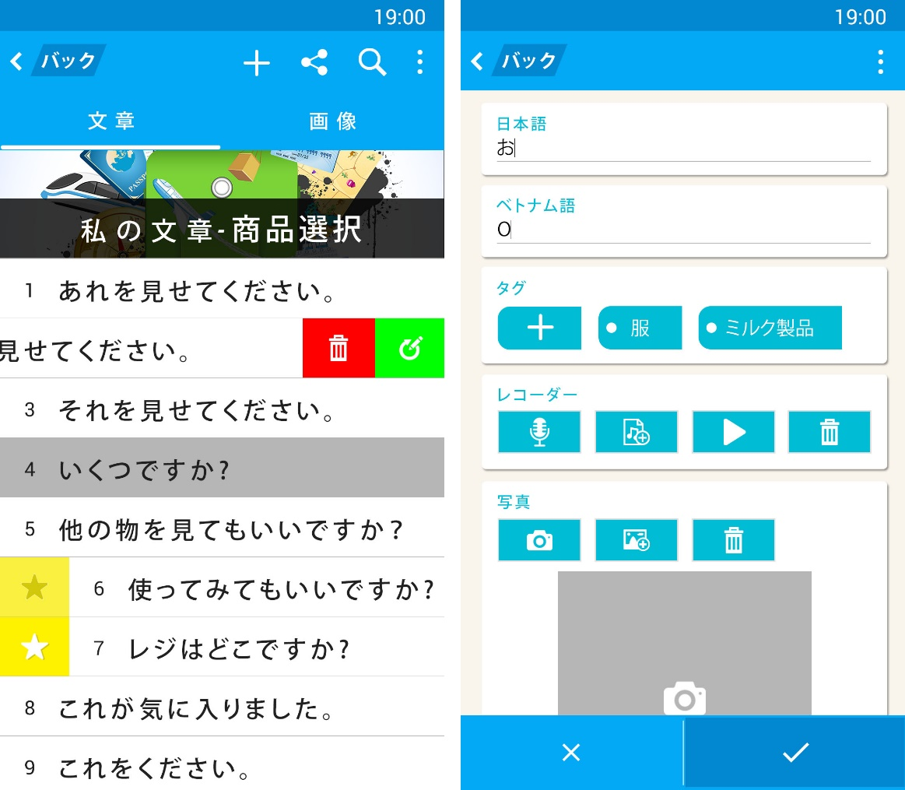

1. SC-VTT-06(left) and SC-VTT-07
2. My sentence list screen description

|  |  |  |  |  |  |
| --- | --- | --- | --- | --- | --- |
| **No.** | **Element** | **Type** | **I/O** | **Description** | **Parent** |
| 1 | Action bar | Layout | I/O |  |  |
| 2 | Sliding tab bar | Layout | I/O |  |  |
| 3 | Navigation drawer | Button | I | Button for displaying Navigation drawer menu | 1 |
| 4 | Option | Button | I | Button for displaying extend option | 1 |
| 5 | Search | Button | I | Button for searching sentence | 1 |
| 6 | バック | Button | I | Button for going back | 1 |
| 7 | Share | Button | I | Button for sharing sentences | 1 |
| 8 | Add sentence | Button | I | Button for adding new sentence | 1 |
| 9 | 文章 | Listview | I | List view for displaying list sentence | 2 |
| 10 | 画像 | Listview | I | List view for displaying list image | 2 |
| 11 | My sentence title | Textview | O |  |  |
| 12 | My sentence photo | Image | O |  |  |
| 13 | My sentence list | Listview | O |  |  |
| 14 | Delete | Button | I | Button for removing this sentence on my sentence list | 13 |
| 15 | Modify | Button | I | Button for editing this sentence | 13 |
| 16 | Favorite-added | Button | I/O | Button for showing a sentence added to favorite list | 13 |
| 17 | Favorite-none | Button | I/O | Button for showing a sentence not add to favorite list | 13 |

1. Add/Edit my sentence screen description

|  |  |  |  |  |  |
| --- | --- | --- | --- | --- | --- |
| No. | Element | Type | I/O | Description | Parent |
| 1 | Action bar | Layout | I/O |  |  |
| 2 | バック | Button | I | Button for going back | 1 |
| 3 | 日本語 field | Layout | I/O |  |  |
| 4 | ベトナム語 field | Layout | I/O |  |  |
| 5 | タグ field | Layout | I/O |  |  |
| 6 | レコーダー field | Layout | I/O |  |  |
| 7 | 写真 field | Layout | I/O |  |  |
| 8 | Footer | Layout | I/O |  |  |
| 9 | 日本語 | Textview | O |  | 3 |
| 10 | ベトナム語 | Textview | O |  | 4 |
| 11 | Japanese Mean | Textbox | I | Text box for entering Japanese sentence | 3 |
| 12 | Vietnamese Mean | Textbox | I | Text box for entering Vietnamese sentence | 4 |
| 13 | タグ | Textview | O |  | 5 |
| 14 | Add tag | Button | I | Button for adding tag of sentence | 5 |
| 15 | Remove tag | Button | I | Button for removing this tag of sentence | 5 |
| 16 | レコーダー | Textview | O |  | 6 |
| 17 | Recording | Button | I | Button for accessing to recorder of mobile | 6 |
| 18 | Add audio | Button | I | Button for adding audio for sentence | 6 |
| 19 | Play audio | Button | I | Button for playing audio | 6 |
| 20 | Remove audio | Button | I | Button for removing audio | 6 |
| 21 | 写真 | Textview | O |  | 7 |
| 22 | Take photo | Button | I | Button for accessing to camera of mobile | 7 |
| 23 | Add photo | Button | I | Button for adding photo | 7 |
| 24 | Remove photo | Button | I | Button for removing photo | 7 |
| 25 | Displaying photo | Imageview | O |  | 7 |
| 26 | OK | Button | I | Button for saving actions | 8 |
| 27 | Cancel | Button | I | Button for canceling actions | 8 |

### Tags

#### Tags list

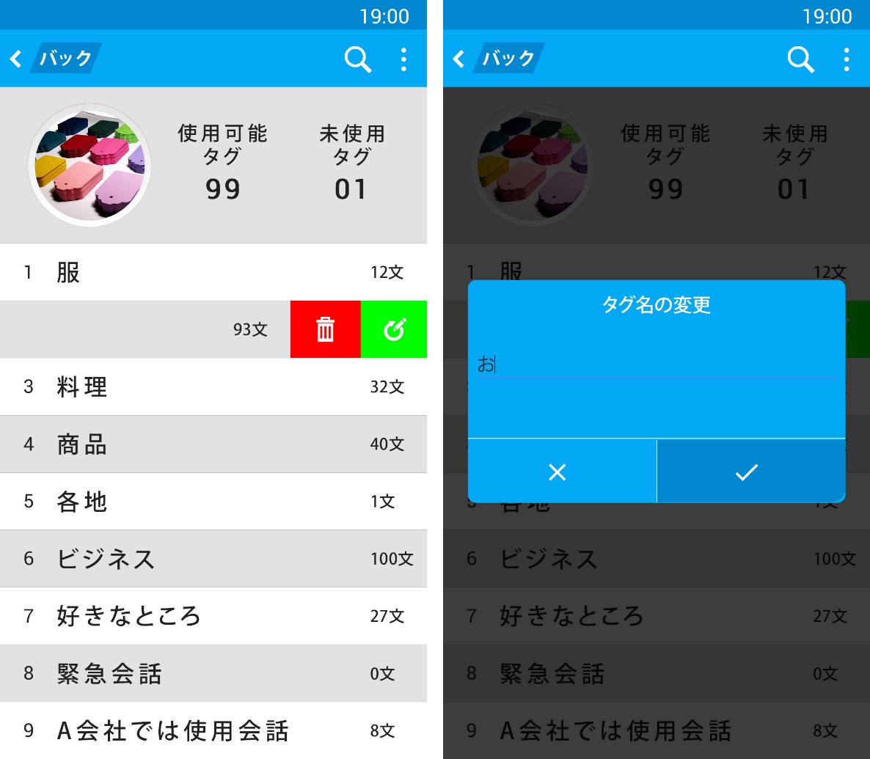

1. SC-VTT-08(left) and SC-VTT-08-1
2. Tag list screen description

|  |  |  |  |  |  |
| --- | --- | --- | --- | --- | --- |
| **No.** | **Element** | **Type** | **I/O** | **Description** | **Parent** |
| 1 | Action bar | Layout | I/O |  |  |
| 2 | Option | Button | I | Button for displaying extend option | 1 |
| 3 | Search | Button | I | Button for searching sentence | 1 |
| 4 | バック | Button | I | Button for going back | 1 |
| 5 | Tag photo field | Layout | O |  |  |
| 6 | 使用可能タグ field | Layout | O |  |  |
| 7 | 末使用タグ field | layout | O |  |  |
| 8 | Tag photo | Imageview | O |  | 5 |
| 9 | 使用可能タグ | Textview | O |  | 6 |
| 10 | 末使用タグ | Textview | O |  | 7 |
| 11 | Tag list | Listview | I | List view for displaying list sentence |  |
| 12 | Number of tag | Textview | O |  | 11 |
| 13 | Remove tag | Button | I | Button for removing this tag | 11 |
| 14 | Modify tag | Button | I | Button for editing this tag | 11 |
| 15 | Modify tag(pop-up) | Pop-up | O |  |  |
| 16 | タグ名の変更 | Textview | O |  | 15 |
| 17 | Tag mean | Textbox | I | Text box for entering tag mean | 15 |
| 18 | OK | Button | I | Button for saving actions | 15 |
| 19 | Cancel | Button | I | Button for canceling actions | 15 |

#### Sentence list order by tag

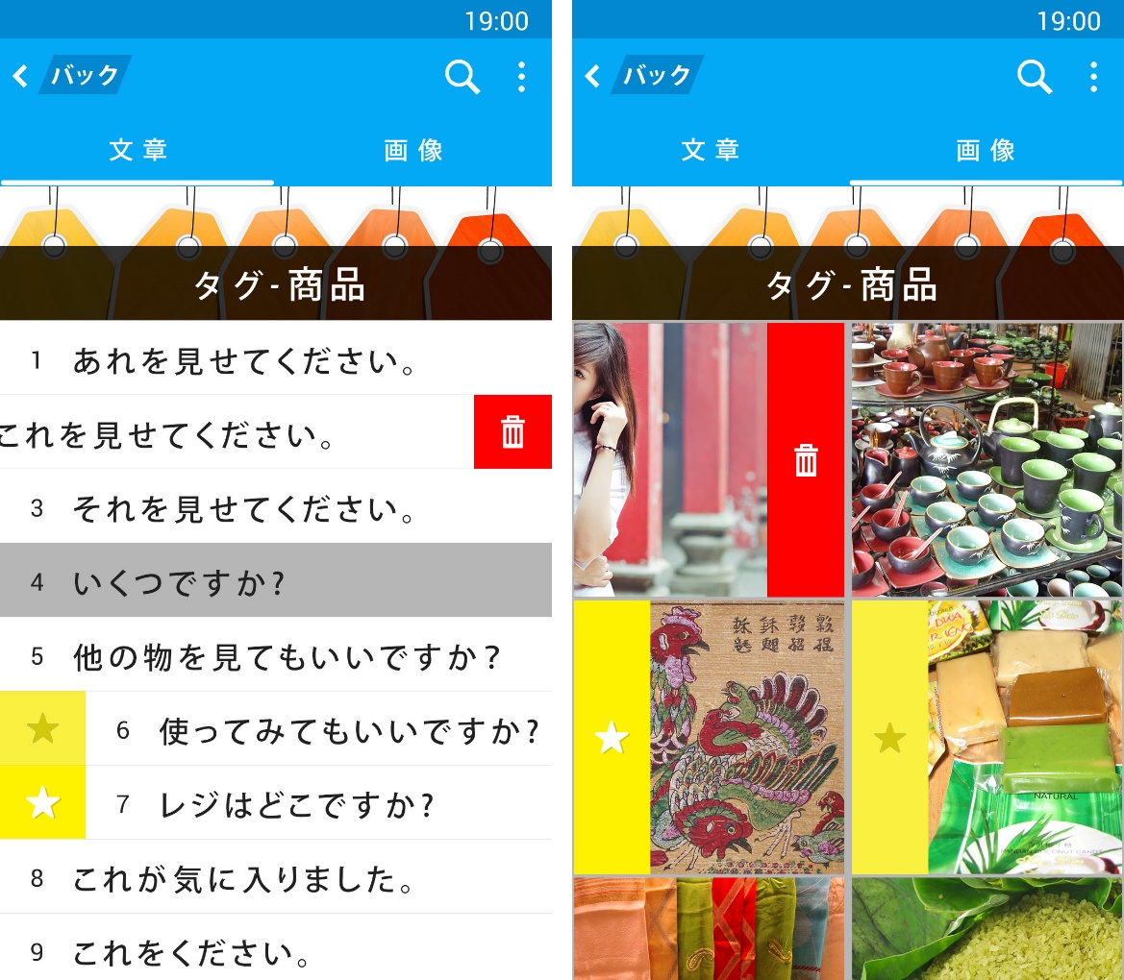

1. SC-VTT-09-1
2. Sentence list order by tag screen description

|  |  |  |  |  |  |
| --- | --- | --- | --- | --- | --- |
| **No.** | **Element** | **Type** | **I/O** | **Description** | **Parent** |
| 1 | Action bar | Layout | I/O |  |  |
| 2 | Sliding tab bar | Layout | I/O |  |  |
| 3 | Navigation drawer | Button | I | Button for displaying Navigation drawer menu | 1 |
| 4 | Option | Button | I | Button for displaying extend option | 1 |
| 5 | Search | Button | I | Button for searching sentence | 1 |
| 6 | バック | Button | I | Button for going back | 1 |
| 7 | 文章 | Listview | I | List view for displaying list sentence | 2 |
| 8 | 画像 | Listview | I | List view for displaying list image | 2 |
| 9 | タグ 商品 title | Textview | O |  |  |
| 10 | Tag title photo | Image | O |  |  |
| 11 | Sentence list order by tag | Textview | O |  | 7 |
| 12 | Image list order by tag | Imageview | O |  | 8 |
| 13 | Delete | Button | I | Button for removing this sentence on sentence list/image list order by tag | 7;8 |
| 14 | Favorite-added | Button | I/O | Button for showing a sentence added to favorite list | 7;8 |
| 15 | Favorite-none | Button | I/O | Button for showing a sentence not add to favorite list | 7;8 |

### Record

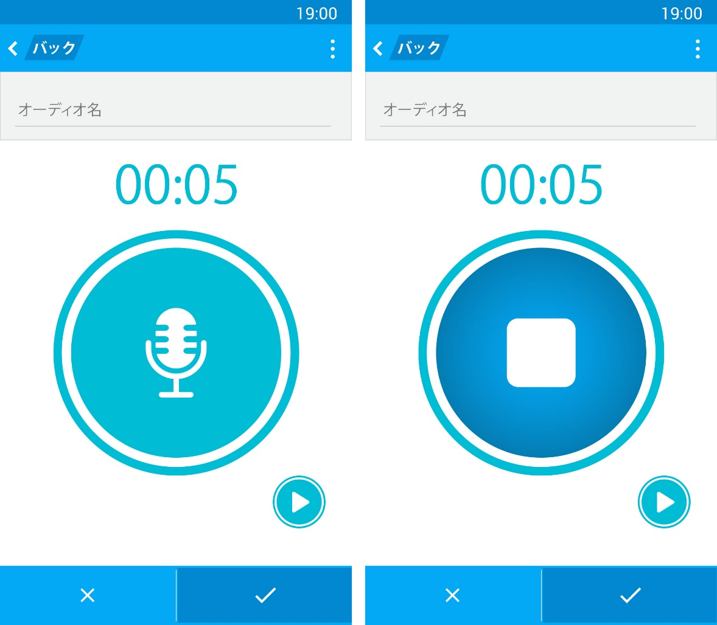

1. SC-VTT-10
2. Record screen description

|  |  |  |  |  |  |
| --- | --- | --- | --- | --- | --- |
| **No.** | **Element** | **Type** | **I/O** | **Description** | **Parent** |
| 1 | Action bar | Layout | I/O |  |  |
| 2 | Option | Button | I | Button for displaying extend option | 1 |
| 3 | バック | Button | I | Button for going back | 1 |
| 4 | Audio name field | Layout | I/O |  |  |
| 5 | Recording field | Layout | I/O |  |  |
| 6 | Footer | Layout | I/O |  |  |
| 7 | Audio name | Textbox | I | Text box for entering audio name | 4 |
| 8 | Audio time | Textview | O | Text view for displaying audio time | 5 |
| 9 | Record | Button | I | Button for recording an audio | 5 |
| 10 | Stop | Button | I | Button for stop recording and finish recording | 5 |
| 11 | Play | Button | I | Button for playing audio added | 5 |
| 12 | OK | Button | I | Button for saving actions | 6 |
| 13 | Cancel | Button | I | Button for canceling actions | 6 |

### Color pattern

The image below show color pattern that must use in this app.

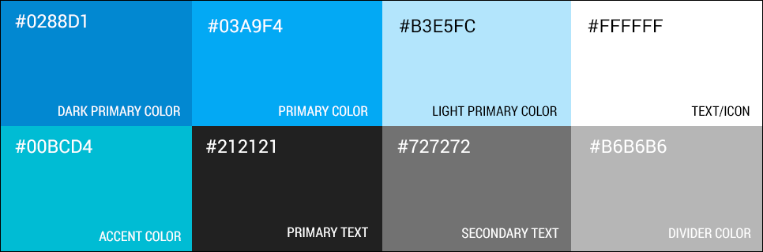

1. Color pattern

We chose blue tone for this app because blue represent patient and smart. So it mean this app has something new and smart. This is a message that we want to send to user: “There is something hide inside our app, a brand new user experience”.

### App’s mascot

Mascot for this app is Aoko Harumoto (青子 春本). She is a brand new character that designed by Phat Nguyen – an artist, also a FPT university student.

This mascot was designed for advertising purpose. And also make our app become more “consumer friendly”.



1. App logo



1. “Don’t have any data” and “Cannot find result” image

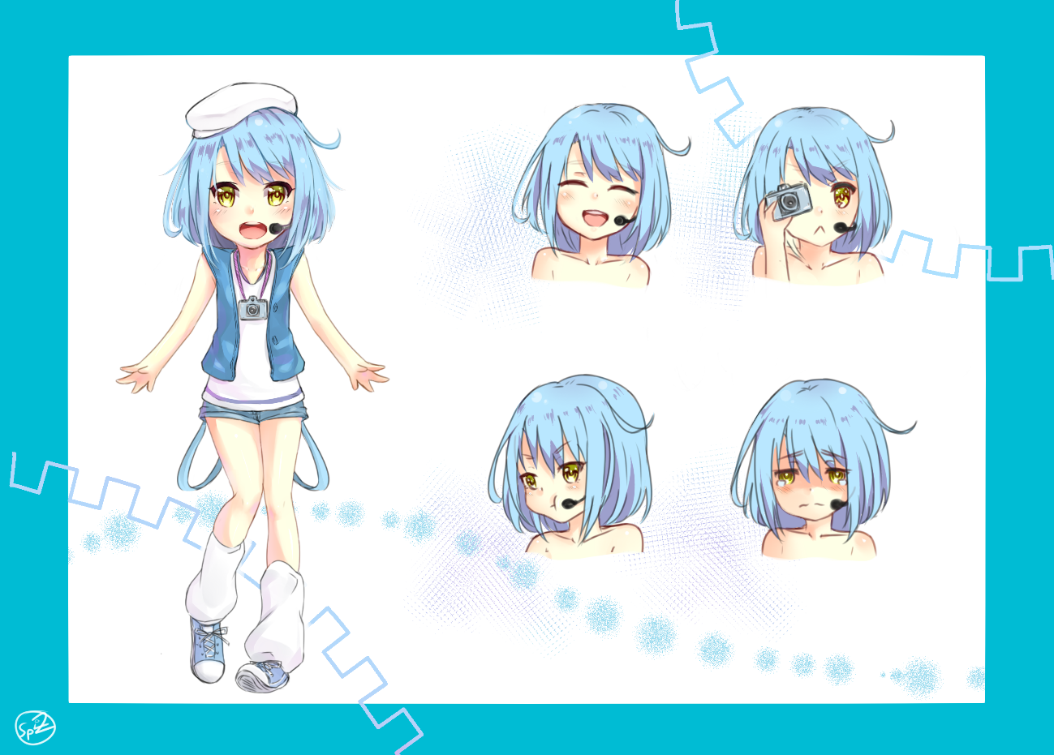

1. Commission character design for app’s mascot

This advertise method is not a new idea in Japan. Microsoft has their own mascot for each product. For example: Nanami Madobe (Windows 7), Claudia Madobe (Windows Azure), Yuu and Ai Madobe (Windows 8), Inori Aizawa (Internet Explorer), Hikaru Aizawa (Microsoft Silverlight) and the newest is Touko Madobe (Windows 10).

# Software Source Code

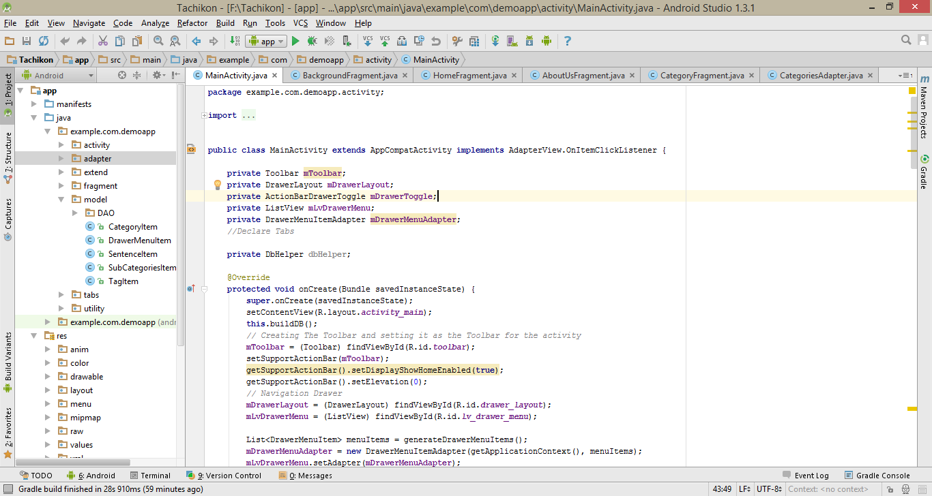

1. Coding screen

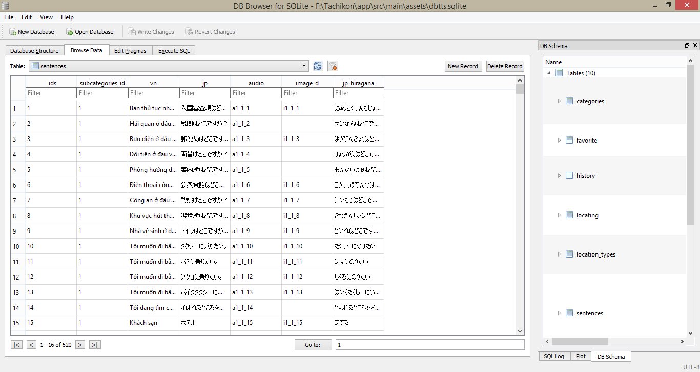

1. Database on DB Browser

# Software Testing

## Introduction

### Purpose

The purpose of this section is to outline the test strategy and overall test approach for the Vietnamese Touch & Talk project. This includes test methodologies, traceability, and resources required and estimated schedule. It contains the following sections:

* Scope of Testing
* Testing Tool and Environment
* Resources and responsibilities
* Test strategy: Test approach, test stages
* Test schedule
* Feature to be tested
* Feature not to be tested
* Test Case
* Test report
* Defect Log

### Scope of testing

|  |  |  |
| --- | --- | --- |
| **ID** | **Test Stages** | **Description** |
| **1** | **Unit testing** | The purpose is to verify the internal logic code by testing every possible branch within the function, also known as test coverage.  Unit test will be done by the developers and will be approved by the implementing team leader to ensure that the building blocks of the system uses work independently of each other and the specific function is working as expected. One function might have multiple tests to catch corner cases in the code. |
| **2** | **Integration testing** | Integration testing will be performed by testers. Requirements of the system will be tested in functional flow. Starting after unit testing complete for each flow.  Focuses on specific areas of uses case when all requirements are completed, integration test should be performed to ensure all components incorporate well. |
| **3** | **System testing** | Compare the system specifications against the actual system.  System testing checks if the integrated product meets the specified requirements. |
| **4** | **Acceptance testing** | Acceptance testing will be performed by the test manager and development team leader.  The acceptance test will be done for a period of 1 week after completion of the System/Integration test process.  Programs will enter into Acceptance test after all critical and major defects have been corrected.  Prior to final completion of acceptance testing all open critical and major defects must be corrected. |

## Test Plan

### Testing tool and environment

#### Testing tool

* **Color Detector 2.0:** Color Detector Tool used for read color ID of Picture

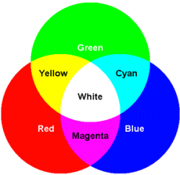

1. Color Detector 2.0

* **Genymotion:** Genymotion is one of the best free Android emulators on the market



1. Genymotion

#### Testing Environment

The contents of the Testing Environment is shown in the table below:

1. Testing environment

|  |  |
| --- | --- |
| **Software** | **Hardware** |
| * Microsoft window 8.1 * Microsoft window 7 * Microsoft Office * Microsoft Project * SQLite browser * MySQL Workbench * Android studio * Genymotion * Tortoise SVN * Google drive * Adobe Photoshop CC | Android smart phone 1:   * Google Android 5.0 (Lollipop) * Qualcomm MSM8974, Snapdragon 800, Quad-core 2.2 GHz * Install memory (RAM) : 2.00GB   Android smart phone 2:   * Android 4.3 (Jelly Bean) * Intel Atom Z2580, Dual-core 2.2 GHz * Install memory (RAM) : 2.00GB   Android smart phone 3:   * Android 4.1.2 (Jelly Bean) * Qualcomm APQ8064, Snapdragon 800, Quad Core 1.7 GHz * Install memory (RAM) : 2.00GB |

### Resources and responsibilities

This table shows the staffing assumptions for our project:

1. Testing resource and responsibilities

|  |  |  |
| --- | --- | --- |
| **ID** | **Resources** | **Responsibilities** |
| 1 | Project Manager | * Responsible for Project Schedules and overall success of the project * Review Test-case and report |
| 2 | Tester | * Preforming the actual system testing * Manage test resource and assign test tasks * Create Test Plan * Create Test Cases * Create Test Report * Execute Test * Test Log report |
| 3 | Developer | * Create Unit Test * Fix bugs |

### Test Strategy

#### Test Model

We use V-model to implement testing process.

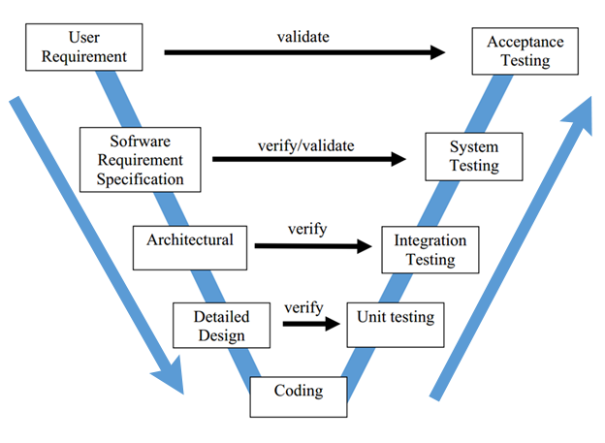

1. V-model

Due to requirement of project must be always suitable with user, we choose V-model to implement testing process. With V-Model, software development is separated into two appropriate phase’s groups: development and testing. In this model, the verification and validation will be done side by side. It emphasizes the strict process flow to develop a quality product. The errors occurred in any phase will be corrected in that phase. Proactive defect tracking defects which are found at early stages even may be in the development phase before application being tested (Unit test).

#### Test Types

Testing Vietnamese Touch & Talk Project will be carrying out in each release package as defined in project plan and depends on internal delivery by development side. Critical test will be defined as any new or modified test for the Vietnamese Touch & Talk system. Project Manager will decide which closed defects which the test team cannot determine.

The different types of testing that will be carry out this project are.

##### Functional Test

* Testing of all implemented functions on the Vietnamese Touch & Talk system.
* The testing that will be covered for those functions in function test is verification the validation of the behavior according to requirements.
* Test cases will have to be designed to cover all the above and executed.
* Implemented function’s error message will be included under this test.

##### User Interface Test

* Graphical User Interface (GUI) Testing verifies a user’s interaction with the software. The goal of GUI testing is to ensure that the GUI provides the user with the appropriate access and navigation through the functions of the target-of-test. In addition, GUI testing ensures that the objects within the GUI function as expected and conform to requirement.
* GUI test will be performed fully on all screens.
* This test is targeted to cover the verification of the overall look and feel of the Vietnamese Touch & Talk system including initial position, font, text size, color, focus, initial button, tab order, label, screen sizes and sentences width.
* Check all the GUI elements for size, position, width, length and acceptance of characters or numbers. For instance, it must be able to provide inputs to the input fields.
* Check Error Messages are displayed correctly
* Check Font used in application is readable
* Check the alignment of the text is proper
* Check the Color of the font and warning messages is aesthetically pleasing
* Check that the images have good clarity
* Check that the images are properly aligned
* Check the positioning of GUI elements for different screen resolution

##### Performance Test

* The testing that will be covered for response time for Vietnamese Touch & Talk system.

##### Regression Test

* The testing is confirmed that the bug was removed including the extent of the impact.

##### Acceptance Test

* The testing is a test conducted to determine if the requirements of a specification or contract are met.
* It involves alpha testing and beta testing. Alpha testing takes place at developers' sites, and involves testing of the operational system by internal member, before it is released to external users. Beta testing takes place at user’s sites, and involves testing by a group of users who use the system at their own locations and provide feedback, before the system is released to all users.

#### Test Stage

Table below are the stages in which common test are executed:

1. Test stage

|  |  |  |  |
| --- | --- | --- | --- |
| **Type of Tests** | **Stage of Test** | | |
| **Unit** | **Integration** | **System** |
| Function Tests | x | x | x |
| GUI Tests |  | x | x |
| Regression Tests |  | x | x |
| Performance Tests |  |  | x |
| Acceptance Tests |  |  | x |

#### Test Schedule

1. Test schedule

|  |  |  |
| --- | --- | --- |
| **Test Schedule** | **Start Date** | **End Date** |
| **Iterative 1:** | **30/06/2015** | **11/07/2015** |
| Unit Testing | 07/07/2015 | 07/07/2015 |
| User Interface Testing | 08/07/2015 | 08/07/2015 |
| Functional Testing | 09/07/2015 | 09/07/2015 |
| Performance Tests | 10/07/2015 | 10/07/2015 |
| Regression Tests | 11/07/2015 | 11/07/2015 |
| **Iterative 2:** | **29/07/2015** | **25/08/2015** |
| Unit Testing | 03/08/2015 | 13/08/2015 |
| User Interface Testing | 11/08/2015 | 15/08/2015 |
| Functional Testing | 16/08/2015 | 20/08/2015 |
| Performance Tests | 21/08/2015 | 22/08/2015 |
| Regression Tests | 23/08/2015 | 24/08/2015 |
| Acceptance testing | 25/08/2015 | then |

#### Deliverables

Table below are the Deliverables for Vietnamese Touch & Talk Project:

1. Test Deliverables

|  |  |  |
| --- | --- | --- |
| **Deliverables** | **Responsibilities** | **Completion date** |
| Test Plan | Tester | 01/07/2015 |
| Test Cases | Tester | 06/07/2015 |
| Test case review | Tester + PM | 07/07/2015 |
| Test Data (Data Set) | Tester | 18/08/2015 |
| Defect report | All members | 24/08/2015 |
| Final test Summary report | PM | 25/08/2015 |

### Feature to be tested

Developers will be performed unit test to ensure that all functions are working as expected.

The test team will be undertaking the responsibility of testing and validating the operation of the part that developed. The functions developed require completing design and execution of function tests to ensure proper coverage.

Following are items that will need to be tested by testers:

1. Feature to be tested

|  |  |  |  |  |
| --- | --- | --- | --- | --- |
| No. | Component | | Feature Name | Feature to be tested |
|  | Interface | Main application | Screen elements | Check the display of elements |
|  | Function | Main application | Touch to talk | View category list |
|  | View subcategory list |
|  | View sentence list |
|  | Touch to has voice |
|  | Searching | Search sentence |
|  | Search tag |
|  | User’s sentence management | Add new user’s sentence |
|  | View user’s sentence list |
|  | Modify user’s sentence |
|  | Remove user’s sentence |
|  | Take photo |
|  | Record audio |
|  | Tagging | Add tag |
|  | View tag list |
|  | Remove tag |
|  | Remove sentence in tag |
|  | Modify sentence’s tag |
|  | Favorite | Add favorite |
|  | View favorite |
|  | Remove favorite |
|  | History | View history |
|  | Suggestion | Suggestion follow location |
|  | Performance | Main application | Response time | |
|  | Voice Test | Main application | Check content and sound of sentence | |

### Feature not to be tested

* Maintainability
* Security testing

### Test Cases

#### Unit Test Cases

Refer to VTT_Unit test case to know all Unit test case

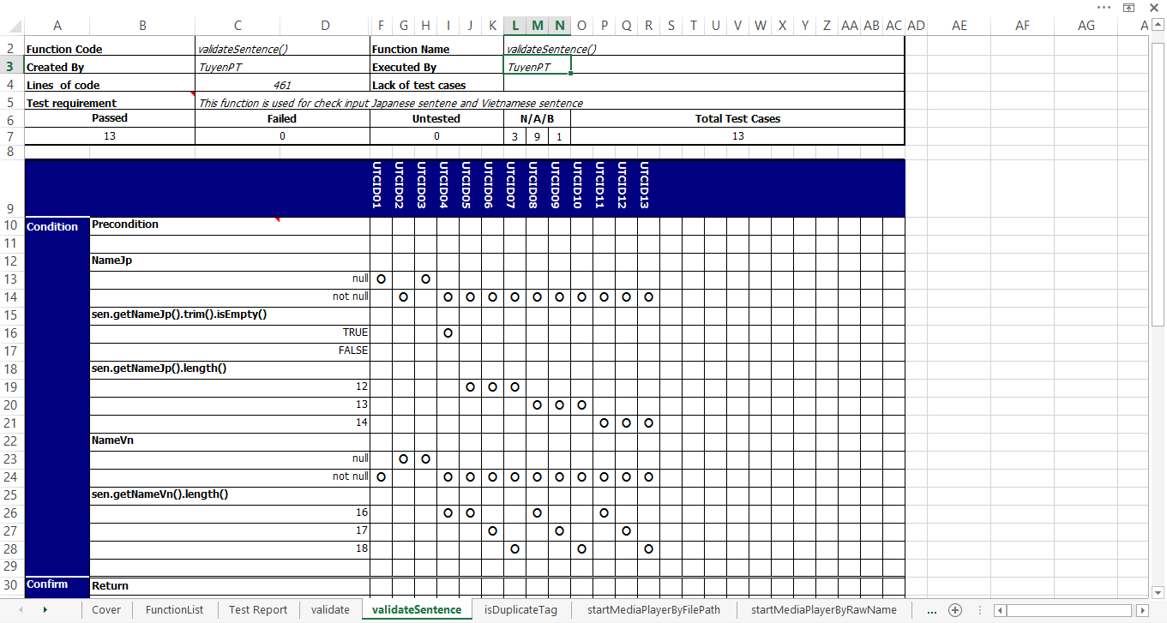

1. Unit test case

#### GUI

Refer to VTT_TestCase to know all GUI test cases

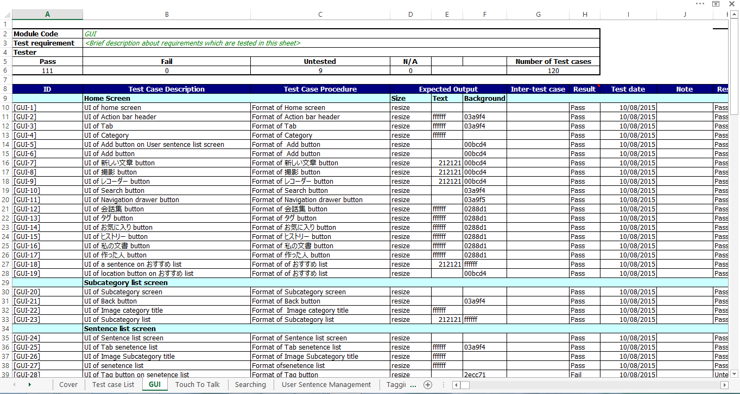

1. GUI test case

#### Function Test

Refer to VTT_TestCase to see all test case execution

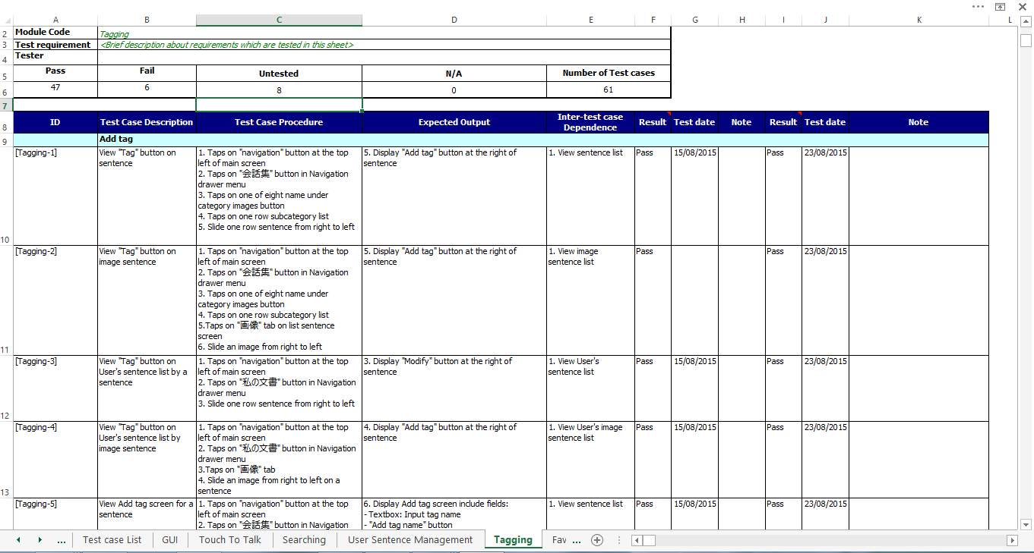

1. Function test case

#### Check list

Refer to VTT_Checklist to see all check list test case execution

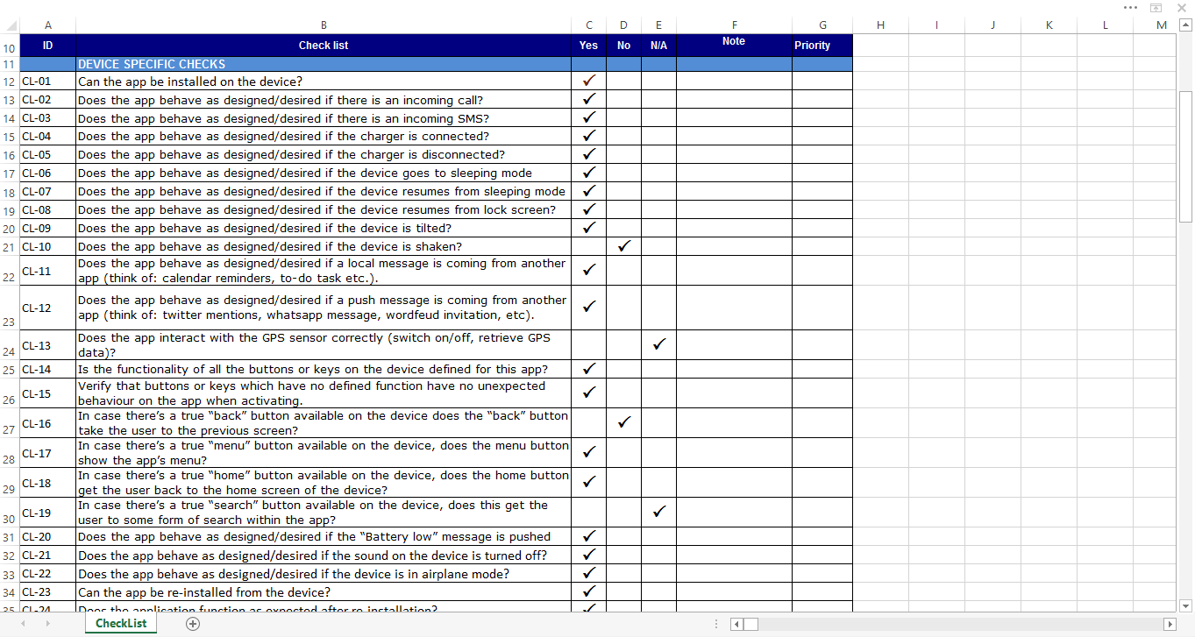

1. Checklist test case

## Test Report

### Test Report

* + **Unit Test**

|  |  |  |  |  |  |
| --- | --- | --- | --- | --- | --- |
| Date | Aug-15 | | | | Total |
| 04/08 | 05/08 | 06/08 | 07/08 |  |
| Execute Test (TC) | 25 | 19 | 14 | 23 | 81 |
| TuyenPT | x | x | x | x |  |
| Bug | 0 | 3 | 1 | 0 | 4 |

|  |  |  |  |  |  |  |
| --- | --- | --- | --- | --- | --- | --- |
| No | Module code | Pass | Fail | Untested | N/A | Number of test cases |
|  | Unit Test | 77 | 4 | 0 | 0 | 81 |

* + **Function Test**

|  |  |  |  |  |  |
| --- | --- | --- | --- | --- | --- |
| Date | Round 1 | | | Round 2 | Total |
| Aug-15 | | | Aug-15 |
| 10/08 | 15/08 | 18/08 | 24/08 |  |
| Execute Test (TC) | 183 | 237 | 625 | 425 | 1470 |
| ChinhNL | x | x | x | x |  |
| Bug | 25 | 14 | 0 | 15 | 54 |
| Method | Touch to has voice, Searching, User’s Sentence, History, Favorite | Tagging, GUI, Performance, Common | Suggestion, Test Voice | All |  |

* **Round 1**

|  |  |  |  |  |  |  |
| --- | --- | --- | --- | --- | --- | --- |
| **No** | **Module Test** | **Pass** | **Fail** | **Untested** | **N/A** | **Number of test cases** |
| 1 | GUI | 111 | 0 | 9 | 0 | 120 |
| 2 | Touch To Talk | 29 | 0 | 0 | 0 | 29 |
| 3 | Searching | 11 | 0 | 0 | 0 | 11 |
| 4 | User’s Sentence Management | 46 | 16 | 39 | 0 | 101 |
| 5 | Tagging | 41 | 5 | 15 | 0 | 61 |
| 6 | Favorite | 22 | 2 | 2 | 0 | 26 |
| 7 | History | 14 | 2 | 0 | 0 | 16 |
| 8 | Suggestion | 4 | 1 | 0 | 0 | 5 |
| 9 | Performance | 29 | 0 | 0 | 0 | 29 |
| 10 | Common | 27 | 0 | 0 | 0 | 27 |
| 11 | Voice Test | 620 | 0 | 0 | 0 | 620 |
|  | **Sub total** | 954 | 24 | 65 | 0 | 1045 |

|  |  |  |  |
| --- | --- | --- | --- |
| **Test coverage** |  | **98,37** | % |
| **Test successful coverage** |  | **97,13** | % |

* **Round 2**

|  |  |  |  |  |  |  |
| --- | --- | --- | --- | --- | --- | --- |
| **No** | **Module Test** | **Pass** | **Fail** | **Untested** | **N/A** | **Number of test cases** |
| 1 | GUI | 114 | 6 | 0 | 0 | 120 |
| 2 | Touch To Talk | 29 | 0 | 0 | 0 | 29 |
| 3 | Searching | 11 | 0 | 0 | 0 | 11 |
| 4 | User’s Sentence Management | 100 | 1 | 0 | 0 | 101 |
| 5 | Tagging | 53 | 8 | 0 | 0 | 61 |
| 6 | Favorite | 26 | 0 | 0 | 0 | 26 |
| 7 | History | 16 | 0 | 0 | 0 | 16 |
| 8 | Suggestion | 5 | 0 | 0 | 0 | 5 |
| 9 | Performance | 29 | 0 | 0 | 0 | 29 |
| 10 | Common | 27 | 0 | 0 | 0 | 27 |
| 11 | Voice Test | 620 | 0 | 0 | 0 | 620 |
|  | **Sub total** | 1030 | 15 | 0 | 0 | 1045 |

|  |  |  |  |  |
| --- | --- | --- | --- | --- |
| **Test coverage** |  | **100,00** | % |  |
| **Test successful coverage** |  | **98,56** | % |  |

* **Test coverage**: ([number of test cases pass] + [number of test cases Fail] ) / ([number of test cases] - [number of test cases N/A] )
* **Test successful coverage:** [number of test cases pass] / ([number of test cases] - [number of test cases N/A]

### Defect Log

Refer to Defect Log to see all Bug List

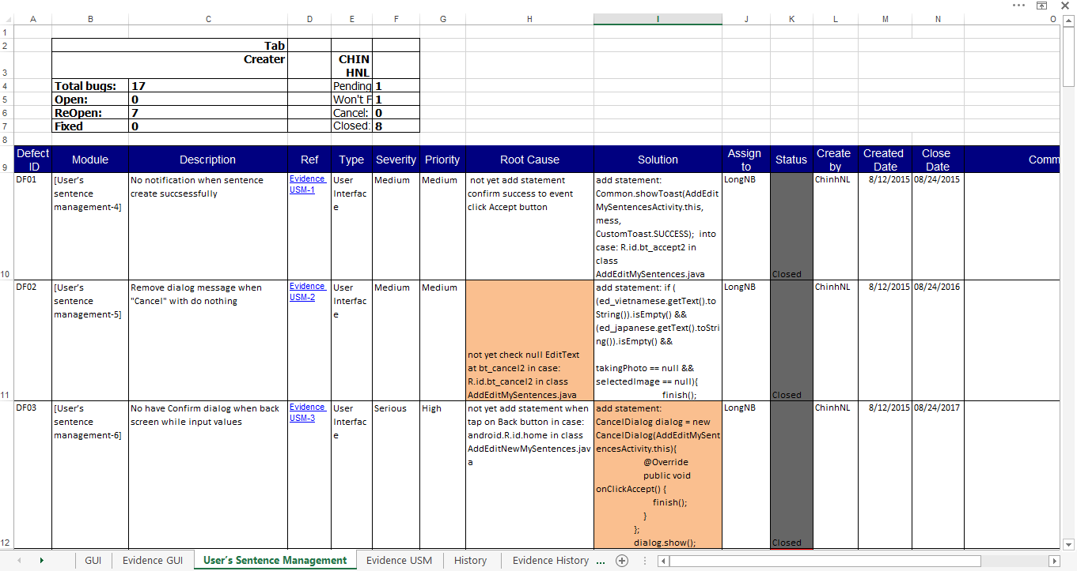

1. Defect log

# User Guide

## Installation Guide

### English Version

#### Prerequisites

This section contains the list of prerequisites that must be fulfilled before install can begin.

* A smart phone use Android 4.4 or higher.
* 47 MB free or higher

#### Installation Procedures

Tap on the icon of the CH play, search for “Tachikon” Application then tap on Install button.

#### Uninstall Procedures

Tap and hold the icon of the VTT application then tap on the x symbol in the corner of the icon.

### Japanese Version

#### 前提条件

このセクションでは、インストール開始ができるために以前に満たさなければならない前

提条件のリストが含まれています。

* Android 4.4 以上での携帯電話
* メモリは 47MB い上、無料

#### インストール手順

CH Play のアイコンをタップし、「Tachikon」アプリケーションを検索し、「Install」

ボタンをタップする。

#### アンインストール手順

「Tachikon」アプリケーションのアイコンをタップし、そのままにアイコンを持ち、

アイコンの隅の「x」記号をタップする。

## User Manual

|  |  |
| --- | --- |
|  | * Menu: Include category, tag, favorite, history, user’s sentence, about. * Quick add user’s sentence |

|  |  |
| --- | --- |
|  | * Not favorite: Sentence is not favorite, tap on this button to add to favorite. * Favorite: Sentence is favorite, tap on this button to remove from favorite. * Tag: Edit this sentence’s tag. * Location: Show location. |

|  |  |
| --- | --- |
|  | * Current location: Swipe this button on map to pick location. * Back to current location. |

|  |  |
| --- | --- |
|  | * Replay: Tap on this button to replay sound. |

|  |  |
| --- | --- |
|  | * Revert: Revert tag if you delete wrong tag. * Add tag: After type tag’s name, tap on this button to add tag to sentence. * Remove tag: Remove tag from sentence. |

|  |  |
| --- | --- |
|  | * Delete sentence: Tap on this button to delete sentence. * Edit sentence: Tap on this button to edit sentence. |

|  |  |
| --- | --- |
|  | * Add tag: Add tag to new sentence. * Choose audio: Choose audio from mobile. * Record audio: Record new audio for new sentence. * Take picture: Take new picture for new sentence. * Play audio: Play audio just added. * Delete audio: Delete audio just added. * Choose picture: Choose picture form mobile. |

# Conclusion

This was the first time all member working in one team, with so many things that we need to learn through project life cycle. Of course, we made a lots of mistakes because of lack of experiences. However, we managed to end this capstone project completely and meet the success criteria that we defied at the project start time. Working together on this project, we have a change to apply everything learned at university. And also earn a lot of experiences about new method, new process, and new technic.

**Future work**

Four months working this project, we can say that this is just a first step. First of all, the product in the future may not only apply for Japanese Traveler, it will aim to everyone in the world to make people closer together. Second, for user’s sentence function, we can build a server where users can easily share their data to anyone. And finally, we want to make app more and more cleaver by using machine learning algorithms to understand what user need.

# Appendixes

## Progress report

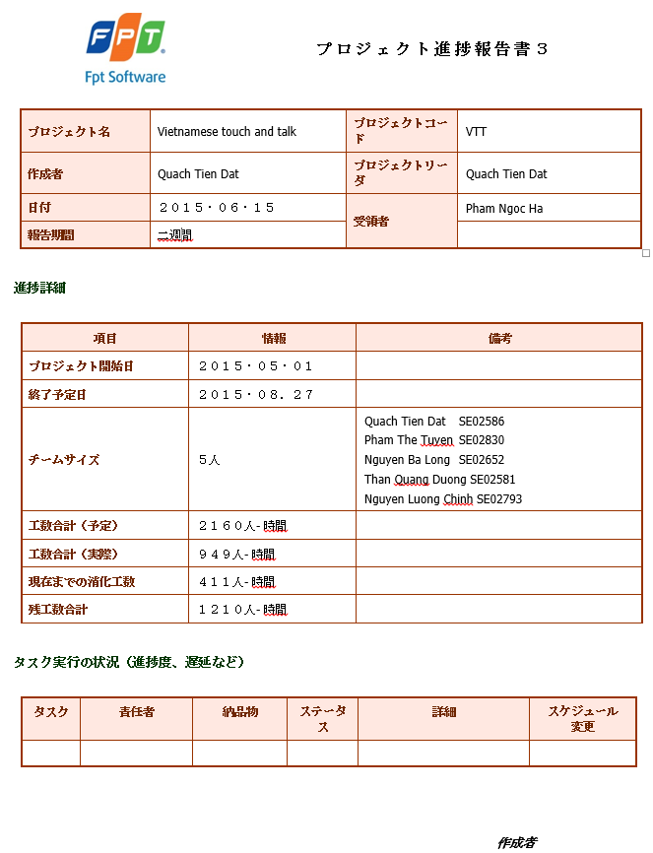

1. Progress report 3

## Meeting minutes

1. Meeting minutes Jap

|  |  |  |  |  |  |  |  |
| --- | --- | --- | --- | --- | --- | --- | --- |
| **Project:** | | Vietnamese Touch & Talk | | **Project Code:** | | VTT | |
| **Project Manager:** | | Quach Tien Dat | | **Conductor:** | | Pham Ngoc Ha | |
| **Secretary:** | | Nguyen Luong Chinh | |
| **Date:** | | 2015/07/22 | | **Time:** | | 6:00 PM – 7:00 PM | |
| **Venue:** | | 11th floor, FPT Cau Giay | | | | | |
| **Meeting topic:** | | スーパーバイザ第5会議 | | | | | |
| **Attendees:** | | | | | | | |
| **No** | **Full name** | | **Unit/Group** | | **Position** | | **Attendance** |
| 1 | Pham Ngoc Ha | | Fsoft | | Supervisor | | Present |
| 2 | Quach Tien Dat | | HSTeam | | Project manager | | Present |
| 3 | Pham The Tuyen | | HSTeam | | Member | | Present |
| 4 | Nguyen Ba Long | | HSTeam | | Technical leader | | Present |
| 5 | Than Quang Duong | | HSTeam | | Member | | Present |
| 6 | Nguyen Luong Chinh | | HSTeam | | Test leader | | Present |
| **Objectives:** | | | | | | | |
| * テストケースを確認します。 * シーケンス図を確認します。 | | | | | | | |
| **Agenda:** | | | | | | | |
| * テストケースを確認します。 * シーケンス図を確認します。 * 欠陥のバグを確認します。 * 新しいタスクを与えます。 | | | | | | | |
| **Contents:** | | | | | | | |
| 1, テストケースを確認   * 約200のテストケースは、可能な規格です。 * レビューフォームテストケース：比較的完全な。 * ユースケースの完全なテストケースフォロー名、テストケースを簡単に管理するために、シートに機能を分割する必要があります。 * テストケースGUIは、チェックリストに従ってください。   2, レビューシーケンス図   * シーケンス図の画面の説明は、いくつかのミスを持っています。   3, レビュー欠陥のバグ   * フォームと説明を修正する必要があります。 * モジュールの名前はテストケースIDに従ってください。 * 説明が理解し、簡単なです。 * バグ画面やコメントを追加します。 * バグを記録する方法については、テスターと開発者の作業。   4, 新しいタスクを与えます   * 完全なシーケンス図。 * 開発者は、20〜30ユニットテストを書きます。 * クラス図を更新します。   5, 詳細計画   * 7月29日の完全なラウンド1と書類を提出： * 完了し、シーケンス図を提出します。 * 完了し、クラス図を提出します。 * 完全なテストケース * 完全なユニットテスト * 7月29日または8月4日に多分次のミーティング。 * 8月15日には：最終的かつ完全な書類を提出してください。 | | | | | | | |
|  | | | | | | | |
| **Discussed Items** | | | **Decisions** | | | | |
| 1, テストケースを確認 | | | 修正し、完全なテストケースする必要があります。 | | | | |
| 2, レビューシーケンス図 | | | 修正し、完全なシーケンス図する必要があります。 | | | | |
| 3, レビュー欠陥のバグ | | | フォーム欠陥のバグを修正する必要があります。 | | | | |
| 4, 更新クラス図 | | | 修正し、完全なクラス図にする必要があります。 | | | | |
| 5, ユニットテストを書きます | | | ユニットテストを記述する必要があります。 | | | | |

1. Meeting minutes Eng.

|  |  |  |  |  |  |  |  |
| --- | --- | --- | --- | --- | --- | --- | --- |
| **Project:** | | Vietnamese Touch & Talk | | **Project Code:** | | VTT | |
| **Project Manager:** | | Quach Tien Dat | | **Conductor:** | | Pham Ngoc Ha | |
| **Secretary:** | | Nguyen Luong Chinh | |
| **Date:** | | 2015/07/22 | | **Time:** | | 6:00 PM – 7:00 PM | |
| **Venue:** | | 11th floor, FPT Cau Giay | | | | | |
| **Meeting topic:** | | Fifth meeting with supervisor | | | | | |
| **Attendees:** | | | | | | | |
| **No** | **Full name** | | **Unit/Group** | | **Position** | | **Attendance** |
| 1 | Pham Ngoc Ha | | Fsoft | | Supervisor | | Present |
| 2 | Quach Tien Dat | | HSTeam | | Project manager | | Present |
| 3 | Pham The Tuyen | | HSTeam | | Member | | Present |
| 4 | Nguyen Ba Long | | HSTeam | | Technical leader | | Present |
| 5 | Than Quang Duong | | HSTeam | | Member | | Present |
| 6 | Nguyen Luong Chinh | | HSTeam | | Test leader | | Present |
| **Objectives:** | | | | | | | |
| * Review the Test Case. * Review the Sequence diagram. | | | | | | | |
| **Agenda:** | | | | | | | |
| * Review the Test Case. * Review the Sequence diagram. * Review the Defect bug. * Assign new tasks. | | | | | | | |
| **Contents:** | | | | | | | |
| 1, Review the Test Case   * About 200 Test Cases meet the standards. * Review form test case: Relatively complete. * Complete Test case by Use Case name, Test case should divide functions into sheets to manage easily. * Test Case GUI should follow checklist.   2, Review the Sequence diagram   * Sequence diagram screens descriptions have some mistakes.   3, Review the Defect bug   * Need to fix forms and descriptions.   + Module names follow Test Case ID.  + Descriptions are short and understandable + Add bug screen and comments   * Instruction on how to log bug and tasks of Tester and Developer.   4, Assign new tasks   * Complete the Sequence diagram. * Developers write 20-30 Unit test. * Update Class diagram.   5, Detail plan   * On the 29th of July: Complete round 1 and submit following documents:   + Complete and submit the sequence diagram.  + Complete and submit the class diagram.   * Complete the Test Case * Complete the Unit test * The next meeting maybe at 29th July or 4th August. * On the 15th of August: Submit final version and complete documents. | | | | | | | |
|  | | | | | | | |
| **Discussed Items** | | | **Decisions** | | | | |
| 1, Review the Test Case | | | Need to fix and complete the test case. | | | | |
| 2, Review the sequence diagram | | | Need to fix and complete the sequence diagram. | | | | |
| 3, Review the Defect bug | | | Need to fix Defect bug form. | | | | |
| 4, Update the Class diagram | | | Need to fix and complete the class diagram. | | | | |
| 5, Write the Unit test | | | Need to write up the Unit test. | | | | |

## Q&A

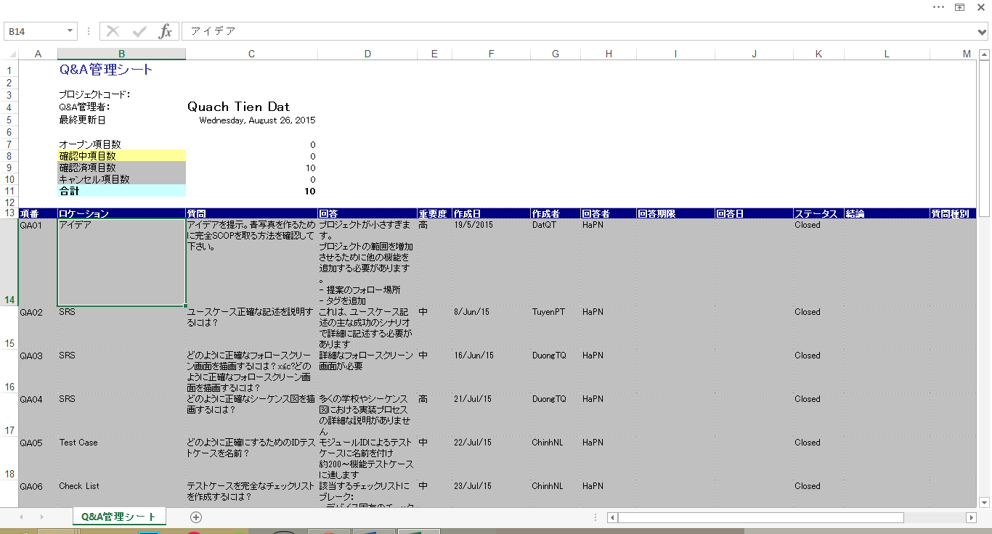

1. Q&A

## Survey document

Visit link below to see survey details:

<https://docs.google.com/forms/d/1eUn7gDvb0Bf5fvXuJKQO1oqTpED-9hBjgykefMx-5Og/viewform>

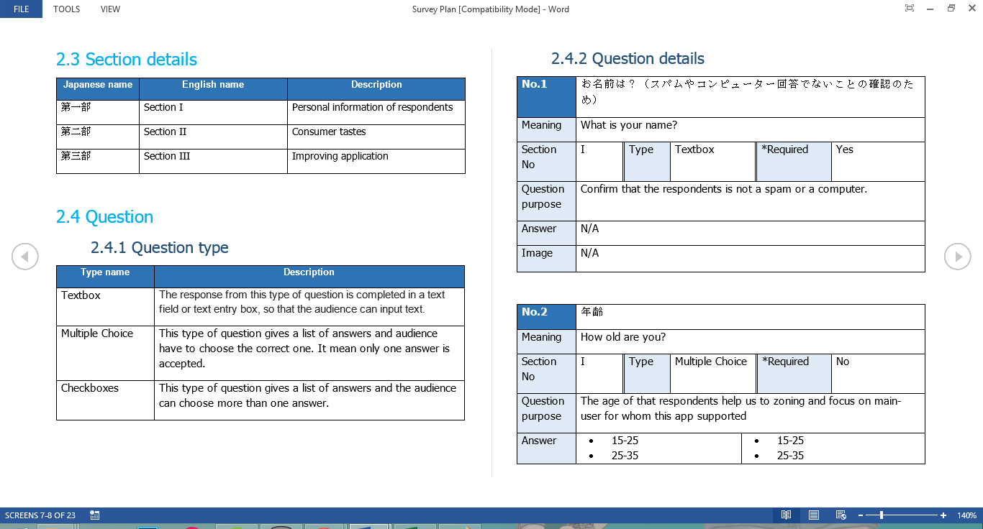

1. Survey plan document

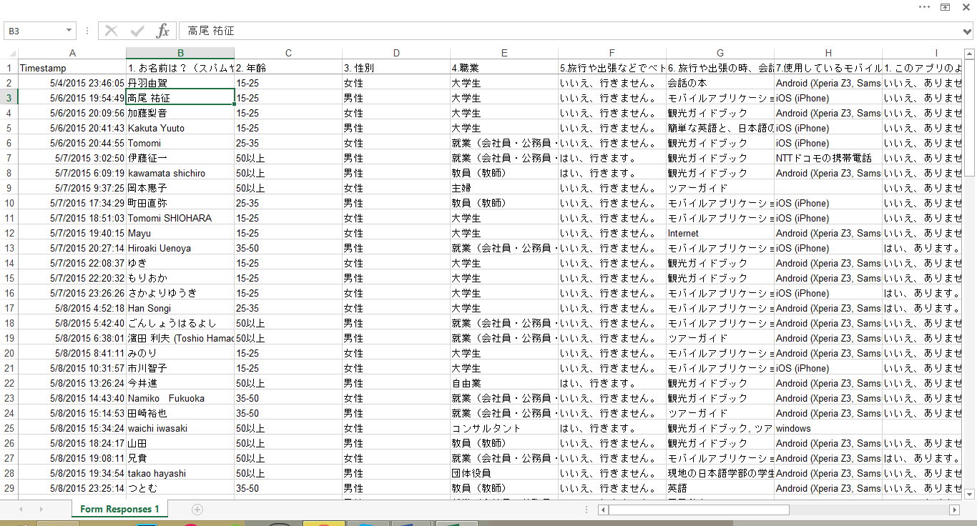

1. Survey responses

## UI design evolution

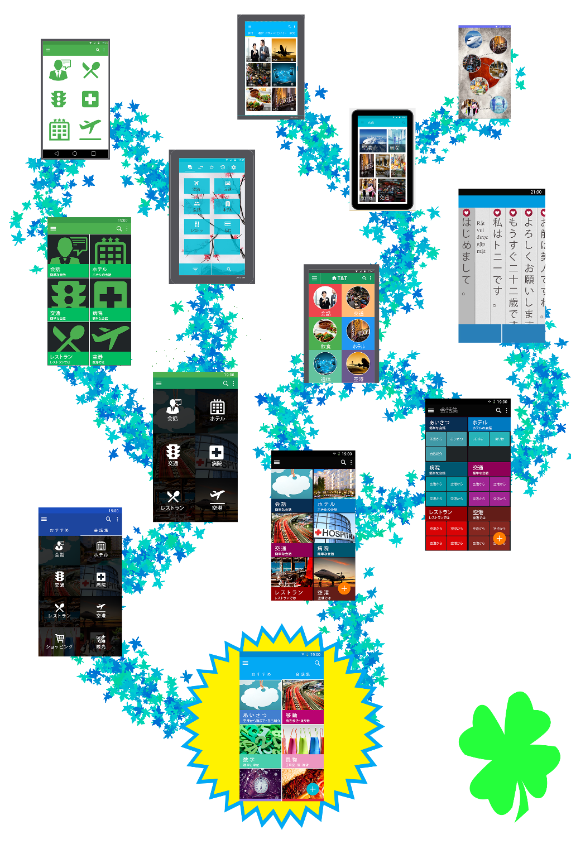

1. UI design evolution

## Build data document

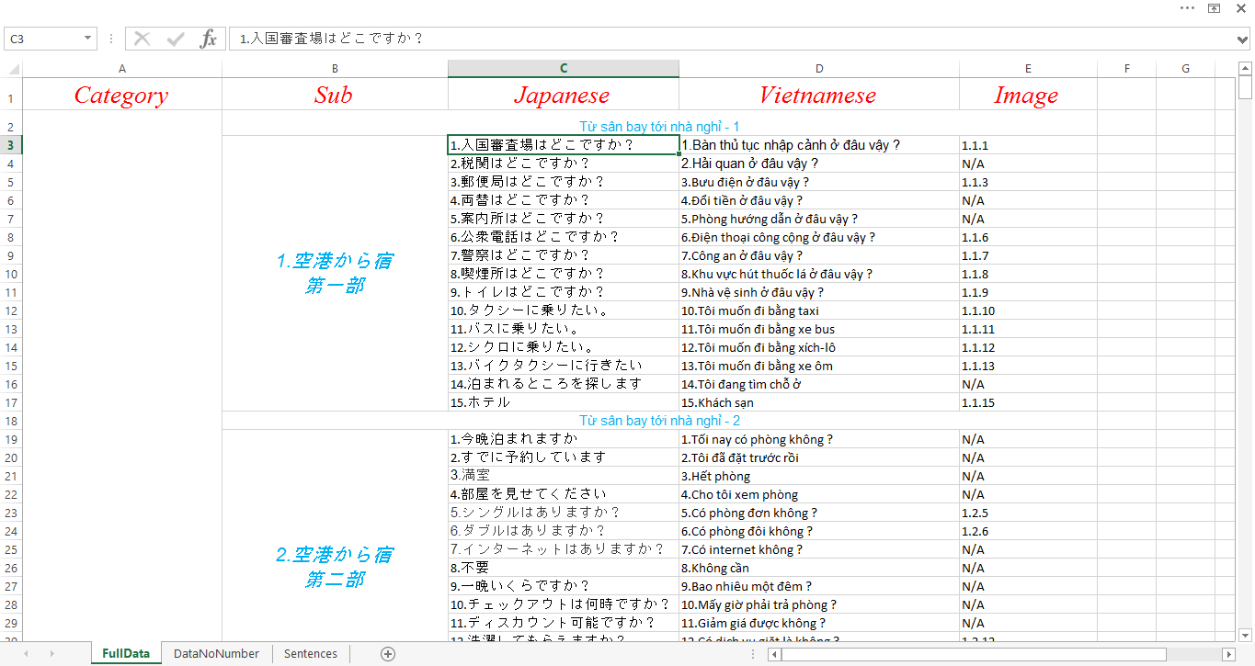

1. Full sentence data document

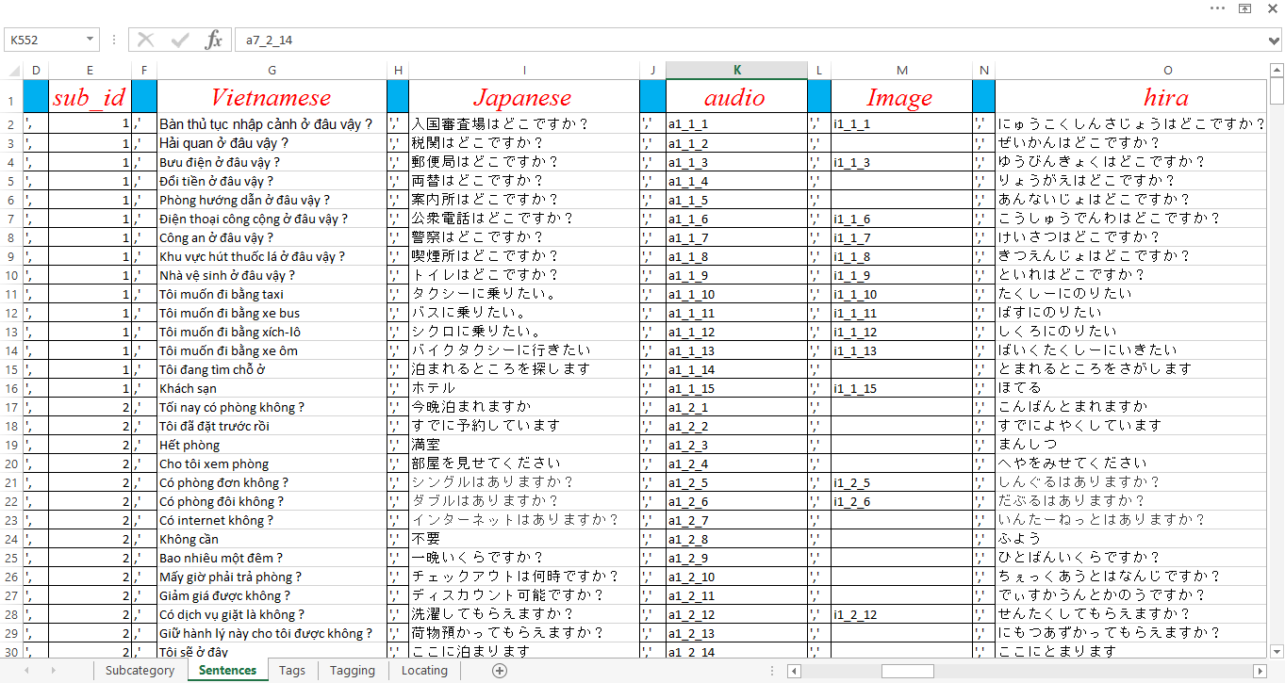

1. SQLite insert query document

# Reference

**Documents:**

1. [RTF_FinalReport.docx, Project Code: RTF, FPT University, Hanoi, Vietnam.](../../7.%20Other/Sample%20report/Report%201%20Introduction/RTF_Report_1_Introduction.docx)
2. [[Diabetes Buddy]FinalReport.docx, Project Code: Diabetes Buddy, FPT University, Hanoi, Vietnam.](../../7.%20Other/Diabetes%20Buddy/%5bDiabetes%20Buddy%5dFinalReport.docx)
3. EC_FinalReport_v1.0.pdf

**Websites:**

1. <https://play.google.com/store/apps/details?id=com.tss21.rightnow.vnm.main&hl=en>
2. <https://docs.google.com/forms/d/1eUn7gDvb0Bf5fvXuJKQO1oqTpED-9hBjgykefMx-5Og/viewanalytics>
3. <https://play.google.com/store/apps/details?id=com.gdc.android.yubisashi.jpvn&h\>
4. <http://www.usabilityfirst.com/about-usability/introduction-to-user-centered-design>
5. <http://uxmastery.com/what-does-a-user-centred-design-process-look-like>